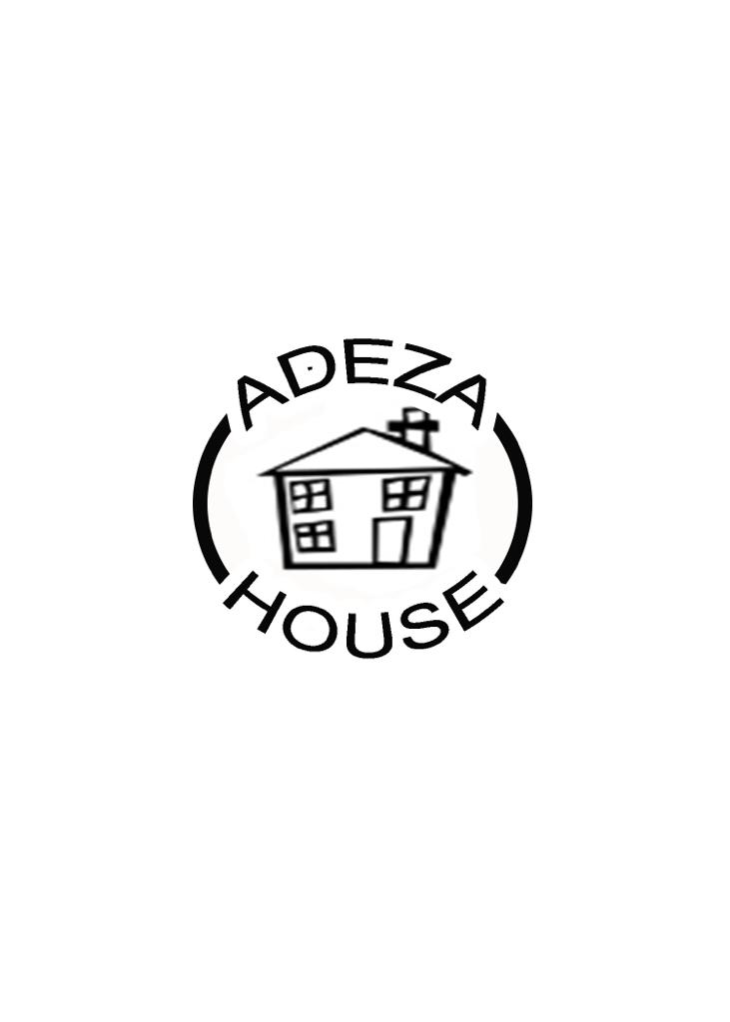

Adeza House

Postal Address: PO Box 24548, London E17 3UE

Email: [adeza.care@ntlworld.com](mailto:adeza.care@ntlworld.com) / [referrals@adezacarehomes.org.uk](mailto:referrals@adezacarehomes.org.uk)

Tel: (020) 8539 3318 or 07957 111164; Fax 020 923 5017

Website: www.adezahouse.org.uk

**Adeza House - Referral Impact Risk Assessment**

**A Proactive Approach to Gathering Information to Consider Referrals, Planning, Implementation and Reviews**

Adeza House implements this Risk Assessment as part of its proactive approach to managing challenging behaviour and to ensure that young people who displays challenging behaviours have the same rights and safeguards as other people.

This Risk Assessment also highlights occupational health and safety considerations for Adeza Grove Green and its staff. Taking a proactive approach to managing challenging behaviour is one way of effectively understanding challenging behaviour whilst minimising and preparing for any risks in our working environment.

This Risk Assessment aims to identify the reason or potential reasons for the behaviour rather than merely reacting to it; therefore, our proactive approach aims to try to prevent factors that may trigger the behaviour in the first instance.

This Risk Assessment will help staff to respond to and to provide support to each young person in an ethically appropriate and effective manner.

This proactive approach to gathering information supports our efforts to reduce the occurrence of challenging behaviour through the application of the following principles:

* Respecting the rights of all young people and their unique needs.
* Provide options for managing challenging behaviour and mechanisms to have these reviewed.
* Understanding that challenging behaviour serves a purpose.
* Understanding the impact that a placement may have on the existing young people in the Home.
* The importance of separating the person from their behaviour.
* The importance of effective communication between staff and young people.
* The importance of building positive relationships and having unconditional positive regard for young people.
* Respecting the rights of staff who work at the home.
* Positive beliefs, values and attitudes can influence the outcome of planning in a positive way so learnt behaviour can be changed through the principles of Positive Behavioural Management.

**Notes**

Please take the time to complete the Risk Assessment below, giving as much detail as possible. If an area does not apply to your current referral, write not applicable (N/A). Please do not leave any areas blank as this may lead to uncertainty as to whether or not the area was accidentally overlooked or not.

|  |  |  |  |
| --- | --- | --- | --- |
| **1. REFERRER DETAILS** | | | |
| **Name of Referrer:** |  | | |
| **Position:** |  | | |
| **Name of Agency:** |  | | |
| **Contact Address:** |  | | |
| **Telephone Number:** |  | | |
| **Email Address:** |  | | |
| **Date of Referral:** |  | | |
| **Team Manager:** |  | **Tel Number:** |  |
| **IRO Details:** |  | **Tel Number:** |  |

|  |  |  |  |
| --- | --- | --- | --- |
| **2. YOUNG PERSON’S DETAILS** | | | |
| **Name:** |  | | |
| **D.O.B:** |  | | |
| **Gender/Ethnicity/Religion:** |  |  |  |
| **Contact Address:** |  | | |
| **Telephone Number:** |  | | |
| **Legal Status:** |  | | |
| **Does the YP have a disability?** If so, please state: |  | | |
| **Religion:** |  | | |
| **Language Spoken:** |  | | |

|  |  |  |  |
| --- | --- | --- | --- |
| **3. HEALTH** | | | |
|  | Y | N | Details |
| Current Illness/Injury: |  |  |  |
| Previous Illness/Injury: |  |  |  |
| Current Smoking Habit: |  |  |  |
| Current Substance/Alcohol Misuse: |  |  |  |
| Medical Conditions: (please list) |  |  |  |
| Treatment in Last 12 Months: |  |  |  |
| Current Medication: |  |  |  |
| Special Dietary Requirements: |  |  |  |
| Medical Information: |  |  |  |
| Fears/Phobias/Sleep: |  |  |  |
| Glasses Wearer/Hearing Impaired: |  |  |  |

|  |  |
| --- | --- |
| **4. MENTAL WELL BEING** | |
| Have any assessments been completed? | Y/N *(Please State)* |
| By Whom? |  |
| Contact Details: |  |
| When *(Date)*: |  |
| List any known Suicidal Ideation, Attempts of Suicidal Behaviour or Incidents of Self Harm *(including dates)*: |  |
| Methods Used to Respond: |  |
| Outcome and Follow Up Treatment (any upcoming appointments?): |  |

|  |  |
| --- | --- |
| **5. EDUCATION/TRAINING/WORK DETAILS** | |
| Is the YP engaged in any of the above? *Delete as appropriate.* | **YES / NO (if yes, please complete details below)** |
| Current Education Provider: |  |
| Contact Name: |  |
| Telephone Number: |  |
| Email Address: |  |
| Statement of Educational Needs *(Please state any other relevant details):* |  |
| Details of Days & Times of Education, Transport Arrangements: |  |

|  |  |  |  |
| --- | --- | --- | --- |
| **6. PLACEMENT HISTORY:** | | | |
| Current Placement: |  | Length of Placement (from/to): |  |
| Previous Placement: |  | Length in Placement (from/to): |  |

|  |
| --- |
| **7. REASONS FOR REFERRAL:** |
| **Please state reason for Referral:** |

|  |
| --- |
| **8. YOUNG PERSON PROFILE:** |
| **What are the risk factors presented in support of a placement at Adeza? Which behaviours give cause for concern? (Violence, Aggression, CCE, CSE, Self-Harm). Please include details regarding any injuries sustained (self-inflicted or otherwise) that are related to any of the risk factors outlined.**  **What needs to happen to decrease risk and improve safety?** |

|  |
| --- |
| **9. WORK ALREADY UNDERTAKEN BY REFERRING AGENCY:** |
| **Please state any work already undertaken regarding any concerns highlighted above:** |

|  |  |  |  |
| --- | --- | --- | --- |
| **10. FAMILY & SOCIAL RELATIONSHIPS:** | | | |
|  | **Father:** | **Mother:** | **Siblings:** |
| **Names of Family Members:** |  |  |  |
| **Contact Address:** |  |  |  |
| **Telephone Number(s):** |  |  |  |
| **Contact Arrangements currently in Place:** |  |  |  |

|  |  |  |  |
| --- | --- | --- | --- |
| **APPROVED CONTACTS FOR YOUNG PERSON: (T=Tel / L=Letter / V=Visit / *=Supervised)** | | | |
| **Name** | **Relationship** | **Type of Contact** | **Frequency** |
|  |  |  |  |

|  |  |  |  |
| --- | --- | --- | --- |
| **11. RISKS TO HEALTH:** | | | |
| **Description of Behaviour** | **Details of Behaviour *(How & Where It Took Place)*** | **Risk Assessment** | **When?**  ***(Date)*** |
| Inappropriate Sexualised Behaviour: |  |  |  |
| Child Criminal Exploitation (CCE): |  |  |  |
| Child Sexual Exploitation (CSE): |  |  |  |
| Absconding: |  |  |  |
| Substance Misuse: |  |  |  |
| Alcohol Misuse: |  |  |  |
| Any Other Significant Risk-Taking Behaviour: |  |  |  |

|  |  |  |  |  |  |  |  |  |  |
| --- | --- | --- | --- | --- | --- | --- | --- | --- | --- |
| **12. RISK FACTORS:** | | | | | | | | | |
| *Please Tick (High Risk/Medium Risk/Low Risk) the following risks. At the end of the section please write down comments on high/medium risks identified so that the home is able to risk manage and identify appropriate support needs.* | | | | | | | | | |
| **Disruptive Cycles/Refusal to Co-Operate:** | **High Risk** |  | **Medium Risk** | |  | **Low Risk** | | |  |
| Comment (what support they might need to assist them): | | | | | | | | | |
| **Verbal Abuse:** | **High Risk** | | **Medium Risk** | | | | | **Low Risk** | |
| Incidental, no offence intended: |  | |  | | | | |  | |
| Persistent, intended to be offensive: |  | |  | | | | |  | |
| Vicious / threatening: |  | |  | | | | |  | |
| Obscene: |  | |  | | | | |  | |
| Comment  The comments /issues have been within the family home: | | | | | | | | | |
| What strategies are used to manage episodes of verbal abuse? | | | | | | | | | |
| **Violent Behaviour:** | **High Risk** | | **Medium Risk** | | | | | **Low Risk** | |
| Punching: |  | |  | | | | |  | |
| Biting: |  | |  | | | | |  | |
| Kicking: |  | |  | | | | |  | |
| Serious Fighting: |  | |  | | | | |  | |
| Use of Weapons / Objects: |  | |  | | | | |  | |
| Head Banging (floor / walls / others): |  | |  | | | | |  | |
| Jostling: |  | |  | | | | |  | |
| Intimidation: |  | |  | | | | |  | |
| Throwing Objects: |  | |  | | | | |  | |
| Comment (include dates of episodes): | | | | | | | | | |
| What strategies are used to manage episodes of violent behaviour? | | | | | | | | | |
| **Has he/she ever been accused of, reported or prosecuted for assault?** | | | **Yes** | | | |  | | |
| Adult: | | |  | | | |  | | |
| Child: | | |  | | | |  | | |
| Other: | | |  | | | |  | | |
| If Yes, please give details *(include dates of all episodes):* | | | | | | | | | |
| What strategies are used to manage episodes of assault? | | | | | | | | | |
| Are any other agencies involved in managing this behaviour? *(for example, YOS):* | | | | | | | | | |
| **Vandalism including Criminal Damage:** | **High** | | | **Medium** | | | | **Low** | |
| Abuse of personal property: |  | | |  | | | |  | |
| Damage to other people’s property: |  | | |  | | | |  | |
| Damage to equipment / property |  | | |  | | | |  | |
| Graffiti / Defacing: |  | | |  | | | |  | |
| Please give details (include dates of all episodes): | | | | | | | | | |
| What Strategies are used to manage episodes of assault? | | | | | | | | | |
| Are any other agencies involved in managing this behaviour? | | | | | | | | | |

|  |  |  |  |
| --- | --- | --- | --- |
| **Name of Person Completing Form:** |  | **Date:** |  |
| **Role of Person Completing Form:** |  |

**OFFICE (ADEZA’S) USE ONLY:**

**Placement Acceptance Criteria**

**Young Person: Referring Authority:**

|  |  |  |  |
| --- | --- | --- | --- |
| **Criteria for Acceptance:** | | **Yes** | **No** |
| YP 11-18 years? | |  |  |
| **Is the Placement:** | Planned? |  |  |
| Emergency? |  |  |
| Long Term? |  |  |
| Short Term? |  |  |
| Emotional & Behavioural Difficulties | |  |  |
| Young Person Bailed to LA by the Courts | |  |  |
| Family Breakdown | |  |  |
| Not Able to Return Home | |  |  |
| Alternative Environment/Smaller Group Home Living | |  |  |
| Transitional Skills Development | |  |  |
| Does This Potential Placement Match with Present Young People in the Home? | |  |  |
| **What impact, if any, will this placement have on current placement?** | | | |
| **Placement Accepted:**  **Placement Not Accepted:**  *Give reason for decision* | | | |

**Signed By:**

**Referral/Placements Officer: Date:**

**Registered Manager: Date:**