On a scale of 1 to 10 with ten being the highest, circle the number that represents how you would describe yourself.
 | Not at all |  | Somewhat |  |  | Above Average |  |  | Agree
I am optimistic. | 1 | 2 | 3 | 4 | 5 | 6 | 7 | 8 | 9 | 10
I am satisfied with my life. | 1 | 2 | 3 | 4 | 5 | 6 | 7 | 8 | 9 | 10
I am satisfied with my health. | 1 | 2 | 3 | 4 | 5 | 6 | 7 | 8 | 9 | 10
I am satisfied with my financial situation. | 1 | 2 | 3 | 4 | 5 | 6 | 7 | 8 | 9 | 10
I am satisfied with my social life. | 1 | 2 | 3 | 4 | 5 | 6 | 7 | 8 | 9 | 10
I feel good about my personal relationships. | 1 2 |  | 3 4 5 |  |  | 6 7 8 |  |  | 9 10
1, What are my three most significant accomplishments?

- What are my three most significant disappointments?

- Describe my top three strengths.

- Describe my most aggravating weakness.

_____________________________________________________________________________________________________________________

- I am happiest when I _________________________________________________________________________________________

6. I feel lowest when I ___________________________________________________________________________________________

7. How would I describe my state of health? ______________________________________________________________________

8. How would I describe my state of well-being? _____________________________________________________________________

______________________________________________________________________________________________________________________

9. If I could do anything, I would _____________________________________________________________________________________

______________________________________________________________________________________________________________________

10. Describe any goal(s) or desire(s) that I have yet to fulfill. _____________________________________________________________

______________________________________________________________________________________________________________________

11. What has hampered me from achieving my goal(s) or desire(s)? _______________________________________________________

12. People like me because I am _____________________________________________________________________________________



One of the first things I find most valuable in my journey is getting a clear understanding of my goals and objectives. I want to know where I want to end up and what my life will be like when I have achieved success. To accomplish this, I had to go through each of the six categories we discussed earlier (Circle of Individual Perspective). How does that sound?
The categories are Career, Relationships, Financial, Health, Spiritual, and Well-Being.
I must determine which is the most important to start
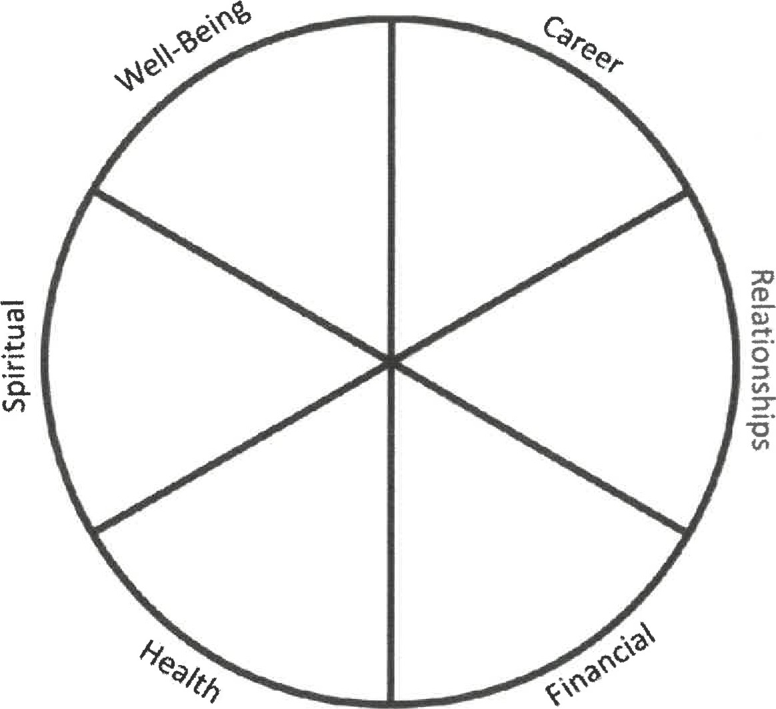

What are some of the most immediate/most pressing/most important goals you would like to achieve with this coaching experience?
- What will achieving these goals mean to you? How will you feel? What will it look like? What will you hear?
- What will happen or be different once you have achieved these goals? What will you see, hear and/or feel?Who do you want/need to help you accomplish these goals?
- What actions must be taken to achieve these goals?
- When do you expect to achieve these goals? When you achieve these goals what will be the impact on other aspects of your life?
- Do you foresee anything that has already or could get in the way of achieving this goal?
- What skills, tools and resources do you have already that will help you achieve this goal?
- What additional tools/skills/resources will you require to achieve these goals?
- What action steps will you take to ensure you achieve these goals?
2 of 8
:

Reaching Into Darkness
ACTION STEPS FROM PREVIOUS SESSION
1.
2. 3.
Sample Questions:
- Which goal would I like to start with today?
- When will I achieve this goal:
-What will I see...hear...feel?
- What benefits will I or those around you experience?
- What are the first few steps I need to take to achieve this goal?
- Can I foresee any roadblocks that I may run into?
- What could I do or avoid overcoming them?
NOTES
ACTION STEPS COMMITMENT FOR NEXT SESSION
1.
2.
CELEBRATE VICTORIES
CONFIRM DATE AND TIME FOR NEXT COACHING SESSION
1 of

QUESTIONS TO ASK FOR EACH GOAL:
Why is this goal important to me?
What benefit(s) will I gain once I have accomplished this goal?
When do I hope to accomplish this goal?
Imagine for a moment that I have already achieved this goal. What will be different?
How will I feel, look or act?
What specific action steps are necessary to complete this goal? (Organize in sequence)
When will I complete each action step?
Can I think of any potential roadblocks that might get in my way toward accomplishing this goal?
What specific actions can I take to work around each roadblock
What action steps will you take between now and our next session? (List below)
ACTION STEPS COMMITMENT

COACHING SESSION
One of the things that will be helpful to move forward as quickly and easily as possible in our coaching sessions is to identify your goals. They can be short-term goals or long-term goals.
Once you have your list of goal arrangse them in the order of priority.
GOALS





8


7


