**Beet Greens – How did I never taste them before?**

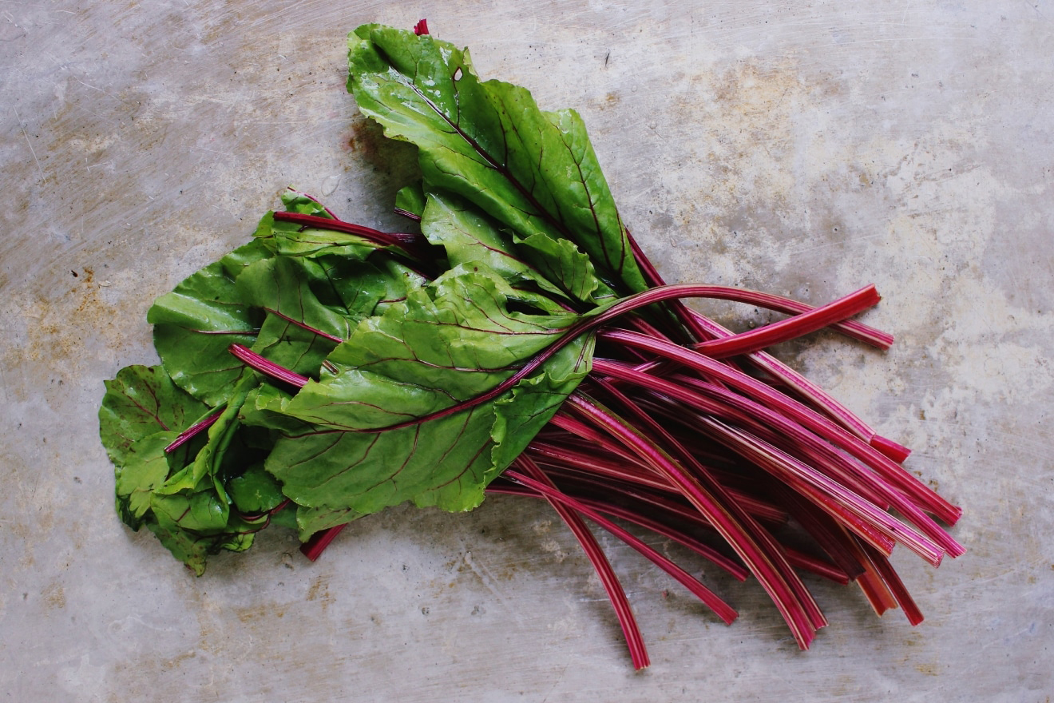

Think twice before you toss the leaves growing from your beetroot. Beet greens are sweet, mild, and cook up into the silkiest, most tender greens you'll ever eat. And the stems? They're far more delicious than those of kale and collards.

They're also more nutritious. Beet greens are some of the most nutrient-rich greens around, containing more antioxidants and other phytonutrients than the bulbous roots themselves, according to Jo Robinson, author of [Eating On The Wild Side](https://www.amazon.com/Eating-Wild-Side-Missing-Optimum/dp/0316227935?ots=1&slotNum=0&imprToken=bac4c062-6eb3-3a97-042&tag=epicurious09-20&linkCode=w50). In terms of general health benefits, beet greens are right up there with kale, but much sweeter and tastier! Who knew. Ok maybe you did, but I am mind blown!

Next was how should I cook them: search for recipes, there are many where you can use the greens and the beetroot!

**Braising is the simplest way to prepare beet greens. Here's how to do it.**

1. Swish leaves and stems vigorously in a big bowl of water to remove the sand from the leaves, which also gets lodged between the ridges of the stems.
2. Cut the stem and the thick part of the center rib from each leaf. The easiest way to do this is to fold the leaf in half along the rib. Chop the stems and leaves separately.
3. A teaspoon or two of olive oil into a frypan. Cook up some chopped onion, spring onion, or garlic over medium heat, covered with the lid, until softened for 1 to 5 minutes.
4. Add the stems along with 1/3 cup water and salt to taste and braise the chopped stems, covered, until tender for 4 to 6 minutes.
5. Finally, add the chopped leaves (and a few tablespoons of water if the pan looks dry) and simmer, covered, stirring occasionally, until the leaves are tender for 3 to 4 minutes.
6. Season with salt and pepper, and you're good to go!