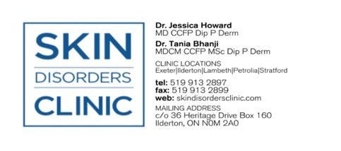

REDUCING DRYNESS ON ISOTRETINOIN (i.e EPURIS)
Isotretinoin is an oral form of vitamin A that reduces the amount of oil (sebum) your skin produces, unclogs pores, and decreases inflammation. It also helps shrink the oil glands, which prevents new acne from forming. Dryness on isotretinoin happens because the medication significantly reduces the production of oil (sebum) in your skin.

A combination of any of the below strategies can reduce the amount of dryness you experience:

FACE
- PM: 1. Wash your face with a gentle cleanser (i.e. Cetaphil, CeraVe) nightly before applying a thick moisturizing cream (i.e. CeraVe moisturizing cream).
- 2. Additionally, petroleum jelly (i.e. Vaseline, Eucerin Aquaphor Healing Ointment) can be placed on top of moisturized areas on areas of redness or flaking.
- AM: 1. Wash your face with the same gentle cleanser (or just water if you are very dry). Apply a thick moisturizing cream (i.e. CeraVe moisturizing cream).
- 2. Apply tinted sunscreen to help reduce dark spots (post-inflammatory hyperpigmentation) caused by acne.

LIPS
- Apply petroleum jelly-based product (i.e Vaseline Petroleum Jelly Original or Eucerin Aquaphor Healing Ointment) every 1-3 hours or as needed. Reapply after showering, brushing teeth, eating or drinking.

NOSE
- Apply a petroleum jelly-based product (i.e Vaseline Petroleum Jelly Original or Eucerin Aquaphor Healing Ointment) to nasal passages twice daily or as needed.
- Use a nasal saline spray: (i.e. Hydrasense Daily Nasal Casre Gentle Mist) as needed.
- Use a nasal lubricant: (i.e NeilMed Nasogel for Dry Noses) as needed.

HANDS
- Apply a thick moisturizing cream and/or ointment after washing hands, showering, and before bed or more frequently as needed (i.e. LaRoche Posay Ciclaplast Mains, Glysomed Eczema Control 2% Colloidal Oatmeal, Eucerin Aquaphor Healing Ointment, Vaseline Petroleum Jelly).

SUNSCREEN
- Isotretinoin (Epuris) increases sun sensitivity. Use SPF 30+ sunscreen daily, reapplying every 2 hours when in direct sunlight. Tinted sunscreen may be more effective as it can also block visible light (from computers and phones).

