LOAD UP FOR LENT!
  - We have your fish fry needs.
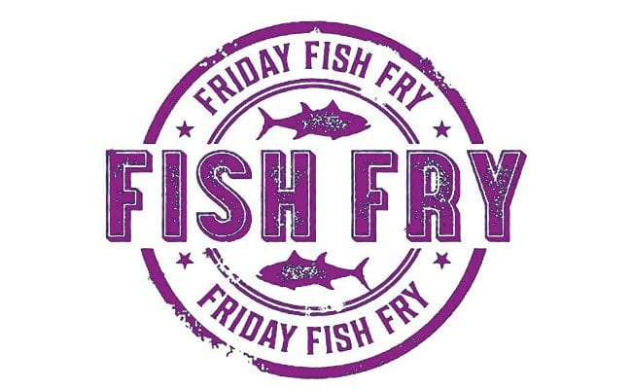

Pollock

Swai

Tilapia

We have great prices everyday with plenty of inventory.  For more information:  Call Ossie at (361) 333-5773 | 

Available for Pick Up or Delivery

