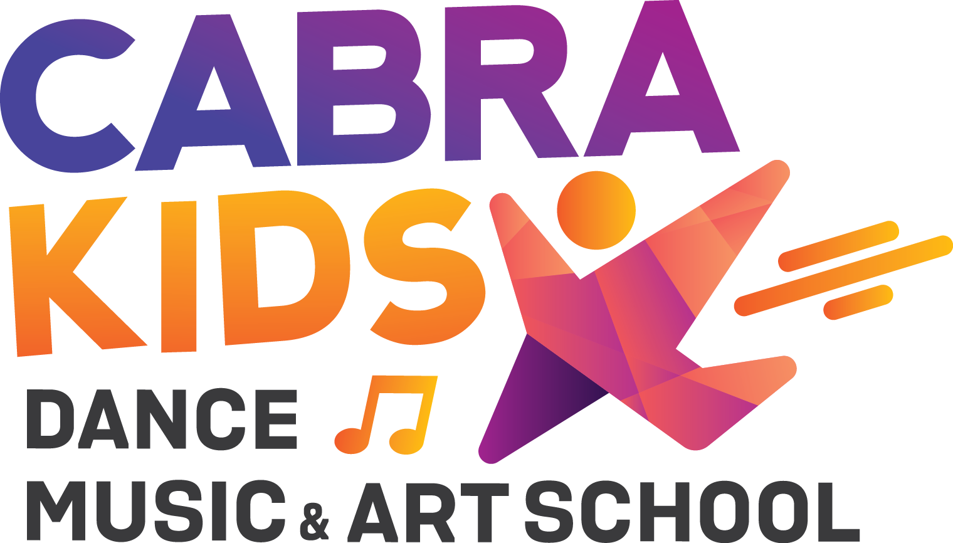

|  |  |
| --- | --- |
| Student First Name: | Surname: |
| Phone Mobile: | DOB: |
| Email: | |
|  | |

Class Day Amount

Does your child have any medical conditions? Yes/No

If yes, please list:

Does your child have any recurring injuries that

may restrict them during class? Yes/No  
If yes, please list:

Please list any regular medications required. Inc

List:_____________________________

Voucher Number:

Start Date:

Activity

Term

Please tick the box if you do not allow photographs to be taken of your child for advertising

**Notes**

Parent/Guardian signature Date

**Cabra Kids Dance & Music School**

**BSB 062-692**

**Acc- 4685 0621**

**Terms and Conditions**

1. Fees are payed within 7 days of invoice date and all fees are to be finalised by the due date.

2. Two weeks’ notice to the office, by submission in writing or email is required for termination of tuition or full term payment will be required.

3. Cabra Kids Dance, Music & Art School Pty Ltd reserves the right to change or cancel the timetable

and price structure at any point in time.

4. There will be no classes on Public Holidays. Make-up classes are available to compensate for these days, please check with the office for available make-up lessons – (classes are held on pupil free days).

5. All care according to the "Code of Conduct by Teachers” will be taken by the school, however, the school accepts no responsibility for injury or loss to person or property, howsoever caused and without limiting the generality of the foregoing damage or injury resulting from or caused by any negligence of the Principal, instructors or other employees of the " Cabra Kids Dance, Music & Art School Pty Ltd”.

6. There is a No Nut policy at " Cabra Kids Dance, Music & Art School Pty Ltd”. Parents and children are prohibited from consuming or bringing any nut related food.

7. The school is responsible for the children only for the duration of the class only. Before and after class is the responsibility of the parent/carer.

8. Students involved in multiple classes over a morning or afternoon session may only wait in the designated areas between classes, however these areas are NOT regularly supervised by " Cabra Kids Dance, Music & Art School Pty Ltd” teachers or staff, so it is at the discretion of the parent/carer if you leave your child at the studio unsupervised. Any student wishing to leave during a class must first provide the teacher with a written note signed by a parent / carer. Supervisor will call the designated phone number to confirm legitimacy of the note.

9. If a student decides not to continue a class part way through the class, then they must remain in the premises with the teacher or staff until the class is finished. Under no circumstances are students permitted to leave the premises while a class is underway unless prior arrangements have been made as per point 10.

10. All children must be collected from the studio. They are required to picked up by a parent/carer. A fee will be charged if the parent/carer are unable to pick up their child within a reasonable time

11. Any and all grievances are to be directed to the Principal via email. Moves Dance Studio is committed to ensure that your personal information entrusted to us is treated with the appropriate degree of privacy.

12. Physical contact through technical placement correction is required in the study of dance; I/we realise, acknowledge and agree this is necessary to aid in the teaching of dance.

13. To help maintain a controlled and positive teaching environment, classes during the term are closed to all visitors, unless you are notified otherwise.

14. Liability Disclaimer – " Cabra Kids Dance, Music & Art School Pty Ltd” and the instructors are not liable for personal injuries or loss of, or damage to personal property for any and all registrants. By registering you are agreeing, all participants confirm that they are aware of and

understand the nature of the event, as well as safety and other rules. Each student may decline to participate in any activity. Please inform instructor of any physical limitation you may have. If you have any doubt as to your physical abilities, please consult with your physician before participating.

15. Variation of Terms and Conditions: These terms and conditions can be varied at the discretion of Cabra Kids Dance, Music & Art School Pty Ltd at any time.

Sign by parent Date _____/______/______