David Pye AZ AV Club products for sale:

14 RPG Abffusors 24” x 48” x 4” Provides a relatively broad spectrum of diffusion using the QRD phase grating pattern of different well depths along with absorption, which increases if placed further from the wall. Recommended by the Master Handbook of Acoustics to be placed on the front and side walls of listening rooms and home theaters (vertically and horizontally each location). Can be covered with different colors of acoustically transparent cloth. Originally listed for $800 each. Asking $300 each. See http://www.rpgeurope.com/products/product/abffusor.html

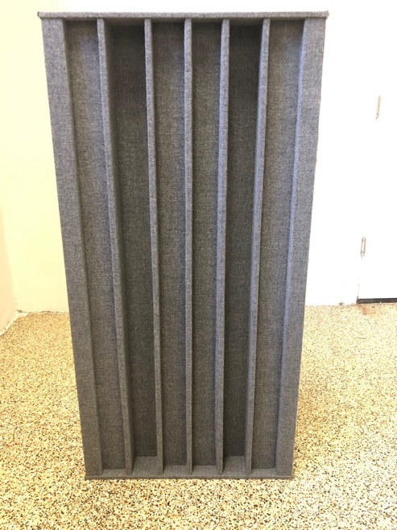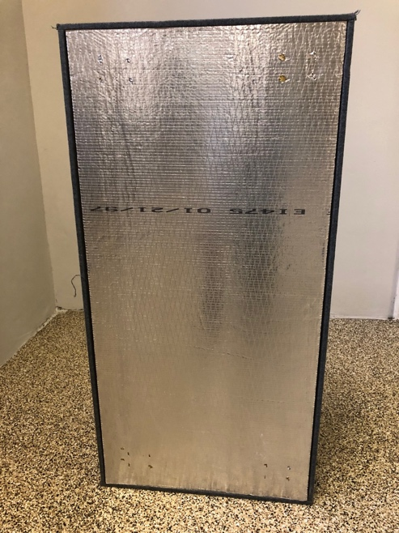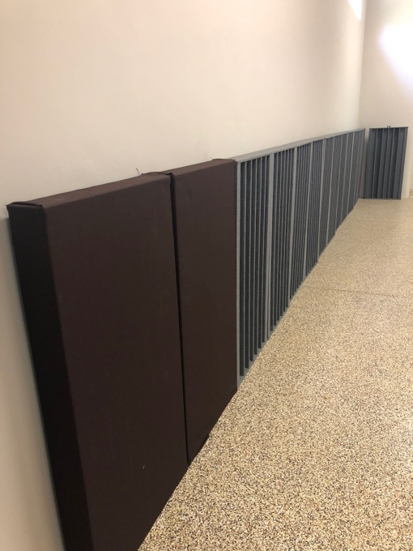

4 ASC Tube Traps 16” x 48” round in Forest Green. Placed in corners (stackable) they reduce unwanted bass booms between 55-250 Hz. Remarkably, your midrange becomes clearer. Can also reduce reflections if placed at the reflection points. You can tune high frequency diffusion be positioning the built-in diffusor. List for $688 each. Asking $325 each. Sold in pairs. Take the $50 ASC MATT test to see your problems and how they can be improved. https://www.acousticsciences.com/

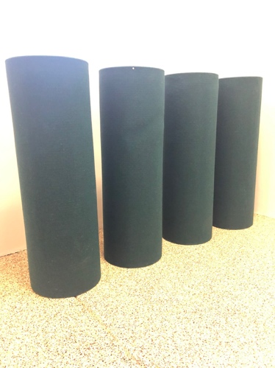

2 Real Traps Mondo Corner Traps in grey. 24” x 4’9” x 4.4” Similar to Tube Traps, they reduce bass resonances that distort your midrange. Hang in corners and take up less room than Tube Traps. Can be covered with different acoustical fabrics. List for $370 each. Asking $300 for 2. See https://realtraps.com/

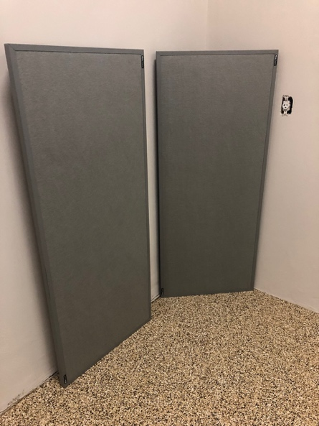

10 ASC Sound Planks 6” x 36” x 2” Absorbs mid-range echoes. Provides built-in and physical diffusion. Lightweight. Can be glued or easily attached to walls. Can change the color by replacing the straw-colored acoustical fabric. Needs some glue. New 60” now on sale for $109 each. Asking $350 for all 10.

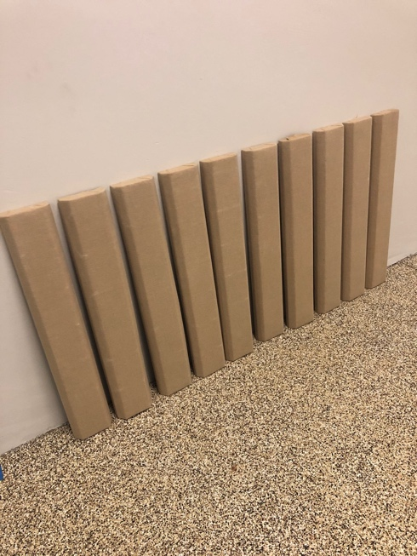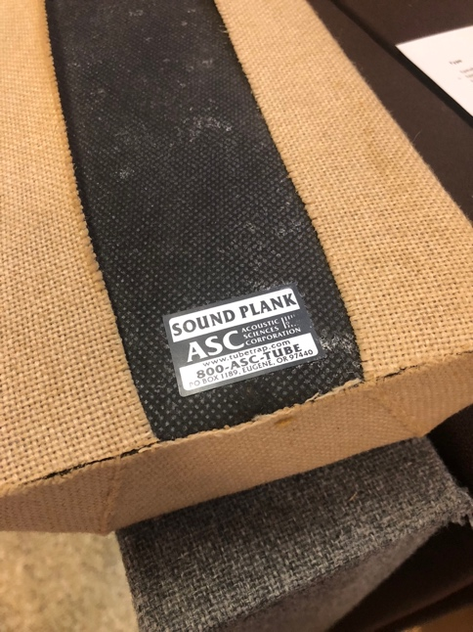

2 RPG BAD Panels 24” x 24” x 1” white. Use randomly placed holes to provide omnidirectional diffusion with a little absorption to maintain a sense of space and avoid overdamping. Can be placed at first reflection points and rear wall. Lightweight. Fabric can be easily changed to other colors. Sell new for $270/pair. Asking $120 for both. See https://www.rpgacoustic.com/bad-panel/

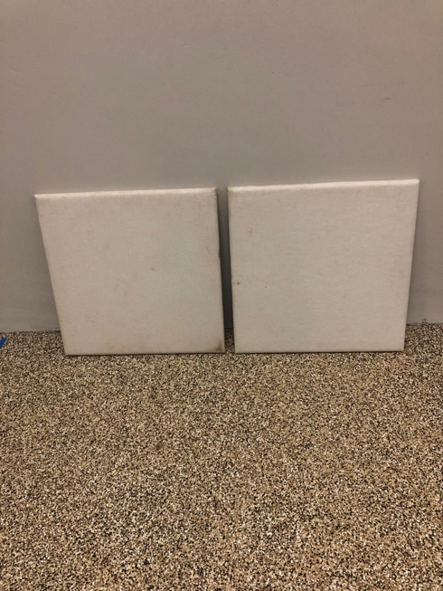

Adcom GSA-700 Surround Sound Processor/3 channel amplifier: 100 watts to a central channel and 50 watts to 2 (rear) channels. Uses Dolby ProLogic to create 5.1 surround channels from your 2-channel stereo or discretely via an interface cable. Originally $800. Asking $30

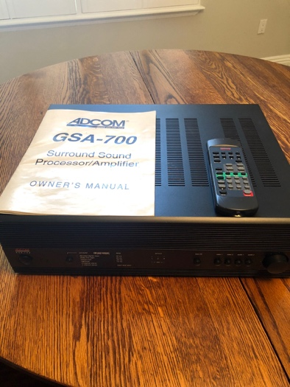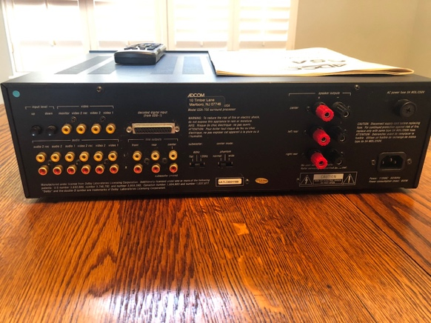

NHT SuperOne stereo speakers. Includes wall bracket. Asking $30
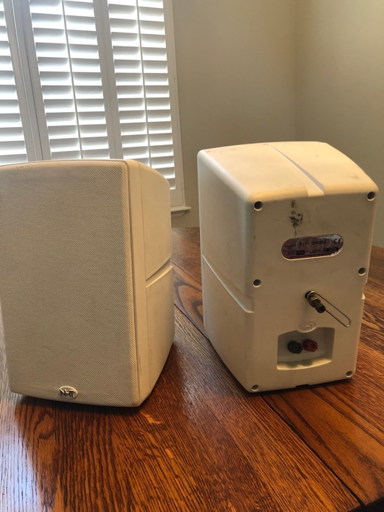

JVC DLA HD-100 front projector. 1080p via pixel shifting. $8k new. Needs work. Shuts down after ~30 minutes. Original packaging.

Integra DHC-9.9 Surround Sound Processor. Originally $2k. Asking $325. Supports HD processing of Dolby TrueHD, DTS-HD and Master Audio, Neo:6. THX plus all other legacy formats. Converts stereo to 7.1 channels. Automatic Audyssey MultiEQ XT room correction (testing microphone included). 7.1 input & output channels including RCA and XLR outputs. 3 zones. 4 HDMI inputs, 2 outputs. 9 analog stereo inputs. 192K/24bit DAC, 6 digital inputs. HQV video processing for ISF reference calibration. Remote, documentation, original packaging.

Specifications
Audio Decoding:
Dolby: TrueHD, Digital Plus, Digital 5.1, EX, Pro Logic IIx
DTS: HD Master Audio, HD High Resolution Audio, DTS, ES Matrix, ES Discrete, Neo:6
Other: THX Ultra2 Cinema, THX Surround, THX Music, THX Loudness Plus
THX Certification: Ultra2 Plus
Video Processing: HQV Reon-VX
Auto Setup/Room EQ: Audyssey MultEQ XT, Pro, Dynamic EQ/Volume
Inputs:
Video: HDMI 1.3a (4), component video (3), S-video (6), composite video (6)
Audio: Coaxial digital (3), optical digital (3), 7.1-channel analog (1), stereo analog (9)
Additional: Ethernet (1)
Accessory: iPod dock, Sirius (1), XM Radio (1)
Outputs:
Video: HDMI 1.3a (2), component video (2) S-video (2), composite video (3)
Audio: Optical digital (1), stereo analog (2), 7.1-channel XLR (1) 7.1-channel preamp (1)
Additional: RS-232 (1), 12-volt trigger (3)
Dimensions (W x H x D, inches): 17.13 x 7.63 x 17.5, 23x22.5x13” boxed
Weight: 29.3, 38 lbs packed
List Price: $2,000

See http://www.integrahometheater.com/Products/model.php?m=DHC-9.9&class=Preamplifier&source=prodClass

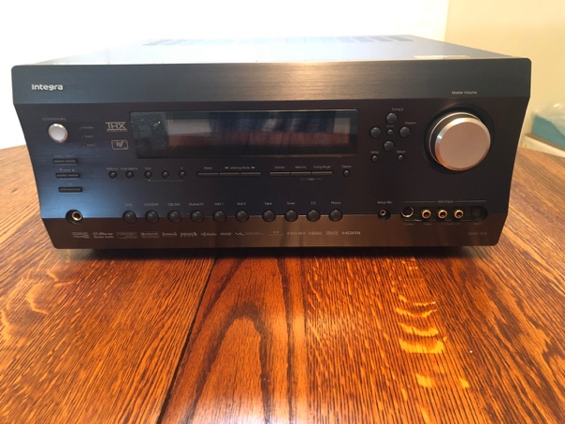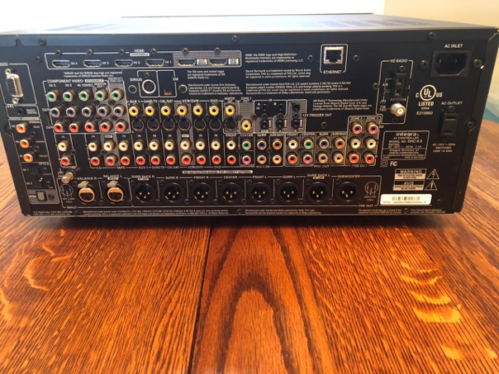

Classe CDP.5 CD player Original List $2,000. Asking $200.

Very good CD player from a high-quality supplier. Original owner. In excellent shape
HDCD decoder
20 bit Burr Brown PCM
8x oversampling filter
-106 db signal to noise
Digital AES/EBU on XLR-3 connector enables the player to output CDs to other DACs
Remote, original manual and packaging included
19” W x 11.5” D x 4” H
16 pounds, 22 lbs packed
Boxed 24.5x19.5x11”

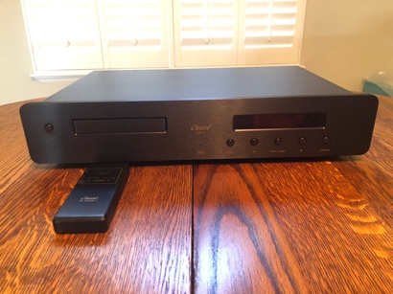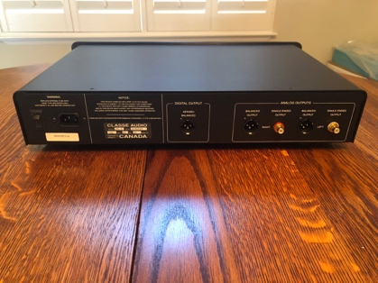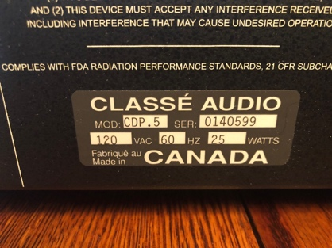

Kenwood Dolby Digital 5.1 AV Surround Sound Receiver. Asking $30
6 channels preamp in; 5 channel amp out. Remote control included

