Written by Joe Goswami
The Arizona DIY Speakerbuilder Event 2020 was a huge success as organized by Jason & Camille Terpstra. Thanks to all whom both brought their amazing DIY builds and to the curious who simply came to hear from California, Phoenix, Tucson, and surrounding areas.
There will be no “best sounding speaker BS” because to my ears, they ALL sounded awesome. Every Speaker pair was built with Love and Passion and served a purpose that the individual builder had in mind. Crossovers, cabinetry, tweaking by ear, and driver placement can drive a person to drink. The end results were literally Music to the ears.
While I was preparing for Saturday on Friday night installing Parts Express 5 Way Posts on three of my five 901’s, others in attendance I’m sure were also doing similar prep work. The drive early Saturday morning from Phoenix into Tucson was amazing as usual.
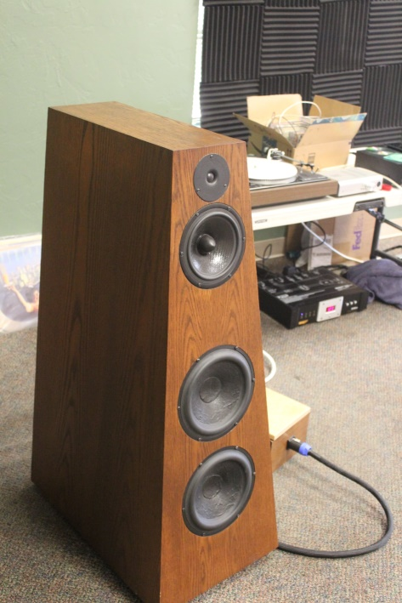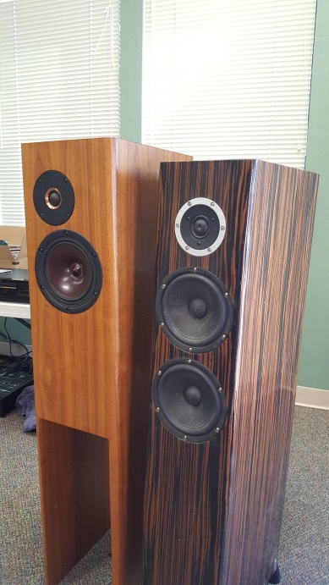
Jason Terpstra’s Tower’s (right side). Rob Elder’s (left side)
Maynard Goff’s Tower’s/Crossover’s Everyone’s fit and finish & finishes were amazing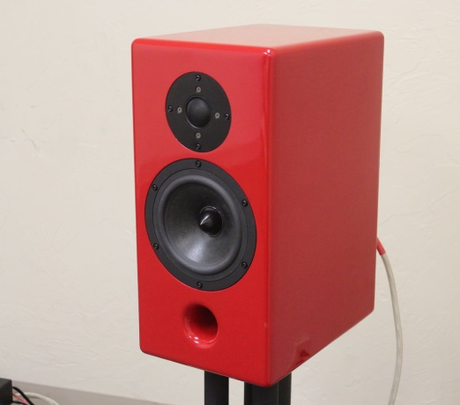 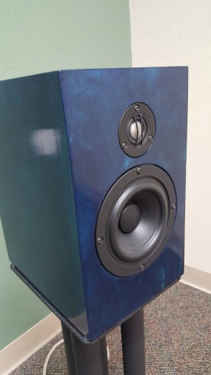 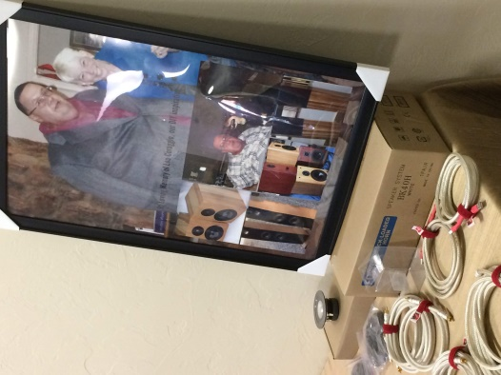
Bookshelf’s designed by Lou Coraggio (R.I.P) and built by Rob Elder
Michael Long’s Bookshelf’s
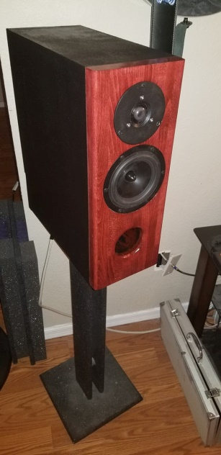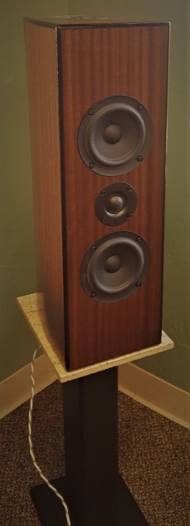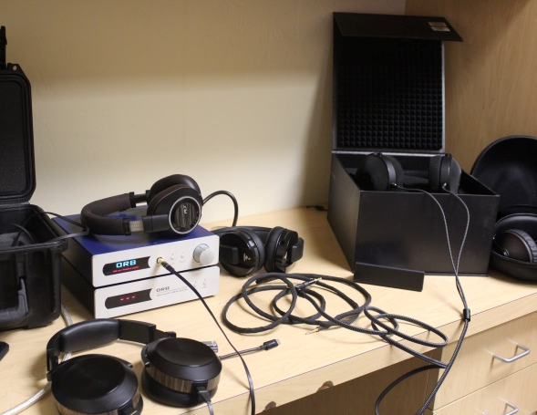
Phil Groben’s D’Appolitio’s with help from Ben Taylor’s placement suggestions sounded great in the Vintage Room
Headphone Room
Mark Miller’s Bookshelf’s
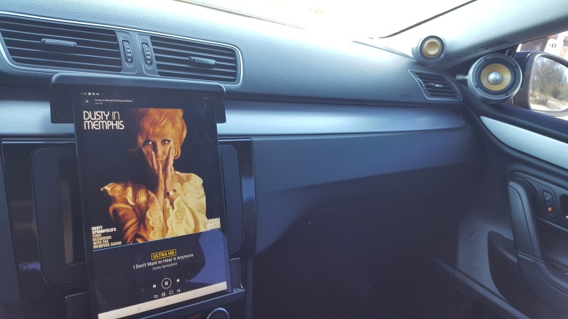
John Daniel Wanamaker’s VW CC Focal Super Custom Car Audio System

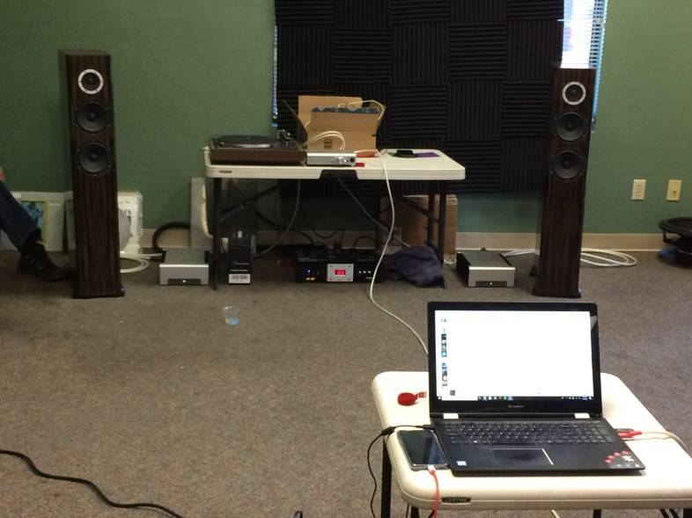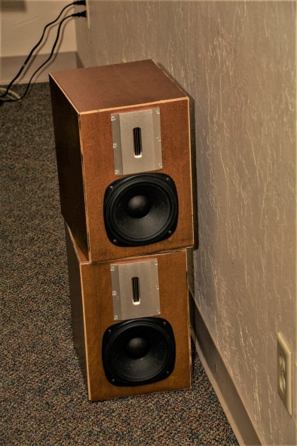
Travis Terpstra’s Mini Monitor/Bookshelf Speakers. Close your eyes and these little Guys disappeared

Jason Terpstra’s Speakers with Schitt Amplifiers in The Main Room

The Vintage Room with Jason’s Dad’s almost 50 year Pioneer Box Speaker’s. Jason refoamed the Midranges and they sounded great. Tom Higgins along with his friend Doug from California were just this huge wealth of Audio knowledge. Tom brought his Allied Electronics very Vintage Tube Integrated Amplifier and spun a wide variety of LP’s from his collection.
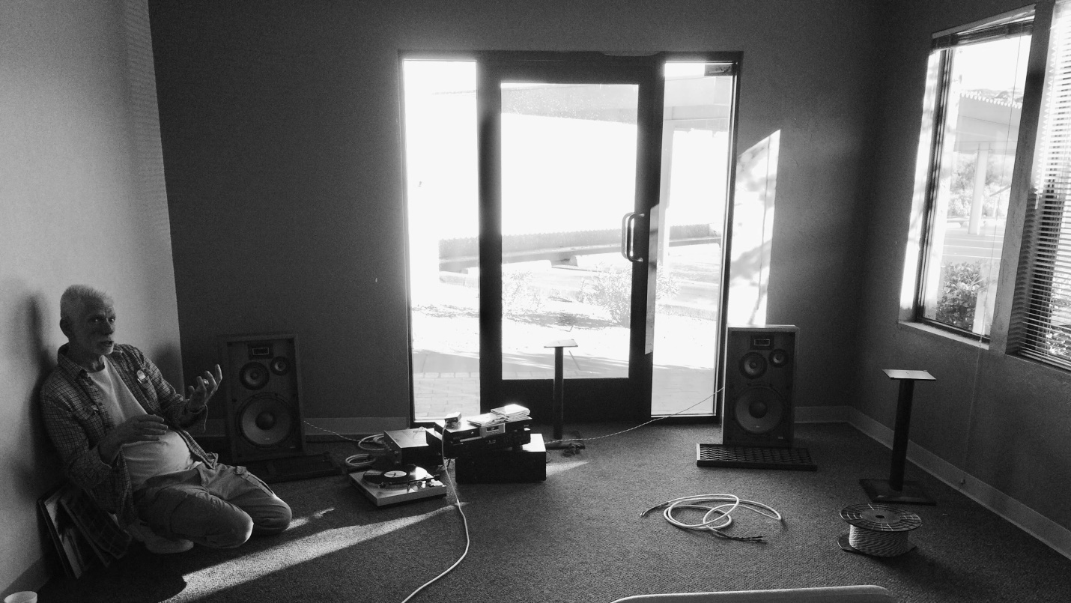
The Raffle that was put together for the Event by Jason’s own Cable Company, Madisound, and Jason’s Patented Speaker Binding Posts. Jason even generously GAVE AWAY RCA 75 Ω Digital Cables, USB Cables, and various Gauges of Speaker Wire. A roll of 16 AWG red/blk wire he lent me saved my Ass !
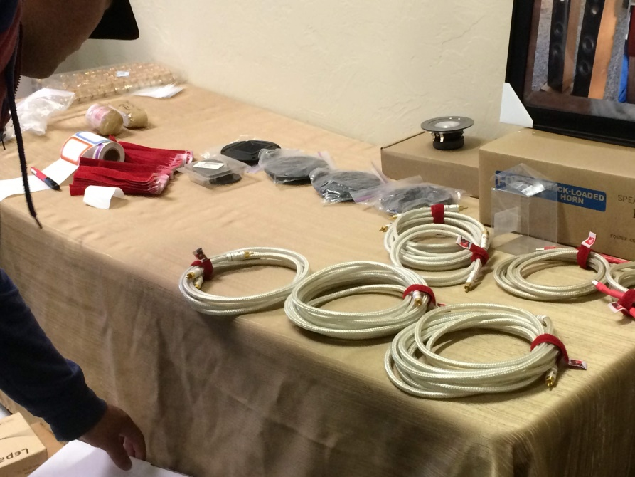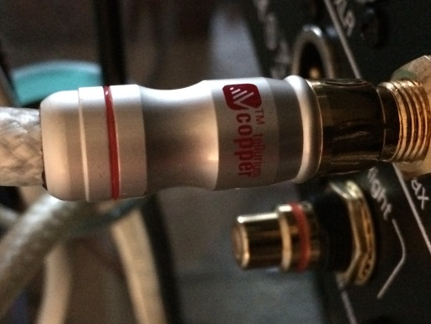
And then there was my Bose 5.0 Channel Vintage Series 1 & 2 Room away from the real DIY’rs. My DIY was refinishing the front 3 Left, Center, & Right for a more modern look along with the two Surround Continental Series 2 901’s. All are of the power hogging Sealed Box Vintage. They are the best sounding 901’s of the 49 year run and 6 Series’ produced. Watts per Channel is not a problem with PS Audio Class D M700’s on L, C, & R duty along with two NCORE DIY also Class D Amplifiers on loan from fellow Arizona Audio Video Club member Curt Dragomanovich. Thanks Curt ! PS DirectStream Sr. DAC was used for the front L & R channels. The XLR hacked by me Sony AVR and Universal Disc Player/Streamer’s DAC’s was used for the remaining channels. Three MiniDSP’s are stuffed inside a Bose Series 2 EQ Box. All True Balanced Outputs ! The EQ Curve I dialed in was Audiophile approved by all who came into the room. Jason once again saved my Ass by lending me a pair of his Company’s XLR’s for the Surround Amps.
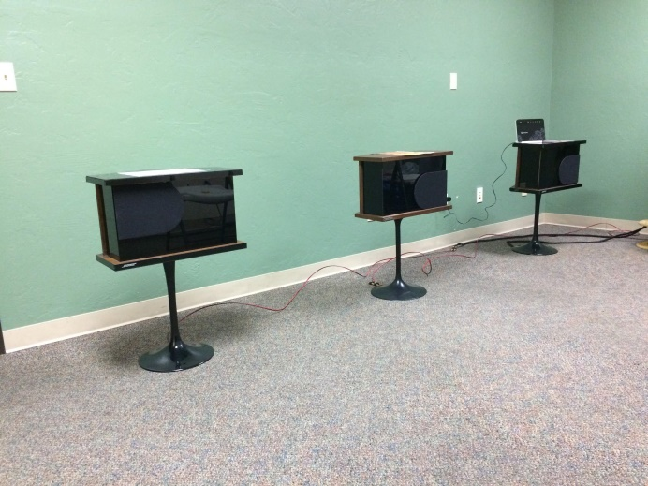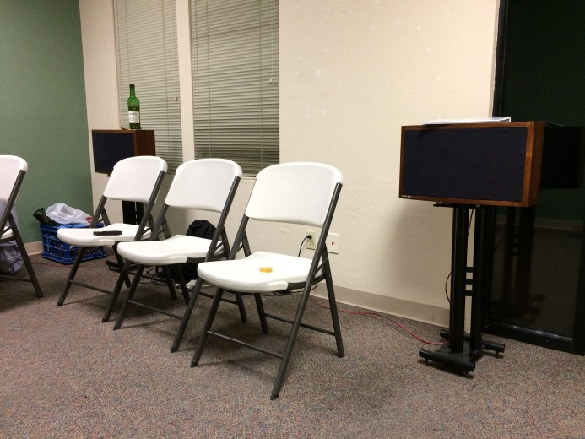
The Rare Series 2 Continentals used as Surround Channels
The L,C,R Series 1 and 2 Bose 901’s
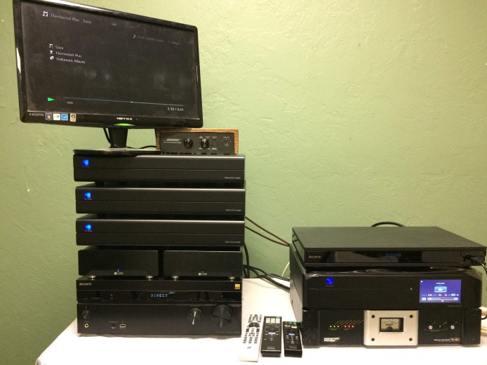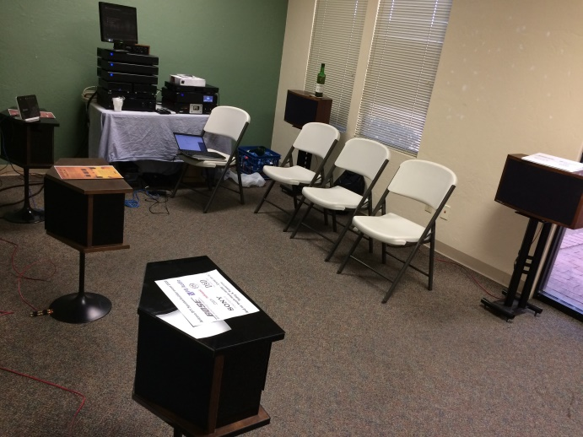
This is what it takes to do a full Digital 5.0/3.0/2.0. The PS Audio DAC is worth every Penny. It lost in the AZAVClub’s DAC-It-Out last Summer. The DS Sr. better suites my application than the Line Magnetics & Jolida DAC that were the 1st & 2nd place Winners (I missed the event regardless). Jason lent me the Monster Cable Line Conditioner. Thx Man !
The Bose Room. As scary as this looks, it worked and I felt Vindicated ! Listeners were than impressed. The Glenfiddich 12yr. old helped…LOL. Linda Ronstadt ‘s What's New & Joni Mitchell’s Both Sides Now DVD Audio discs were the clear winners in this room. Also Sgt. Pepper in 5.0 was a new experience for those who heard it in Surround. Lots of RUSH (R.I.P. Neil Peart) !

A huge Thank You to this lovely couple for putting this whole event together. Jason & Camille Terpstra put a lot of work into making this weekend a success.
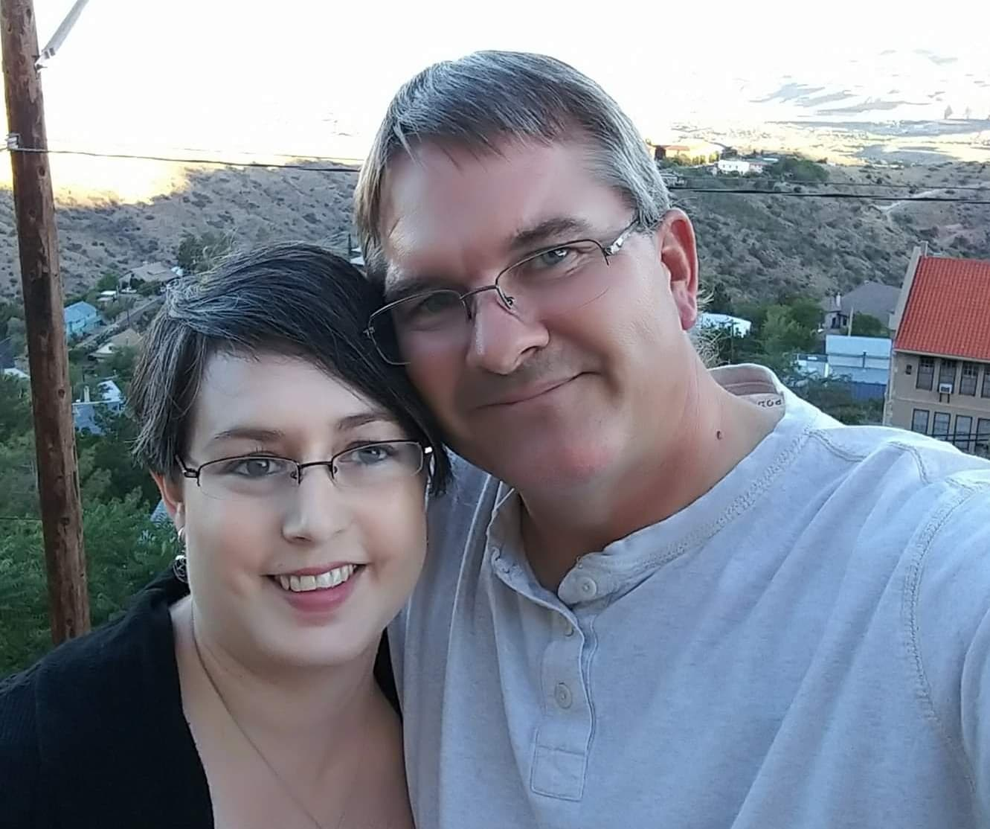
And thank you Camille Terpstra for the awesome food !
