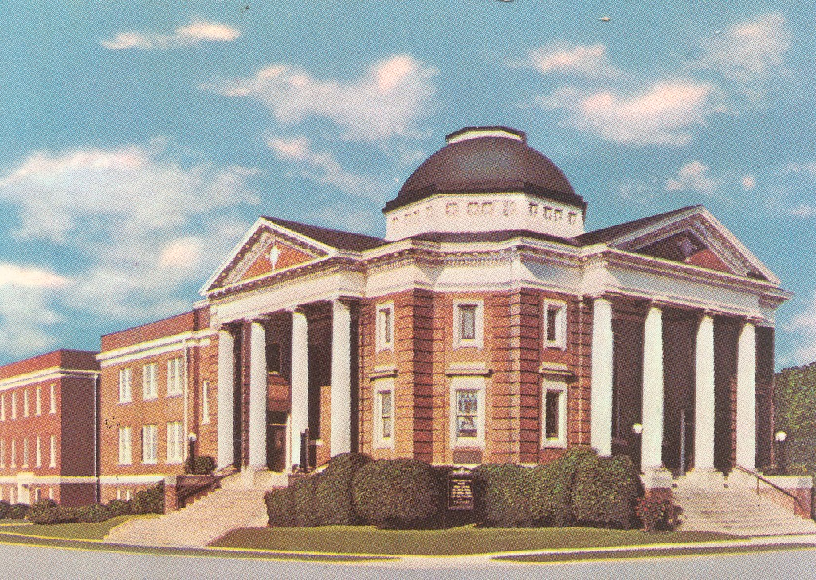

First Christian UCC 3RD Quarter 2021

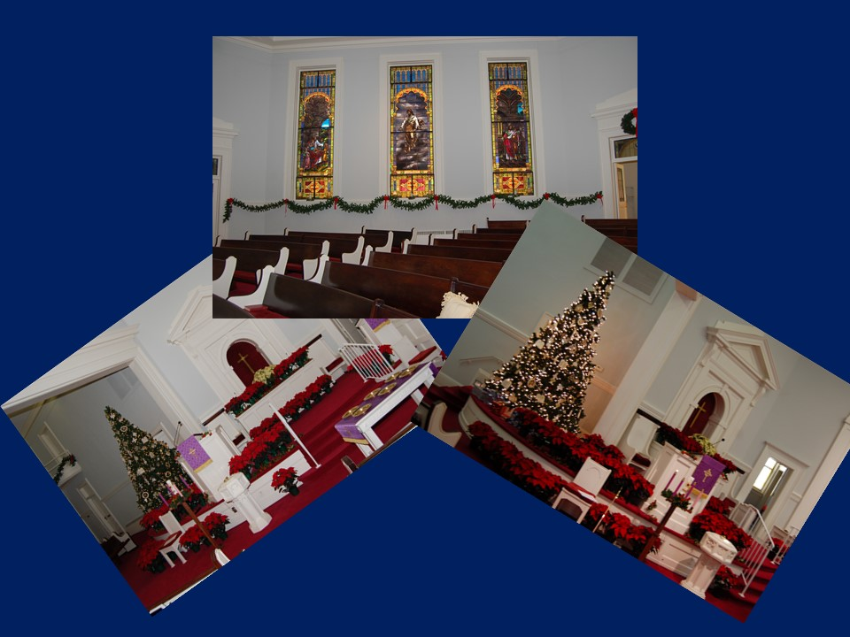

The Christmas Season at First Cristian UCC is always filled with great gatherings filled with praise, worship, fun, fellowship and wonderful music!

Pastor’s Column

News from Rev. Michelle Funk

We (the church) received a card and letter from Rev. Mark & Margot Pickett during the Christmas Season… we thought share these with you…

The Greatest Gift At Christmas …

Alamance Strings Concert

Supper Club – December 3rd

The Supper Club will gather at 5:45 pm at Kimber’s in Gibsonville.

it’s a busy season

christmas fund offering

The light of God surrounds us,
The love of God enfolds us,

office closed

Margaret Lightbourne Circle

The Margaret Lightbourne Circle will meet Monday, January 6th at 10:320 am in the conference room.

Financial Information

Year to Date through 10-31-19

Actual Budget
Income: $170,763.80 $172,415.00
Expense $135,079.48 $172,434.19
Net Balance: $35,684.32 <$19.19>

Balance in Checking 09-30-18 $16,992.89
As you can see, everyone’s continued support is still greatly needed to carry on the ministry of the church. Please send in your giving today.

Respectfully Submitted,
Ken Little and Connie Collins,
Treasurer and Accounting Manager

