GREEN VALLEY VILLAS WEST
2022 LANDSCAPE ZONE MAP
ZONE 2
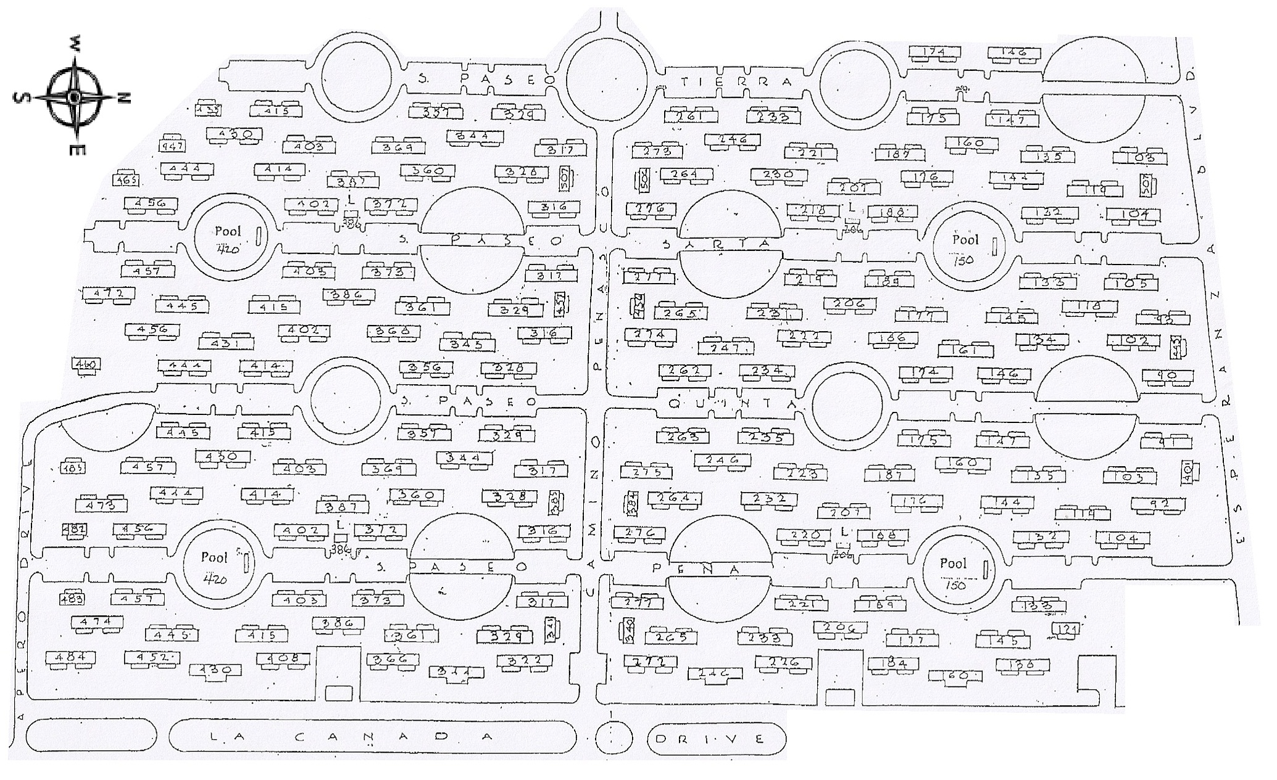
ZONE 2
ZONE 1
ZONE 3
ZONE 4
ZONE 5
ZONE 6
ZONE 7
ZONE 8

OVERSEEDING WILL BE DONE 10/24/22-11/11/22
NO ZONE WORK WILL BE DONE DURING THIS TIME

