Run Thrus @ the WASCUNY SPARKLER !
Friday, July 17th. Start as soon as we can set up the rings.
Aiming for 4-6pm
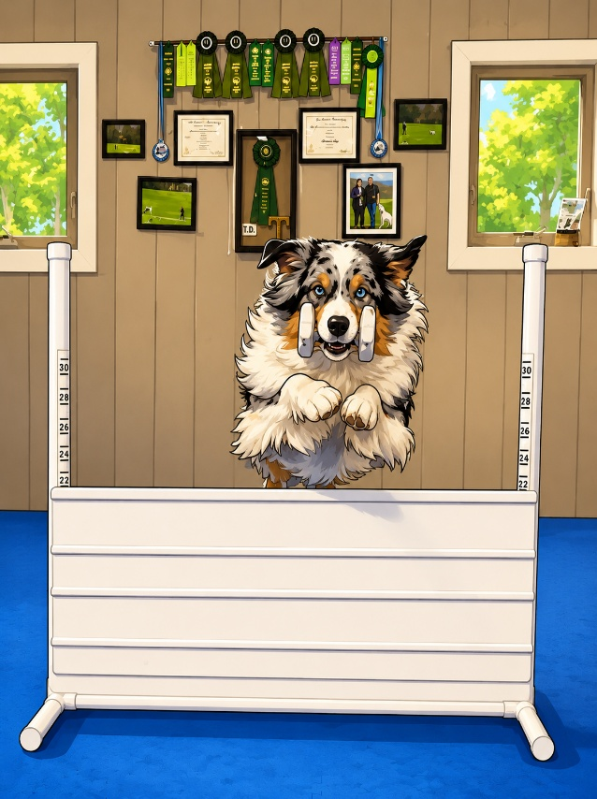
No prior sign up required, just walk up and put yourself on the list.
$10 gets you 10 minutes in the ring. Cash or paypal.
We will set up Utility first, then Open and novice. If you want to bring your rally dog in the ring, you are welcome to but we will not be setting up a rally course specifically. You can bring toys and dry non crumbling treats into the ring, please be considerate about this as to not distract the trialing dogs unnecessarily.
Thank you!
If you would like a volunteer “judge”, we are happy to help with that.
This is a great and rare opportunity to train in a trial setting so come and take advantage.

