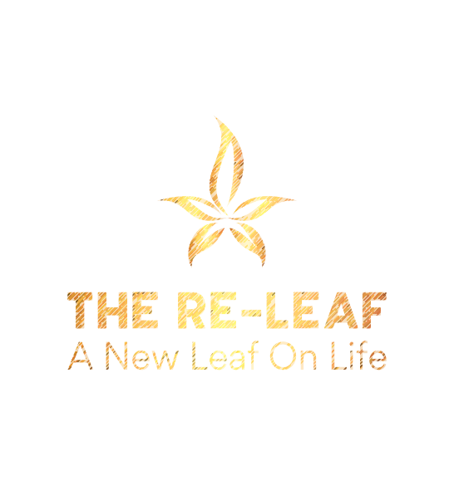

ARTICLES OF INCORPORATION

THE RE-LEAF: SOUTHWEST GEORGIA RELIEF CENTER, INC.

Article I – Name

The name of the corporation is The Re-Leaf: Southwest Georgia Relief Center, Inc. (the “Corporation”).

Article II – Duration

The period of duration of the Corporation is perpetual.

Article III – Purpose

This Corporation is organized and shall be operated exclusively for charitable and educational
purposes within the meaning of Section 501(c)(3) of the Internal Revenue Code of 1986, as
amended (the “Code”).

The specific purposes of the Corporation include, but are not limited to, providing
essential services and supportive programs to underserved individuals and families, Including
but not limited to: meal assistance, education and training, mental health support, housing
assistance, identification recovery, employment readiness, and other programs that promote
stability, dignity, economic security, and self-sufficiency.

Article IV – Nonprofit Nature and Restrictions

No Private Inurement

No part of the net earnings of the Corporation shall inure to the benefit of, or be
distributable to, its directors, officers, members, or other private persons, except that the
Corporation shall be authorized and empowered to pay reasonable compensation for services
rendered and to make payments and distributions in furtherance of the purposes set forth
herein.

Political and Legislative Activities

No substantial part of the activities of the Corporation shall consist of carrying on
propaganda or otherwise attempting to influence legislation, and the Corporation shall not
participate in, or intervene in (including the publishing or distribution of statements), any
political campaign on behalf of or in opposition to any candidate for public office.

Other Activities

The Corporation shall not engage in any activities not permitted to be carried on by a
corporation exempt from federal income tax under Section 501(c)(3) of the Code.

Article V – Board of Directors

The affairs of the Corporation shall be managed by a Board of Directors, consisting of not
fewer than three (3) directors, as provided in the bylaws. The Board of Directors shall have all
powers necessary to oversee, govern, and direct the activities and policies of the Corporation,
including the authority to adopt bylaws, establish committees, and ensure compliance with all
applicable laws. Directors shall serve without compensation, except for reimbursement of
reasonable expenses.

Article VI – Registered Agent and Registered Office

The name of the Corporation’s registered agent is:
KEITH DALE SHORT
The street address of the Corporation’s registered office is:
634 Moore Rd
Cairo Ga, 39828

Article VII – Incorporator

The name and address of the incorporator are:
KEITH DALE SHORT
630 Moore Rd
Cairo Ga, 39828

Article VIII – Dissolution
Upon the dissolution of the Corporation, assets shall be distributed for one or more
exempt purposes within the meaning of Section 501(c)(3) of the Internal Revenue Code, or shall
be distributed to the federal government, or to a state or local government, for a public
purpose. Any such assets not so disposed of shall be disposed of by a court of competent
jurisdiction in the county in which the principal office of the Corporation is then located,
exclusively for such purposes.

Article IX – Members

The Corporation shall have no members.

IN WITNESS WHEREOF, the undersigned incorporator has executed these Articles of Incorporation on this ___ day of _______, 2026
__________________________________

Signature of Incorporator
Printed Name: _____________________

