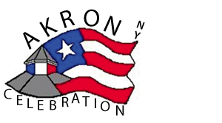

Donation Request
AKRON CELEBRATION COMMITTEE
www.celebrateakron.org

Organizing and hosting celebrations for the Fourth of July and New Year’s Eve
The Celebration Committee is beginning to organize and schedule events for this year’s Fourth of July festivities. The fireworks are planned for July 3rd in Veterans Park and the gala parade on July 4th in the Village of Akron. We will also be recognizing the Town of Newstead’s Bicentennial this year. Your generosity and continued support will help make this a memorable celebration for the entire community. Sustaining these traditions is only possible with your donations.

Donor Information:
Name ______________________________________________________________________
Address ______________________________________________________________________
Pledge Information:
I pledge a total of $____________ Please use the following name in all acknowledgements:

___ I will be emailing our logo to be used in acknowledgements (akroncelebration@gmail.com)

___We will be participating in the Parade – July 4th @ 4:30 – formation at Akron Central Schools
Provide name and email address: ___________________________________________

__ We would like to volunteer our time
Provide name and email address: ____________________________________________

Signature Date

Please make checks payable to: Akron Celebration Committee
PO Box 16
Akron NY 14001

Thank you for your support and generosity!

