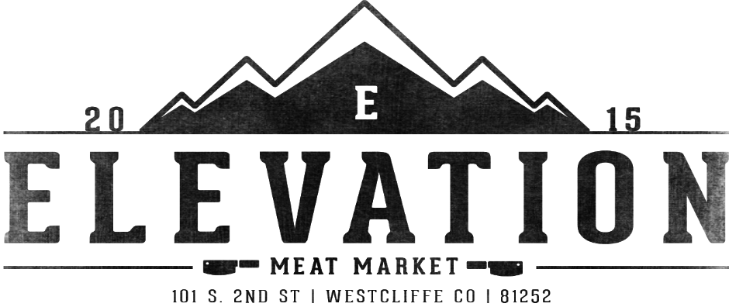

Wild Game Donation Form

