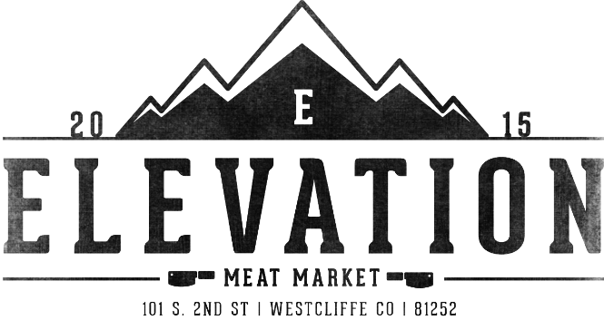

**NOT FOR SALE**

Name_____________________________________

Phone Number_____________________________________

Address_____________________________________

**Wild Game** **Whole Elk** ____ $1.40lb **Elk Quartered ___**$275 ea.

**Whole Deer/Bear**_____ $1.40lb **Deer/Bear** **Quartered**____$200 ea.

**Antelope/Mountain Goat**____$140 ea.

**Skinning any Species** _____$50ea **After Hours Drop Off** ____ $25ea

Are you in a Hurry and Need to Get your animal done so it avoids costly shipping charges? Rush orders add on _____ $130

**Grind Only Any Species must be ready No Bones**______$1.40lb poly tube

**Would you like your order boxed for $4.00 per box? Y/N**

**Back Strap:**  Leave Whole?_______ Or Cut to **Thickness**_____inch **Steaks per Package: ____________**

**Tenderloin:** Leave Whole?_______ Or Cut to **Thickness_**____inch **Steaks per Package: ____________**

**Hindquarters:**_Steaks, Roasts, Stew Meat, Minute Steaks? __________________________________________________________________________________________________________________________________________________________________________________________

Due the rising cost of materials and labor involved we are charging extra for Vacuum Pack Grind per package.

**Grind:** **1lb 2lb 5lb** Packages. **Add Pork Fat Trim** 10% or ____% **Add Beef Fat Trim** 10% or ____% ***Market Price***

Poly Tube Chubs no extra Charge____ or Vacuum Pack Grind add $.50per package. ______

**Smoking or Sausage:**

Snack Sticks 12.5 lb Batch $5.99lb ($56.13 per batch) Flavors: BBQ, Teriyaki, Summer, German. _______________

Snack Sticks Jalapeno Cheddar 12.5 lb Batch $6.49 lb ($62.38 per batch)__________________________________

Summer Sausage (Smoked in 2lb roll,cut in ½ for Packaging) $5.99lb ($74.88 per batch)______________________

Summer Sausage Jalapeno Cheddar (2lb roll,cut in ½ for Packaging) $6.49lb ($81.13 per batch)________________

Smoked Jerky Whole Muscle Sliced $7.99lb (minimum 10 lb)____________________________________________

Bulk Sausage 12.5 lb Batch $1.50 lb Flavors: Breakfast, Italian, Hot Italian, Chorizo __________________________

Breakfast Links Sheep Casing 12.5 lb Batch $3.00 lb ___________________________________________________

Bratwurst Links Hog Casing 12.5 lb Batch $2.50 lb Flavors: Bratwurst, Polish, Beer and Cheddar, Linguica_________

Notes:________________________________________________________________________________________

_____________________________________________________________________________________________