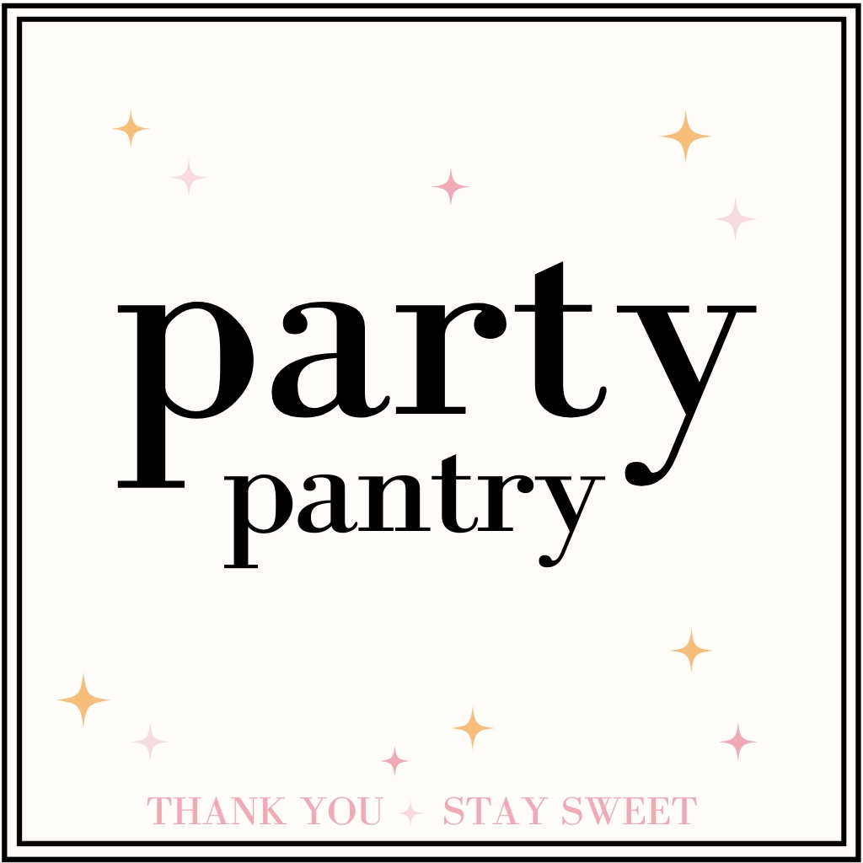
Party Pantry Intake Questionnaire
We're so excited to help make your event deliciously unforgettable.
1. Who are we celebrating and what’s the occasion?

2. Event Location (venue name + address):

3. Event Date and Time:

5. Estimated guest count:

7. Preferred pickup time after the event:

8. Is your party indoors or outdoors?

9. What’s your party theme or vibe?

10. What colors are you using for your event?

12. What are their (or your) favorite candy flavors or types?

13. Are there any Candy flavors you absolutely dislike and do NOT want at all ?

15. Are there any severe allergies we should know of?
(While we can’t guarantee allergen-free, we’ll do our best to avoid them!)

Visuals are always appreciated and can be emailed to party.pantry@outlook.com or submitted on our website under the CONTACT US button!
*Any gate codes or directions that might be helpful*

