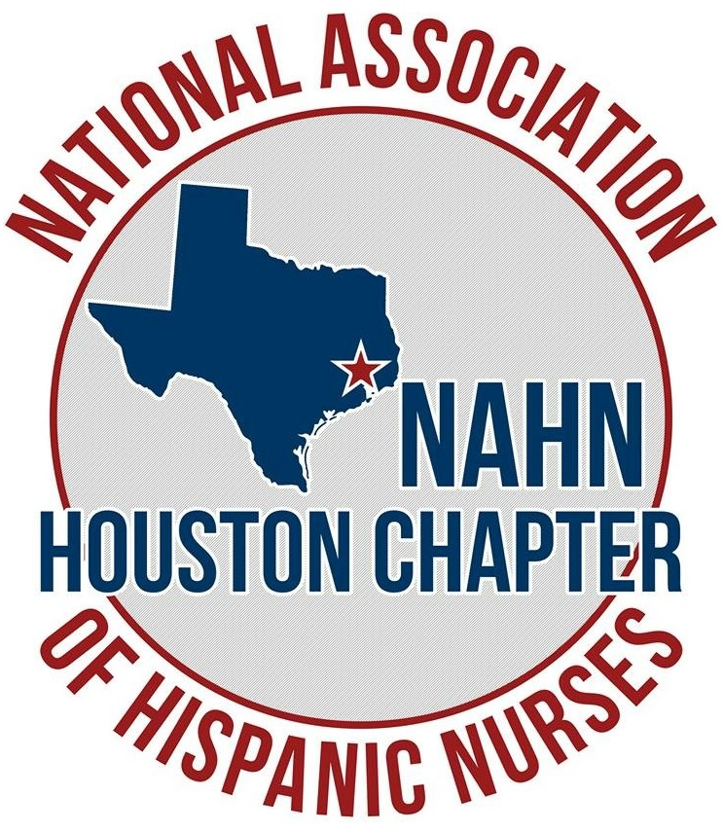 |  |  | Nurses On The Move INC  NAHN Houston Initiative
 |  |  | 5/10/2023

Dear members & friends,
Nurses on the Move INC (a NAHN Houston Chapter initiative) is thankful for its medical mission donors and sponsors throughout the years. Your support allows us to accomplish our overall mission to provide aid to the people of Puerto Rico and other countries.
A recap of 2022 mission’s donations – various municipalities were visited, impacting 150 residents and 1 school. Despite postal service delays, 19 large duffle bags and suitcases filled with supplies were donated. We also made a small financial donation to the Women’s Shelter and a Nursing Home in Ciales. Our efforts led to the development of the Fundación Cabecitas de Algodón which continues to foment program sustainability and community empowerment.
This year we hope you continue to support our mission and vision in aiding Puerto Ricans. We aim to visit the municipalities of Vieques, Culebra, Penuelas, Villalba and Salinas during the month of December 2023.
The supply list is specific to the needs of each community identified for this mission. In addition, we are kindly soliciting monetary support for specific mission expenses (i.e., van rental) required during our mission trip. No donation* is too small.
Financial contributions can be made through CashApp ($NursesOnTheMoveOrg), Venmo (@Nursesonthemove), PayPal (NAHN Houston).
Sincerely,
Jacqueline Crespo Perry RN, BSN, MSN
Officers:
Maria T. Villot RN, BSN
President

Jacqueline Crespo Perry MSN RN
Vice President

Dr. Jennifer Figueroa-Delgado
Secretary

Marina Ruiz RN
Treasurer

Lilliam Diaz
Member-at-Large

Email:

teremv@nursesonthemove.org

Website:

Nurses on the Move INC (nursesonthemoves.org)

