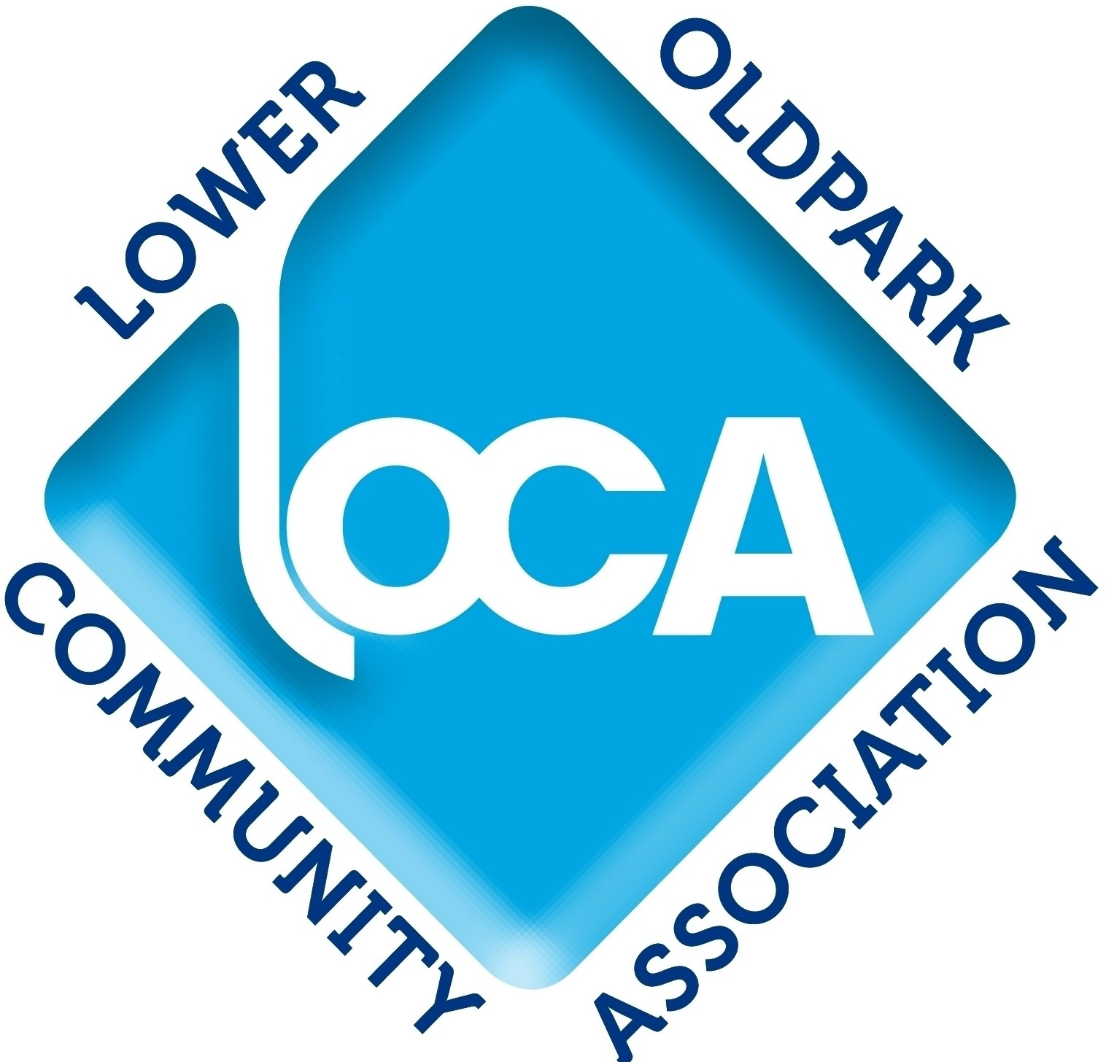
Need A Grass Cutting Service?

A Lower Oldpark Community Association Information leaflet.

9-23 Avoca Street Belfast BT14 6EN. Tel: 028 90351334 or 028 96928293. Email: loweroldparkhousing@gmail.com

Community Needs
During a resident survey carried out by Lower Oldpark Community Association (LOCA) in early 2025, a number of people said they would like to receive information on grass cutting services available.
Garden Services
In response to this, LOCA included the following Action in its Regeneration and Community Needs Strategy 2026 – 2029, ‘LOCA will make available to Lower Oldpark residents, information on garden maintenance services they could use’.

Yell.com
The information in this leaflet was identified by way of a search carried out on the online directory yell.com .
Endorsement/ Recommendation
LOCA does not endorse or recommend any of the contractors listed.
Accuracy
Also, LOCA cannot guarantee the accuracy of the information provided or guarantee that all service providers were identified during its yell.com search.
Other Information Sources
Other garden grass cutters may be available and details of where information on these might be found are also provided in this leaflet.




TREECO is a social economy business that provides garden maintenance services, including grass cutting, for households. It offers reduced charges for elderly and disabled residents.
Contact: TREECO 301-303 Donegall Road, Belfast, BT12 5NB.
Tel: 028 9023 3375. Email: info@tre-eco.org. Web: tre-eco.org

Online Leaflet
This leaflet is available online at https://loweroldparkhousing.co.uk/useful-info . The online version provides links to all the Yell.com service providers listed in this leaflet.

LOCA Gardening Equipment Lending Service
Lower Oldpark residents can borrow gardening equipment, free of charge, within their own neighbourhood.
To make use of this Lower Oldpark Community Association service, contact Gary Hughes on 028 96928293 or 028 90351334 or email loweroldparkhousing@gmail.com .

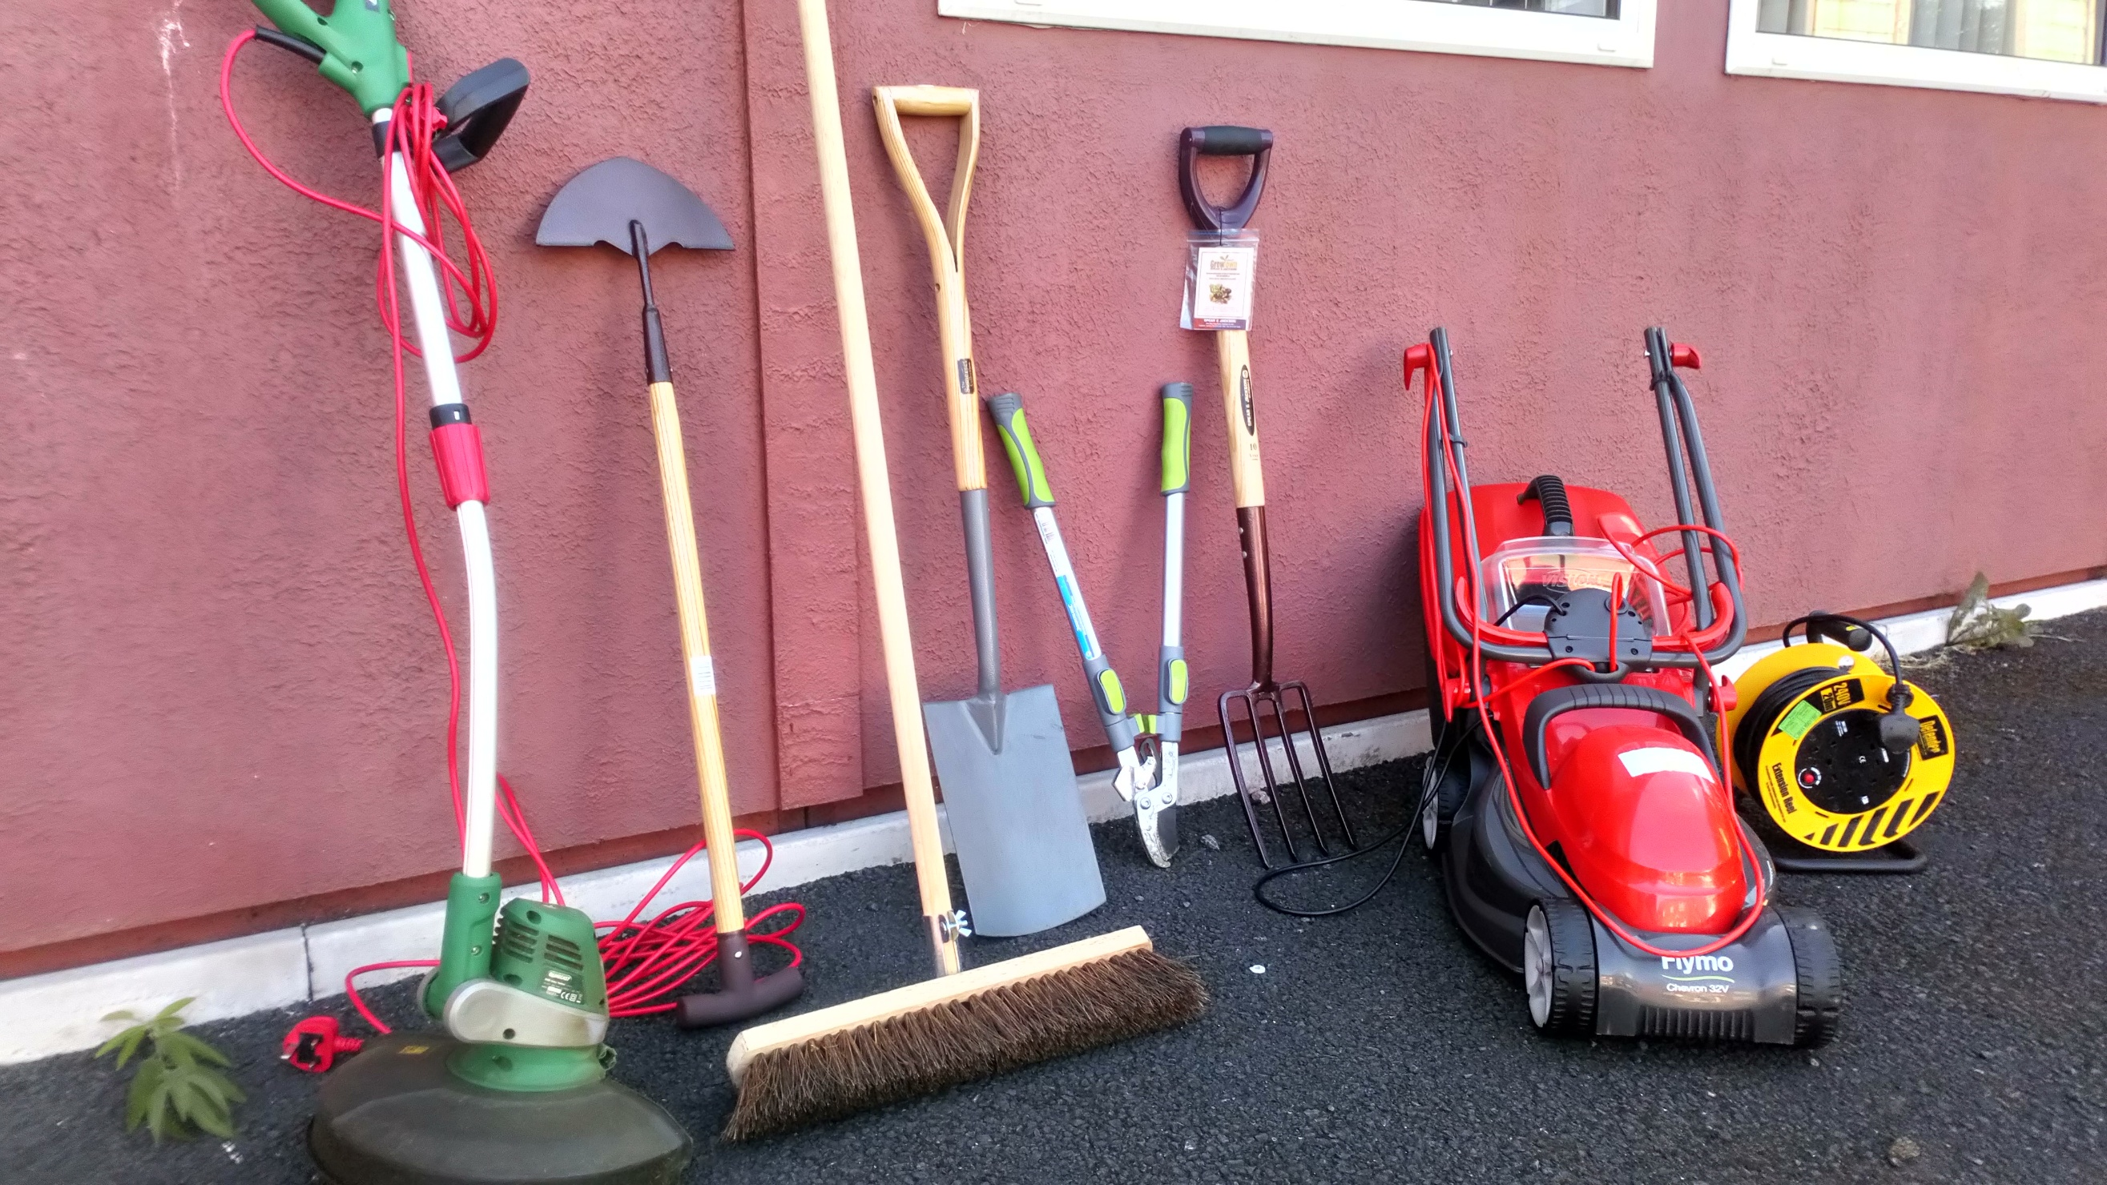

Grass Cutting Services - Greater Belfast

Area |  | Service Provider |  | Contactor Details
Greater Shankill BT13 |  | Tiger Lily Gardening |  | • Address: 202 Ballygomartin Rd, Belfast BT13 3NG.  • Phone/ Mobile: 07496 776188.
North Belfast BT14 |  | Actual Garden Services |  | • Address: 31 Oakley St, Belfast BT14 8BL.  • Phone/ Mobile: 07522 369608.  • Website: https://www.actualgardenservices.com/
 |  | CTS Landscaping |  | • Address: 163 Lylehill Rd, Belfast BT14 8SN.  • Phone/ Mobile: 07889 681703
 |  | Freshcut |  | • Address: 10 Ballyutoag Rd, Belfast BT14 8SR.  • Phone/ Mobile: 07999 212938  • Website: https://www.freshcutbelfast.co.uk/  • Email: biffysmith10@gmail.com.
 |  | M & K Tree And Garden Services Ltd |  | • Address: 99 Etna Drive, Belfast BT14 7NN.  • Phone/ Mobile: 07756 705151.
 |  | Pioneer Landscaping & Property Maintenance |  | • Address: 22b Hillview Rd, Belfast BT14 7BT.  • Phone/ Mobile: 07503 954086.
North Belfast BT15 |  | Garden Services |  | • Address: 16 Salisbury Gardens Belfast, BT15 5EL.  • Phone/ Mobile: 07968 190323.
South Belfast BT9 |  | GK Gardening Services |  | • Address: 414 The Belgravia Lisburn Rd, Belfast, BT9 7AP.  • Phone/ Mobile: 07842 434175.  • Website: http://gkgardening.uk/contact.php
South Belfast BT10 |  | Moulds Gardening Services. |  | • Address: 38 Hollymount, Belfast BT10 0GN.  • Phone/ Mobile: 07845 698524 or 028 9029 2805.  • Website: https://mouldsgardeningservices.co.uk/  • Email: info@mouldsgardeningservices.co.uk
West Belfast BT11 |  | All Seasons Garden Services |  | • Address: 11 Kells Avenue, Belfast BT11 9LB.  • Phone/ Mobile: 07749 496115.
 |  | Gro Gardens |  | • Address: 83 Fruithill Park, Belfast BT11 8GF.  • Phone/ Mobile: 07588 032493.
East Belfast BT4 |  | Jonny's Gardening Services |  | • Address: Upper Newtownards Rd, Belfast, BT4 3EN.  • Phone/ Mobile: 07476 061315.
 |  | RK Garden and Landscape Services |  | • Address: 16 Victoria Rd, Sydenham, Belfast BT4 1QU.  • Phone/ Mobile: 07715 531139.
East Belfast BT5 |  | AB Gardening Service |  | • Address: 15 Grace Avenue, Belfast BT5 5JH.  • Phone/ Mobile: 07853 934225.  • Website: https://www.abgardeningservice.co.uk/  • Email: info@abgardeningservice.co.uk
 |  | Bladez Gardening and Landscaping Services |  | • Address: 56 Gilnahirk Park, Belfast BT5 7DY.  • Phone/ Mobile: 07753 175350.
 |  | Stormont Garden Care |  | • Address: 7 Barnetts Green, Belfast BT5 7AG.  • Phone/ Mobile: 07471 046462.  • Website: https://www.stormontgardencare.com/
East Belfast BT6 |  | Carmichael Garden Fencing |  | • Address: 2 Rochester Drive, Belfast, BT6 9JX.  • Phone/ Mobile: 07742 488019.
 |  | Garden Buddy |  | • Address: Ravenhill Avenue, Belfast BT6 8LL  • Phone/ Mobile: 07591 124249
 |  | Go with the Mow |  | • Address: 8 Gibson Park Gardens, Belfast BT6 9GN.  • Phone/ Mobile: 07725 692451.
 |  | Johnston's Gardening Services |  | • Address: 8 Ilford Rd, Belfast BT6 9SN.  • Phone/ Mobile: 07510 998801.
 |  | Torbek Garden Services |  | • Address: Flat 24, 32, Knock Eden Crescent, Belfast BT6 0GQ.  • Phone/ Mobile: 07738 556930.
Grass Cutting Services - Greater Belfast
(Continued)
Area | Service Provider |  | Contactor Details
Belfast City Centre BT2 | 5 Star Tree & Landscaping |  | • Address: Lincoln Building 27-45, Gt Victoria St, Belfast BT2 7SL.  • Phone/ Mobile: 07935 737947.
Newtownabbey BT36 | AM Gardening |  | • Address: 10 Ferndale Crescent, Newtownabbey BT36 5AN.  • Phone/ Mobile: 07714 509643.  • Website: https://www.amgardeningni.com/  • Email: info@amgardeningni.com
 | The Hairy Gardener |  | • Address: 14 Glencraig Gardens, Newtownabbey BT36 5GG.  • Phone/ Mobile: 07724 625817.
 | E M C Landscapes |  | • Address: 22 Vaddegan Rd, Newtownabbey BT36 7SW.  • Phone/ Mobile: 07796 277036.
 | Garden Medic NI |  | • Address: 67 Church Rd, Newtownabbey BT36 7LS.  • Phone/ Mobile: 07703 433214.
 | GD Landscaping |  | • Address: 13 Manse Terrace, Newtownabbey BT36 5UJ.  • Phone/ Mobile: 07938 003179.
 | GM Landscaping & Maintenance |  | • Address: 2b Queens Gardens, Newtownabbey BT36 5JA  • Phone/ Mobile: 07915 053644.
 | Golden Homes Landscapes |  | • Address: 57 Glebe Road, Newtownabbey BT36 6UW.  • Phone/ Mobile: 07887 803403.
 | The Lawn Surgeon |  | • Address: 58 Rogan Wood, Newtownabbey BT36 4BG.  • Phone/ Mobile: 07703 571210.
 | MAC Gardening |  | • Address: 41 Hightown Road, Newtownabbey BT36 7TZ.  • Phone/ Mobile: 07773 432339.
 | MD Landscaping NI |  | • Address: 32b Queens Avenue, Newtownabbey BT36 5HU.  • Phone/ Mobile: 07423 503469.
Newtownabbey BT37 | Bramble Tree & Garden Services |  | • Address: 17 Burnet Close, Newtownabbey BT37 0XU.  • Phone/ Mobile: 028 9085 3196.
 | Premier Lawns |  | • Address: 25 Edenmore Court, Newtownabbey BT37 0ZA.  • Phone/ Mobile: 028 9086 9565.
Dundonald BT16 | Gcuts Gardening Services |  | • Address: 15f Enler Park East, Dundonald Belfast BT16 2DW.  • Phone/ Mobile: 07746 583123.
 | Greengrass |  | • Address: 12 Millars Forge, Dundonald Belfast BT16 1QS.  • Phone/ Mobile: 028 9048 6886.
 | Greenman Gardening Services N.I Ltd |  | • Address: 10 Inchmarnock Drive, Dundonald Belfast BT16 2ND.  •Phone/ Mobile: 028 9041 9667.
 | Urban Lawns NI |  | •Address: 6 Ballyregan Drive, Dundonald Belfast BT16 1JN  • Phone/ Mobile: 07702 498123.
Online Platforms For Quotes
There are also online platforms that allow you to request price quotes for gardening services. These include:
Rated People | https://www.ratedpeople.com/
Checkatrade | https://www.checkatrade.com/
Bark | https://www.bark.com/en/gb/


Check Out
Your Local
Newspaper
For Garden Service
Adverts

Facebook
You may also find garden grass cutters covering your area by searching on Facebook.



Google Maps
Also find garden maintenance services on Google Maps. Search “garden maintenance” on Google Maps.

Need A Home Painter and Decorator?

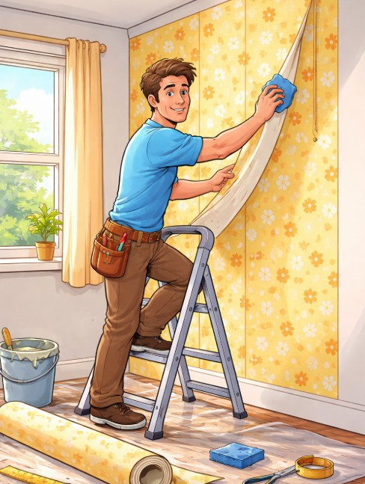
During LOCA’s resident survey carried out in early 2025, a number of people said they would like to receive information on home painting and decorating services available.
In response to this, LOCA included the following Action in its Regeneration and Community Needs Strategy 2026 – 2029, ‘LOCA will make available to Lower Oldpark residents, information on local home decoration services.’
Painter and Decorator Information
The following pages provide information on home painting and decorator services in the Greater Belfast area.

Endorsement/ Recommendation
LOCA does not endorse or recommend any of the contractors listed.

Yell.com
This information was identified by way of a search carried out on the online directory yell.com .

Accuracy
Also, LOCA cannot guarantee the accuracy of the information provided or that all service providers were identified during its yell.com search.

Other Information Sources
Other home painting and decorating services may be available and information on where these might be found is also provided.

Home Painting/ Decorating Services - Greater Belfast

Area | Service Provider | Contactor Details
Greater Shankill BT13 | Classic Decorators | • Address: 13 Cuan Parade, Belfast BT13 3FE.  • Phone/ Mobile: 028 9032 2189.  • Website: https://www.classicdecoratorsbelfast.co.uk/  • Email: classic.d@ntlworld.com
 | GM Painting & Decorating | • Address: 4 Black Mountain Park, Belfast BT13 3TS.  • Phone/ Mobile: 07513 247896.
 | Masterpiece Coatings | •Address: 7 Ainsworth Drive, Belfast BT13 3EJ.  •Phone/ Mobile: 07561 005580.
 | True Colours Decorating | • Address: 6 Highcairn Drive, Belfast BT13 3RT.  • Phone/ Mobile: 07359 219053.  • Website: https://www.truecolours-decorating.co.uk/
North Belfast BT14 | Belfast Painters & Decorators | • Address: 32 Prospect Park, Belfast BT14 7EH.  • Phone/ Mobile: 07523 204923.
West Belfast BT12 | Bracken's Painters & Decorators | • Address: 13 Springhill Gardens, Belfast BT12 7SF  • Phone/ Mobile: 07544 397974.
West Belfast BT13 | MAK Decorators | • Address: 10 Devenish Court, Belfast BT13 2L  • Phone/ Mobile: 07851 238432.  • Website: https://makdecoratorsbelfast.co.uk/
South Belfast BT8 | Belfast Contractors | •Address: 89c Ballynahinch Rd, Carryduff, Belfast BT8 8DP.  • Phone/ Mobile: 028 7003 2026.
Home Painting/ Decorating Services - Greater Belfast
Area | Service Provider | Contactor Details
South Belfast BT8  (continued) | Ivanhoe Painting & Decorating | • Address: Saintfield Rd, Carryduff, Belfast BT8 8BL.  • Phone/ Mobile: 07719 324897.
South Belfast BT9 | Millars Painting & Decorating | • Address: 35 Finch Close, Belfast BT9 6QZ  • Phone/ Mobile: 07377 719901.
South Belfast BT10 | BD Decor8 | • Address: 40 Mayfield Square, Belfast BT10 0QR.  • Phone/ Mobile: 07895 205591.  • Website: https://bdpaintersbelfast.weebly.com/
 | Ronnie Elwood Painting & Decorating | • Address: 202 Locksley Park, Belfast BT10 0AU.  • Phone/ Mobile: 07955 006102.
East Belfast BT4 | Let's Decorate | • Address: 45 Aigburth Park, Belfast BT4 1PQ.  • Phone/ Mobile: 07712 349246.
East Belfast BT5 | Rekote Ltd | • Address: Flat 5, 17, Kings Rd, Belfast BT5 6JF.  • Phone/ Mobile: 07515 353006.  • Website: https://decoratorsbelfast.co.uk/  • Email: hello@decoratorsbelfast.co.uk
East Belfast BT6 | D&M Decorators | • Address: 18 Tullyard Way, Belfast BT6 9NU.  • Phone/ Mobile: 07514 147019.
Dundonald BT16 | Lee's Decor | • Address: 11 Bennan Park, Dundonald, Belfast BT16 2LB.  • Phone/ Mobile: 07761 285021.
Newtownabbey BT36 | BDL | •Address: Unit 1, 324, Antrim Rd, Newtownabbey BT36 5EQ  • Phone/ Mobile: 028 9099 4733.
 | N Murphy Decorating | •Address: 244 Carnmoney Rd, Newtownabbey BT36 6JZ.  •Phone/ Mobile: 07555 529193.  •Website: https://www.nmurphydecorating.co.uk/
Newtownabbey BT37 | Brightwall NI | • Address: 21 Adare Park, Newtownabbey BT37 0HL.  • Phone/ Mobile: 07771824647/ 028 9 568 4675.
 | Perfect Finish Painting and Decorating | •Address: Bleach Green Avenue, Newtownabbey BT37 0BY.  •Phone/ Mobile: 07751 339017.
 | Refresh Coatings NI | •Address: 3 Monkstown Mews, Newtownabbey BT37 0ZE.  •Phone/ Mobile: 07308 239926.
Docks Area BT1 | Brush Strokes | •Address: Apartment 5.2, 62 Donegall Quay, Belfast, BT1 3NG.  •Phone/ Mobile: 07974 355675.

Online Platforms For Quotes
There are also online platforms that allow you to request price quotes from providers of home painting and decorating services. These include:
Rated People | https://www.ratedpeople.com/
Checkatrade | https://www.checkatrade.com/
Bark | https://www.bark.com/en/gb/

Check Out Your Local Newspaper For Painting and Decorator Adverts


Google Maps
Also find painting and decoration services on Google Maps. Search “painting and decorating” on Google Maps.

Facebook
You may also find painters and decorators covering your area by searching on Facebook

Repairs
Northern Ireland Housing Executive Repairs
Reporting A Repair
Contact By
- Phone: (Office and Out of Office hours: 03448 920 901.
- Email: info@nihe.gov.uk
- Visting/ writing: North Belfast Repairs, NIHE, Housing Centre, 2 Adelaide Street, Belfast BT2 8PB
- NIHE Tenant Portal.

After A Repair Is Reported
A Repair Order will be sent to a contractor with the work needed and timeframe for completion.
Phone Call To Tenant
The contractor will phone the tenant to arrange an appointment. With an Emergency Repair, an appointment call will usually be made within two hours. With Urgent/ Routine repairs, it will be made within two working days.
No Access To House
If there is no access, the contractor will leave a card with a number to ring for a new appointment. They will call up to three times. If they can’t gain access, the job will be cancelled and will have to be reported to the NIHE again.
Contractor Doesn’t Turn Up
If the contractor doesn’t come at the agreed time, the tenant should contact the NIHE again.
Inspection Needed
With some repairs, the NIHE has to inspect the problem first. A Maintenance Officer (MO) will contact the tenant within five working days to arrange an inspection. If work is needed, the MO will raise a Repair Order.
Up-to-date Phone Number
Tenants should ensure the NIHE has their current phone number and that they respond to calls from NIHE contractors and MO.

Information To Give the NIHE
Provide the following information:
- If you reported the work before and if it wasn’t done or done properly.
- Full details of the work needed.
- Times you won’t be available.
- Confirmation of your phone number.

Information To Get From the NIHE
When reporting a repair, ensure you ask:
- If a Repair Order has been raised or if an inspection is needed first.
- The Repair Reference Number.
- The priority given to the repair.
- If the repair was reported before and the work hasn’t been done, ask for a reason and what action will be taken.

not an emergency. The NIHE will attend to Urgent Repairs within four working days.
Routine Repairs
If a repair is not Emergency or Urgent, it is Routine and will usually be completed within 4 weeks.
The exception is where the NIHE already has a planned maintenance scheme that will include your repair. The Area Office will advise you of this.
NIHE Repair Categories
There are three types of NIHE repairs.
Emergency
Cover faults that carry a risk of immediate injury to people or major damage to property. The work should be carried out within 24 hours.
Urgent Repairs
An Urgent Repair needs a quick response but is

