Lower Oldpark Community Association (LOCA) Housing Services Privacy Notice (Updated 20.7.21)
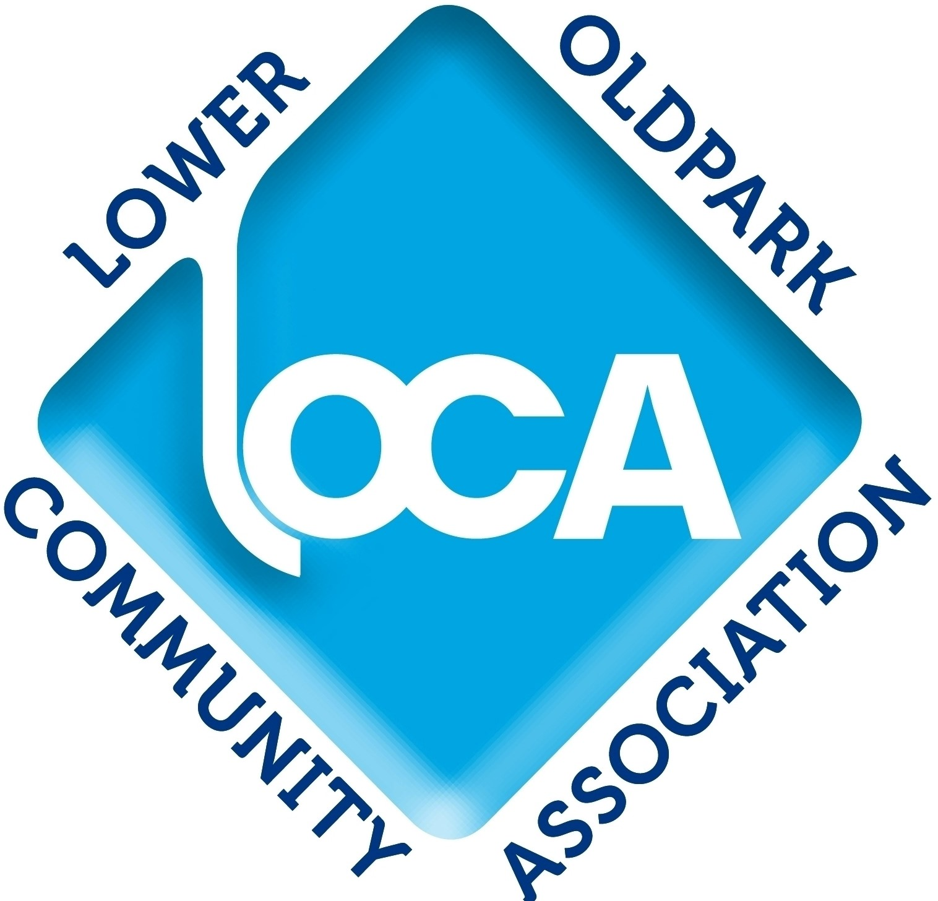
LOCA asks you to read this privacy notice carefully as it contains important information about our Housing Services personal data protection policies and about the personal data protection rights of individuals using the services.
Lower Oldpark Community Association (LOCA)
LOCA is a charitable organisation that is registered with the Northern Ireland Charity Commission. It delivers a number of housing related services from its base at 9-23 Avoca Street, Belfast BT14 6EN. We can be contacted, in relation to these services on telephone number 02890351334 or by emailing loweroldparkhousing@gmail.com.
Personal Information Regulation
LOCA delivers a number of housing related services. We request and process personal data from people when delivering these services.
We are regulated in relation to the processing of this data by the General Data Protection Regulations (GDPR) which apply across the UK.
LOCA is defined as a ‘Data Controller’ and in this role is responsible for making sure that the personal data of individuals is processed in accordance with the GDPR.
We are committed to ensuring that we fulfill all our obligations in relation to GDPR in a professional manner.
How We use Your Information
Housing Advice
LOCA provides a Housing Advice Service within the Lower Oldpark neighbourhood. We collect relevant personal data from our clients to help us:
- Provide an effective service.
- Monitor service quality.
Local Environment Problems Reporting
LOCA provides a Local Environment Problem Reporting Service within the Lower Oldpark neighbourhood. We collect relevant personal data from clients to help us:
- Provide an effective service.
- Monitor service quality.

Garden Equipment Lending Service
From 1st August 2021, LOCA began providing a Garden Equipment Lending Service for residents of the Lower Oldpark neighbourhood. We collect relevant personal data from clients to help us:
- Provide an effective service.
- Monitor service quality.
Community Surveys
LOCA carries out community surveys to help it:
- Identify the needs, circumstances, expectations, views and opinions of households in the community.
- Guide the development of local and wider responses to identified needs, circumstances and expectations.
- Contact residents who indicated during the survey that they would like to receive information or other help.
Types of Data and Data Collection
The types of personal data LOCA collects when delivering its housing related services are set out below.
Housing Advice Service and Local Environment Problems Reporting Service.
When providing these services, we may request and process a range of personal information about our clients. The type of data processed is set out below. This information may be held in electronic or hard copy format.
Type of Data
Full name.
Current and (where appropriate) your previous addresses.
Telephone number (including mobile number).
Email address (when provided).
Date of birth.
National Insurance Number (where appropriate).
Relevant information and documents provided by you and by organisations in relation to your advice enquiry.
Documents relating to your enquiry prepared by LOCA.

We collect this information from the following sources:
- You (‘Data Subject’)
- Persons or organisations you have instructed or authorised to share information with LOCA. Which specific organisations provide personal data about you will depend on the nature and requirements of your enquiry.

Gardening Equipment Lending Service
When providing this service, we may request and process a range of personal information about our clients. The type of data processed is set out below. This information may be held in electronic or hard copy format.
Type of Data
Full name.
Current addresses.
Telephone number (including mobile number).
Email address (when provided).
Age and proof of age.

We collect this information from the following sources:
- You (‘Data Subject’)
Housing Surveys
When providing this service, we request and process a range of personal data about individuals who complete questionnaires.
We request and process a person’s name, address and phone number. This allows us to identify and contact them if they have indicated during the survey that they would like to receive help/ information.
The types of data requested and processed are set out below. This information may be held in electronic or hard copy format.
Name
Address
Phone number
Specific needs
Specific circumstances
Specific expectations
Specific views/ opinions.

We collect this information from the following sources:
- You (‘Data Subject’)
Lawful Basis
Under GDRP, we requires a legal basis to obtain and process your personal data. The law allows for six ways to process personal data (and additional ways for sensitive personal data).
The lawful basis on which LOCA Housing Services processes your data is set out below:

Housing Advice
Your consent.
Local Environment Problems Reporting
Your consent.
Garden Equipment Lending Service
Your consent.
Housing Surveys
Your consent.
Consent
Withdrawal of Consent
You can withdraw your consent at any time to LOCA holding and processing and sharing all or any of your personal data. You can do this by contacting us using the contact details set out above..
Sharing Data
Housing Advice/ Local Environment Problems Reporting
LOCA often needs to discuss your advice enquiry with relevant organisations such your landlord e.g. the NIHE or a housing association. It may also need to share your details when reporting a local environment problem to specific organisations.
LOCA will only share your personal data with relevant organisations. Also, it will only share personal data that is directly relevant to your advice enquiry or your local environment problem report. The purpose of sharing your information in these circumstances is to enable us to deliver the best possible services for you.
LOCA will also need to share your information if it refers you to another organisation for help e.g. Housing Rights Service.
It will also share data when it is necessary to enable the quality of LOCA’s services to be monitored by an authorised organisation.
Garden Equipment Lending Service
LOCA will not share personal data it holds for the purpose of providing the Garden Equipment Lending Service.
Housing Surveys
LOCA will not share personal data it obtains by way of community surveys with any other individuals or organisations without the consent of the person affected.
How Long Personal Data Will Be Held?
Whatever its relationship with you, LOCA will only store personal data relating to them for a specified amount of time, and no longer than is necessary.
Housing Advice/ Local Environment Problems Reporting
LOCA will hold the personal data of individuals who use the Housing Advice and Local Environment Problems Reporting services for a period not exceeding two years from the date of last contact.
Garden Equipment Lending Service
LOCA will hold the personal data of individuals who use the Garden Equipment Lending Service for a period not exceeding two years from the date of last contact.
Housing Surveys
LOCA will hold the personal data of individuals who complete community surveys for a period not exceeding one year from the date of completion of the questionnaire by the individual.
Disposal/ Deletion
Once the necessary retention period has expired, the information will be confidentially disposed of or permanently deleted.
Personal Data Rights
The GDPR provides individuals with a series of rights in relation to their personal data that is held and processed by organisations. These rights are set out below. LOCA is committed to ensuring that, in respect to the housing services it delivers, it will uphold the personal data rights of individuals making use of its services.
We will meet our obligations under your right as soon as possible but, at the latest, within one month, unless circumstances permit this period to be extended.
It may be necessary to verify the identity of the person exercising their right.
Right to be Informed
You have a right to know what personal data relating to you LOCA holds and what it does with this data. You also have the right to ask, in writing, to see our records of the data.
Right of Access
You have the right to get a copy of personal data relating to you that LOCA holds.
Right to Rectification
You have the right to have inaccurate personal data relating to you held by LOCA fixed.

Right of Erasure
You have the right to have personal data relating to you held by LOCA deleted.
Right to Object
You have the right to object to LOCA holding or processing personal data on the basis of legitimate interest or public task.
Right of Restriction
You have the right to limit what LOCA can do with your personal data.
Data Portability
You have the right to receive your personal data from LOCA in a common electronic format.
Privacy Notice Review
We keep our privacy notice under regular review and update it when necessary.
If LOCA wants to use the Housing Services personal data it holds in a different way or for a new purpose, it will firstly obtain your consent. We will also amend our privacy notice to reflect this and communicate it to you.
Questions
If you have any questions about this Privacy Notice, please contact:
Janice Beggs
LOCA Centre Manager
9-23 Avoca Street
Belfast BT14 6EN
Telephone: 02890351334
Email: loweroldparkhousing@gmail.com
Complaints
You have the right to complain to the Information Commissioner if you believe that your data protection rights have been breached by LOCA. Contact details for the Information Commissioner are set out below.
ICO Address
Information Commissioner's Office
Wycliffe House
Water Lane
Wilmslow
Cheshire
SK9 5AF
ICO Telephone
0303 123 1113 (local rate) or 01625 545 745 if you prefer to use a national rate number.
ICO Website
https://ico.org.uk/
Policy Update
This policy was last updated in July 2021.

