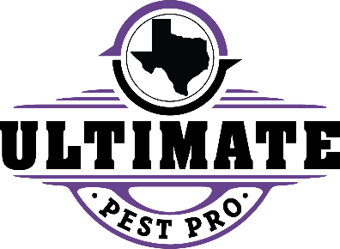
TIPS FOR PREVENTING COCKROACH ACTIVITY

Ultimate Pest Pro uses Integrated Pet Management (IPM) techniques to control roaches. IPM relies on several pest control methods including sanitation, nonchemical and chemical solutions.
The first step is through sanitation. Resident cooperation is key and includes the following items:
- Clean garbage and food spills promptly
- Run garbage disposal regularly and keep sink strainer clean
- Never leave dirty dishes, food or pet food out overnight.
- Clean stove tops, counter tops, cabinets and floors often
- Eliminate moisture sources by keeping sinks drained and dry
- Rinse bottles and cans prior to placing in recycling bins
- Keep trash away from buildings
- DO not use newspaper or contact paper to line shelves and drawers in kitchen cabinets
- Sweep or vacuum dead roaches from floors, cabinets, and around appliances regularly during treatment process
- Be aware that cockroaches thrive in damp and warm environments
- DO NOT APPLY SPRAYS OR “BOMBS” TO CONTROL ROACHES.
We utilize several IPM methods to control roaches including monitoring activity with glue traps, gel and dust baits, residual insecticides and growth regulators. Do it yourself pest control such as sprays or “bombs” should NOT be used as these store-bought products are counterproductive to our IPM products and can move activity to different areas of the unit or building. What to expect:
- Initially you may not notice a change. Our IPM system primarily uses bait products which require time to be consumed and begin working within the colony
- Over time you will see a reduction in the number of active roaches.
- Elimination will require varying time frames on level of infestation and elimination of sanitation issues.

