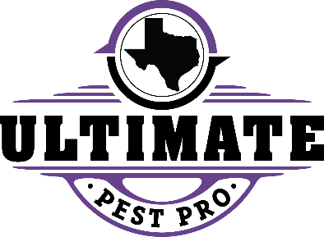
TIPS FOR PREVENTING FLIES
The first step is through inspection and sanitation. Resident cooperation is key and includes the following items:
FLIES (House flies, fruit flies and blow flies)
- The key to elimination is finding where the fly is laying its eggs in and eliminating it.
- Fruit flies or what are mistakenly called gnats will usually nest in dirty garbage disposals, soda, wine or beer cans in recycling bins, rotting fruit and vegetables, or slime or sludge as you might find in stagnant aquarium or dirty sink. Dishes should be washed daily, trash removed regularly and the above areas inspected and cleaned as needed.
- House flies usually nest in feces and are a result of pet waste not being properly disposed of, an uncleaned litter box or rotting garbage. Finding the source and removing it is the solution to the problem.
- Blow flies (also known as bottle flies or flesh flies) generally lay their eggs in rotting meat. An infestation of these is generally indicative of a dead animal in the vicinity of rotting meat. In the garbage or an appliance that has stopped working. As above, inspection and removal of nesting material is the solution to the ploblem.
- DO NOT APPLY SPRAY OR “BOMBS” TO CONTROL FLIES OR PANTRY PESTS
We utilize several IPM methods to control flies including monitoring activity with glue traps, insect growth regulators, aerosol baits and flushing agents. Do it your self pest control such as sprays or “bombs” should NOT be uses as these store-bought products are counterproductive to our IPM products and can move activity to different areas of the unit or building. What to expect:
- Initially after the nesting source is located with 48-72 hours you will see a significant reduction if not elimination of adult flies.
- Elimination time could vary if nesting source is missed during your initial inspection.
- SANITATION IS THE SOLUTION MOST OF THE TIME. Sometimes this sanitation can be in a very specific area.

