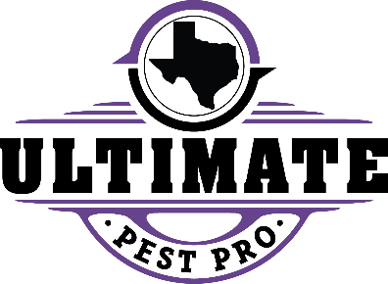

NOTICE OF PEST CONTROL TREATMENT

Date(s) of planned treatment:
Re-entry:
Extenuating Circumstances may require unplanned treatments. To confirm treatment dates please call:

Ultimate Pest Solutions
1809 John McCain Rd.
Colleyville, TX 76034
817-576-5646

For more information call or contact:
National Pesticide Information Center
1-800-858-7378
A Consumer Information Sheet may be obtained from the management.
Pest Control applicators are licensed by the Texas Department of Agriculture, Structural Pest Control Service, P.O. Box 12847, Austin, Texas 78711-2847, (512) 305-8250 TPCL # 084

