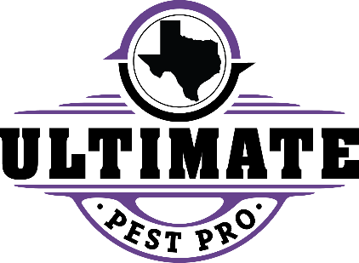
TIPS FOR PREVENTING PANTRY PESTS

Ultimate Pest Control uses Integrated Pest Management (IPM) techniques to control pantry pests. IPM relies on several pest control methods including sanitation, nonchemical and chemical solutions.
The first step is through inspection and sanitation. Resident cooperation is key and includes the following items.
PANTRY PESTS (Weevils, beetles and moths)
- The key to elimination is removal of infested items. Pesticides products are not the answer as they cannot be applied to food products.
- Inspect dry goods, pastas, grains, dried fruit, spices etc. Pet food and treats are also often infested with pantry pests.
- If activity is found, inspection of ALL food items in pantry and pet food items is key to eliminating the problem. Any and all items with pest activity should be discarded.
- Other household items that can be infested include, potpourri, dried flowers, holiday decorations with dried fruit or nuts in them, wicker, peat moss, silk flowers, and children’s art such as macaroni or bean art.
- DO NOT APPLY SPRAYS OR ‘BOMBS’ TO CONTROL PANTRY PESTS.
- Ultimate Pest Control cannot treat any food items
Do it yourself pest control such as sprays and “bombs” should NOT be used as these store-bought products are counterproductive to our IPM products and can move activity to different areas of the unit or building. What to expect:
- Initially after the nesting source is located within 48-72 hours you will see a significant reduction if not elimination of any pantry pests.
- Elimination time could vary if a nesting source is missed during your initial inspection.

