St. Andrew’s
Episcopal Church

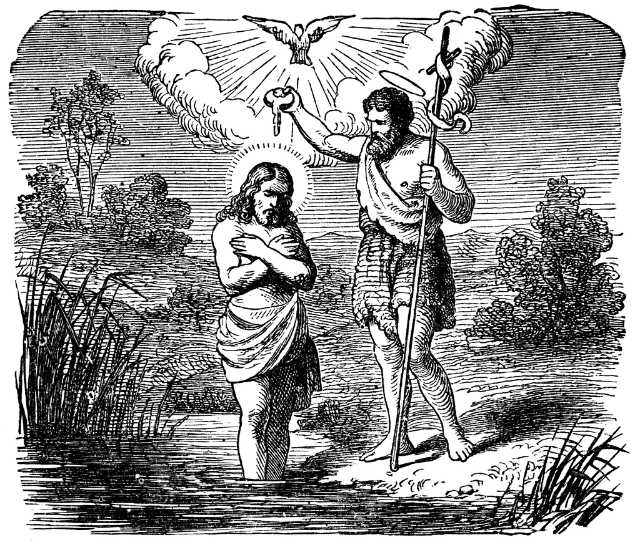

The First Sunday after Epiphany
The Baptism of our Lord
January 11, 2026
Holy Eucharist ~ 10:30am

"Do not neglect hospitality, for through it some have unknowingly entertained angels."
(Heb. 13:1). We warmly welcome all who worship with us today. Children are welcome in worship. Please complete a Visitor's Sheet found on the tables at the back of the church. By completing a sheet, you will receive our newsletter and welcome information.

THE WORD OF GOD

Prelude

Hymn at the Procession 135 Songs of thankfulness and praise

Opening Acclamation BCP p. 355

Celebrant Blessed be God: Father, Son, and Holy Spirit.
People And blessed be his kingdom, now and for ever. Amen.
Celebrant There is one Body and one Spirit;
People There is one hope in God’s call to us;
Celebrant One Lord, one Faith, one Baptism;
People One God and Father of all.

The Collect of the Day
Celebrant The Lord be with you.
People And also with you.

Father in heaven, who at the baptism of Jesus in the River Jordan proclaimed him your beloved Son and anointed him with the Holy Spirit: Grant that all who are baptized into his Name may keep the covenant they have made, and boldly confess him as Lord and Savior; who with you and the Holy Spirit lives and reigns, one God, in glory everlasting. Amen.

The people are seated for the readings and the psalm.

The First Lesson – Isaiah 42:1-9
A reading from the Prophet Isaiah

Here is my servant, whom I uphold, my chosen, in whom my soul delights; I have put my spirit upon him; he will bring forth justice to the nations. He will not cry or lift up his voice, or make it heard in the street; a bruised reed he will not break, and a dimly burning wick he will not quench; he will faithfully bring forth justice. He will not grow faint or be crushed until he has established justice in the earth; and the coastlands wait for his teaching. Thus says God, the Lord, who created the heavens and stretched them out, who spread out the earth and what comes from it, who gives breath to the people upon it and spirit to those who walk in it: I am the Lord, I have called you in righteousness, I have taken you by the hand and kept you; I have given you as a covenant to the people, a light to the nations, to open the eyes that are blind, to bring out the prisoners from the dungeon, from the prison those who sit in darkness. I am the Lord, that is my name; my glory I give to no other, nor my praise to idols. See, the former things have come to pass, and new things I now declare; before they spring forth, I tell you of them.

Reader The Word of the Lord.
People Thanks be to God.

Psalm 29
Please respond at the bold verse
1 Ascribe to the Lord, you gods,
ascribe to the Lord glory and strength.
2 Ascribe to the Lord the glory due his Name;
worship the Lord in the beauty of holiness.
3 The voice of the Lord is upon the waters;
the God of glory thunders;
the Lord is upon the mighty waters.
4 The voice of the Lord is a powerful voice;
the voice of the Lord is a voice of splendor.
5 The voice of the Lord breaks the cedar trees;
the Lord breaks the cedars of Lebanon;
6 He makes Lebanon skip like a calf,
and Mount Hermon like a young wild ox.
7 The voice of the Lord splits the flames of fire;
the voice of the Lord shakes the wilderness;
the Lord shakes the wilderness of Kadesh.
8 The voice of the Lord makes the oak trees writhe
and strips the forests bare.
9 And in the temple of the Lord
all are crying, "Glory!"
10 The Lord sits enthroned above the flood;
the Lord sits enthroned as King for evermore.
11 The Lord shall give strength to his people;
the Lord shall give his people the blessing of peace.

The Second Lesson – Acts 10:34-43
A reading from the Acts of the Apostles

Peter began to speak to them: “I truly understand that God shows no partiality, but in every nation anyone who fears him and does what is right is acceptable to him. You know the message he sent to the people of Israel, preaching peace by Jesus Christ--he is Lord of all. That message spread throughout Judea, beginning in Galilee after the baptism that John announced: how God anointed Jesus of Nazareth with the Holy Spirit and with power; how he went about doing good and healing all who were oppressed by the devil, for God was with him. We are witnesses to all that he did both in Judea and in Jerusalem. They put him to death by hanging him on a tree; but God raised him on the third day and allowed him to appear, not to all the people but to us who were chosen by God as witnesses, and who ate and drank with him after he rose from the dead. He commanded us to preach to the people and to testify that he is the one ordained by God as judge of the living and the dead. All the prophets testify about him that everyone who believes in him receives forgiveness of sins through his name.”

Reader The Word of the Lord.
People Thanks be to God.

Hymn at the Sequence 121 Christ, when for us you were baptized

The Gospel – Matthew 3:13-17

Celebrant The Holy Gospel of our Lord Jesus Christ according to Matthew.
People Glory be to thee, O Lord.

Jesus came from Galilee to John at the Jordan, to be baptized by him. John would have prevented him, saying, “I need to be baptized by you, and do you come to me?” But Jesus answered him, “Let it be so now; for it is proper for us in this way to fulfill all righteousness.” Then he consented. And when Jesus had been baptized, just as he came up from the water, suddenly the heavens were opened to him and he saw the Spirit of God descending like a dove and alighting on him. And a voice from heaven said, “This is my Son, the Beloved, with whom I am well pleased.”

Celebrant The Gospel of the Lord.
People Praise to you, Lord Christ.

Sermon The Rev. Z. Mark Smith

The Service for Holy Baptism BCP p. 301

Candidate for Holy Baptism:

Paisley Magnolia Marie Jenkins

The Peace
Celebrant The peace of the Lord be always with you.
People And with thy spirit.

Announcements

Offertory
Walk in love as Christ loved us and gave himself for us, an offering and sacrifice to God. (Eph.5:2)

"In the Bleak Midwinter" arr. by Heather Sorenson (Barbara Lorton, cello)

Presentation Hymns Hymn #380 (v.3) and Hymn #717 (v.4)

“Praise God, from whom all blessings flow; praise him, all creatures here below; praise him above, ye heavenly host: praise Father, Son, and Holy Ghost.”

“Our fathers’ God, to thee, author of liberty, to thee we sing; long may our land be bright with freedom’s holy light; protect us by thy might, great God, our King.”
The Holy Communion

The Great Thanksgiving, Eucharistic Prayer B BCP p. 367
Celebrant The Lord be with you.
People And also with you.
Celebrant Lift up your hearts.
People We lift them to the Lord.
Celebrant Let us give thanks to the Lord our God.
People It is right to give him thanks and praise.

Celebrant
It is right, and a good and joyful thing, always and every-where to give thanks to you, Father Almighty, Creator of heaven and earth.
Therefore we praise you, joining our voices with Angels and Archangels and with all the company of heaven, who for ever sing this hymn to proclaim the glory of your Name:

Sanctus Hymnal S-130

The congregation may stand or kneel

We give thanks to you, O God, for the goodness and love which you have made known to us in creation; in the calling of Israel to be your people; in your Word spoken through the prophets; and above all in the Word made flesh, Jesus, your Son. For in these last days you sent him to be incarnate from the Virgin Mary, to be the Savior and Redeemer of the world. In him, you have delivered us from evil, and made us worthy to stand before you. In him, you have brought us out of error into truth, out of sin into righteousness, out of death into life.

On the night before he died for us, our Lord Jesus Christ took bread; and when he had given thanks to you, he broke it, and gave it to his disciples, and said, “Take, eat; This is my Body which is given for you. Do this for the remembrance of me.”

After supper he took the cup of wine; and when he had given thanks, he gave it to them, and said, “Drink this, all of you: This is my Blood of the new Covenant, which is shed for you and for many for the forgiveness of sins. Whenever you drink it, do this for the remembrance of me.”

Therefore, according to his command, O Father,

Celebrant and people

We remember his death,

We proclaim his resurrection,

We await his coming in glory;

Celebrant

And we offer our sacrifice of praise and thanksgiving to you, O Lord of all; presenting to you, from your creation, this bread and this wine.

We pray you, gracious God, to send your Holy Spirit upon these gifts that they may be the Sacrament of the Body of Christ and his Blood of the new Covenant. Unite us to your Son in his sacrifice, that we may be acceptable through him, being sanctified by the Holy Spirit. In the fullness of time, put all things in subjection under your Christ, and bring us to that heavenly country where, with blessed Andrew and all your saints; we may enter the everlasting heritage of your sons and daughters; through Jesus Christ our Lord, the firstborn of all creation, the head of the Church, and the author of our salvation.

By him, and with him, and in him, in the unity of the Holy Spirit all honor and glory is yours, Almighty Father, now and for ever. AMEN.

The Lord’s Prayer BCP p. 364
And now, as our Savior Christ has taught us, we are bold to say

Our Father, who art in heaven,

hallowed be thy Name,

thy kingdom come, thy will be done,

on earth as it is in heaven.
Give us this day our daily bread.

And forgive us our trespasses,
as we forgive those who trespass against us.
And lead us not into temptation,
but deliver us from evil.
For thine is the kingdom,
and the power, and the glory,
for ever and ever. Amen.
The Breaking of the Bread BCP p. 364
Celebrant Christ our Passover is sacrificed for us;
People Therefore let us keep the feast.

The Minister offers the following invitation:
The Gifts of God for the People of God. Holy things for Holy People.

All who seek a closer relationship with God through Christ are welcome to participate in Holy Communion.

If you would prefer not to receive, you may cross your arms over your chest and the celebrant will offer God’s blessing. Gluten-free wafers are available; please make your need known to the celebrant.

Celebrant Let us pray.

Post Communion Prayer

Eternal God heavenly Father, you have graciously accepted us as living members of your Son our Savior Jesus Christ, and you have fed us with spiritual food in the Sacrament of his Body and Blood. Send us now into the world in peace, and grant us strength and courage to love and serve you with gladness and singleness of heart; through Christ our Lord. Amen.

Blessing
The Lord bless you and watch over you,
the Lord make his face shine upon you
and be gracious to you,
the Lord look kindly on you
and give you peace;
and the blessing of God Almighty
Father, Son and Holy Spirit be with you this day and always. Amen.

Final Processional Hymn 295 Sing praise to our Creator

Dismissal
Verger Go in peace to love and serve the Lord. Alleluia, Alleluia!

People Thanks be to God. Alleluia, Alleluia!

Postlude

_______________________

Announcements

PARISH PRAYER LIST
Please hold the following people in prayer:
Patrick Afoakwah, Bobby Anderson, Pam Baake, Melanie Baisley, Jan Barnes, The Blackwell Family, Caroline Bradford, Carol Brimm, Pete and Nancy Brown, Christine Butler, Amanda Cain, Misty Cantu, Susan Carroll, Art Carson, Donna Carter, Donnie Carter, Judy Cavin, Jennifer Ceriale, Branden Chan, Judy Consoli, Lanette Cowles, Erica Day, Judi Donnelly, Billy Doughty, Phyllis Doughty, Karol Dyson, Ruby Dyson, Dean G., Brian Gardner, Paula Gardner, Susan Geary, Gloria Gehrig, Alexi Greene, Mary Hansen, The Hansen Family, Jerry Himmelheber, Ryker Hurst, Greta Johnston, Helen Kundracik, Richard Lamb, Terrie Leonard, Thomas Leonard, Elinor Mattingly, Dee McRae, Artie Miller, Bob and Doreen Misener, Betty Lou Nagel, Bernice Nunes, Max Olsen and The Olsen Family, Kyle Patrick, Skylar Patron, Elizabeth Biddle Pumphrey, Natalie Reed, Jane Roderick, The Tom Shearman Family, Mark Stutso, Jonathan Tanner, Taylor, Tegan, Isabella Tenczar, Charlene Townsend, Ryan Turner, Paula Wayland, Angelica Wilkinson, The Willett Family, Stuart A. Wood, first responders and all of those serving in the military and their families.
______________________________________
Serving in Worship today – The Rev. Z. Mark Smith

8:00 am
Lector – Mary Larson

10:30 am
Lector – Susan Bennett
Verger – Kim Stickney

Coffee Hour Hosts – Anne & Art Carson, the Sissons

Coffee Hour follows each service in the Parish Hall.
_________________________________________

Musicians
Choir and Ringers will not rehearse this week. The choir will rehearse next at 9:15 am on Sunday, January 18th for the offertory anthem during that service.

Annual Meeting
The annual meeting will take place on January 25, 2026.
Afternoon at Rev. Mark and Kelly's House
On January 17, we would like to invite the parish to our house for an afternoon to chat and share some food. All who are new to the parish are welcome to bring themselves; those who have been at St. Andrew's for a while are welcome to bring themselves and a dish of their choice. I will provide an entree but the purpose will be to mingle and perhaps talk with those we don't normally see on Sunday mornings. Children are absolutely welcome and we will begin at 2 pm. Looking forward to seeing all who can make it! (25540 Landing Way, Leonardtown, MD 20650)

Faithfully,
Mark+ and Kelly

Kitchen Volunteers
Volunteers are needed to help deep clean the kitchen in preparation for the Pancake and Valentine’s Day suppers. Cleaning will take place January 24th at 10 am; main tasks will include washing drawers and labeling for organization. All volunteers are deeply appreciated. Please contact Peter Woodside if you are able to help.

Sunday School Information
Sunday school is in session! Children will begin in the church with their families, leave just prior to the first reading, and then return for communion. Anyone between the ages of 5 to 12 can join in for singing, a Bible story, and an activity.

WARM
WARM returns to St. Andrew’s the first week of February! The sign-up schedule will be on our website. Volunteers for monitoring, dishwashing, and meals are all available. Don't be shy - sign up early and get all the dates you want! If you have any questions, please see Mary Maker or Robert Abell.

Healing Service
Join us Wednesdays at 12:30 pm for a simple service of scripture, prayer, reflection and anointing for those who wish to receive. Feel free to bring your joys and sadness, prayers for yourself and others and, most of all, for this beautiful, broken world we inhabit.

Bible Study
Bible Study take place on Wednesdays at 1pm, immediately following the healing service. Our guide will be Matthew, who is our companion throughout the Sunday readings this year. Bring a snack and join us if you can!

Adult Forum
Please join us at 9:15 for Adult Forum! Between the services, we will examine the readings for the day, talk a little about their meaning and relationship to one another, and what they have to do with our lives as we live them. We cover a lot of ground in scripture every week, so it’s important that it speak to us as clearly as possible. My hope is that it will provide a chance to ask hard questions of the texts so that we can carry them with us into the week and allow our discipleship to speak through them. Mark+

St. Andrew’s Nursery
Nursery is available from 10:00 am – Noon, every Sunday. Suitable for all little souls from infancy through age 5.

Parish Calendar
The St. Andrew's Parish Calendar is online! To add your events, please email admin@standrewsleonardtown.org To view the calendar, go to the Parish website or use this link: https://standrewsleonardtown.org/parish-calendar

Please visit the Parish website for up-to-date information on Service Schedule, campus events and information. https://standrewsleonardtown.org/

++++++++++++++++

Candidates for Vestry 2026

Mary Hansen
I am a wife to Willy Hansen for 51 years, mother of 2 children, grandmother of 3. I moved to Maryland in the 70's to be here for 2 years. I attended Church of the Ascension, until I came to St Andrews 3 years ago. I became an Episcopalian when I was 20.

When my daughter and I visited St Andrews, we knew we had found our place. A welcoming home for us to grow and nurture my grandchildren. I work sorting in the Thrift Shop, Yard Sale and Altar Guild. I love our church and am eager to serve as a Vestry Member. I also work at Crazy for Ewe, a yarn store in Leonardtown.

Pete Ulrich
A cradle Episcopalian, Peter Ulrich grew up in Oxon Hill, MD attending St. John's and was confirmed at the National Cathedral by Bishop Walker in 1977. He served in the US Navy for 20 years, settling in St Mary's County upon leaving active duty. He and his wife Amy have been members of St. Andrew's for more than 20 years, raising their three children in the church. He has previously served on the Search Committee and on the Vestry, and has acted as an Usher, a Lay Reader, and in the choir.

Randy Gillies
Thank you for considering my nomination to the St. Andrew’s vestry. I am a life-long Episcopalian. My wife Warna and I were married at All Saints Episcopal Church in Chelmsford, Massachusetts 47 years ago last month. I’m “semi-retired” — with occasional consulting work throughout the year having retired in 2019 following a 41-year career supporting US national security issues. We reside in Lusby.

We joined the St. Andrew’s community about a year and a half ago, having relocated to the southern Maryland area to be closer to our son, daughter-in-law, and now two grandsons who live in Alexandria, Virginia. We also enjoy spending time on the Bay aboard our sailboat “Godspeed”.

As a newcomer to the St. Andrew’s parish family, I recognize I have much to learn about the history and impact our church has made in the past. If elected, I look forward to the opportunity to work with Fr. Mark, Susan, and the other vestry members as St. Andrew’s continues to enrich the community we serve.

St. Andrew’s Episcopal Church
44078 St. Andrews Church Road | California, MD 20619 | 301-862-2247
The Rev. Z. Mark Smith, Rector
rector@standrewsleonardtown.org | 215-307-0872

