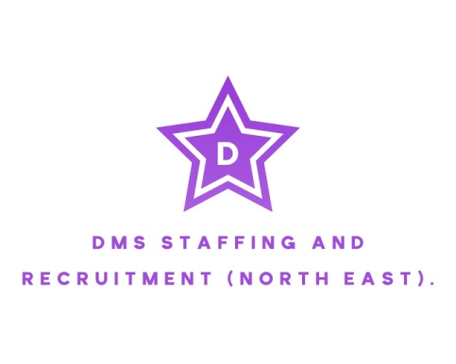
For all your staffing needs.
TEL: 01642 942076.

Name:______________________________  Role: _______________________________ | Client/Home Name and Address:

This Timesheet MUST be completed each week and returned to the office fully completed and signed no later than MONDAY 10am. Failure to meet this could result in delay in payment. Please send completed timesheets to payroll@dms-staffing.co.uk
Day: | Date: | Start Time: | End Time: | No of Hours: | Break Time: | Hours Worked: | Client Signature:
Monday

Tuesday

Wednesday

Thursday

Friday

Saturday

Sunday

Any alterations MUST be countersigned by the client/line manager.
Total Hours Worked: ______________________  Date: _____/_____/_____ | Workers Signature: _________________________  By signing the above you confirm you’re fit for work and practice.

TO BE COMPLETED BY THE CLIENT.
By signing the below you confirm the numbers of hours worked are correct and authorise as an agent/employee for the company for DMS Staffing and Recruitment (North East) to pay the candidate and invoice for hours worked to the nearest quarter. In the event that any candidate are employed by the company on a permanent basis after being introduced by DMS Staffing and Recruitment you will pay a fee based on the terms agreed.
Name: __________________________________ Signed: __________________________

Date: _____/_____/_____ Position: ________________________

