Tyler County Fair Home Economics Entry Form
CANNING and SEWING
Deadline: August 31, 2026

Name:________________________________________________________
Grade:______________ Age as of Sept 1st:__________________
Pee Wee (8 yrs and younger) Junior (9 or 3rd grade-13 yrs old) Senior (14-18 yrs old)

Address:____________________________________ City:____________________________________
Phone:_____________________________________
4H/FFA/FCCLA Chapter:_____________________________________________________________
**Submit a separate entry form for each project**
Entry Fee $10 per entry

A copy of your canning recipe MUST be attached to this entry form!
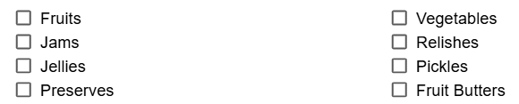


__________________________________________________________________________________________
Exhibitor T-Shirt -Free (select a size to be ordered) Parent (Non-exhibitor) T-shirt $20
Size: Youth_____ Adult______ Size: Youth_____ Adult______

I, ______________________ (exhibitor), certify that I have read and understand all general and division rules.
Parent/guardian ___________________________________________________________ Date:____________
4H Extension Agent, FFA Teacher, FCCLA Advisor:___________________________ Date:____________

