October News from the Children and Youth
What a fun, exciting, and meaningful month we have had during Wednesday Night Live and Sunday school at Westfield! From learning God’s Word and making joyful music to celebrating accomplishments and enjoying fellowship, it has been a month full of faith, friendship, and fun. Earlier in the month the focus during WNL was on Psalm 25:4-5 exploring how God guides us in the right direction. Through fun activities and thoughtful discussion, the children practiced making choices that please God. We also explored Ephesians 6:10-18 and learned about putting on the Armor of God. Our lessons reminded us that even when we face difficult choices, fears, and challenges, God gives us strength and protection. No matter what we encounter, we can trust that He is always with us and will never leave us alone! During SS the children started a study from Galatians 5:22-23, learning about the Fruit of the Spirit and the youth started the book, Experiencing the Heart of Jesus, by Max Lucado. These programs will continue for most of the church year. Music has been another special part of our month! The children sang “I’m in the Lord’s Army” and enjoyed playing the handbells to “How Great Thou Art.” We also had a wonderful accomplishment to celebrate. Congratulations to Nora, Kain, Samuel, and Killian Burt-Anderson for learning The Lord’s Prayer. We wrapped up our wonderful month with Westfield’s Trunk or Treat! A big thank-you to the wonderful members of Westfield who helped host this exciting event and made it such a fun time for our children and families. We look forward to all the amazing things ahead as our children and youth continue growing in their faith together!

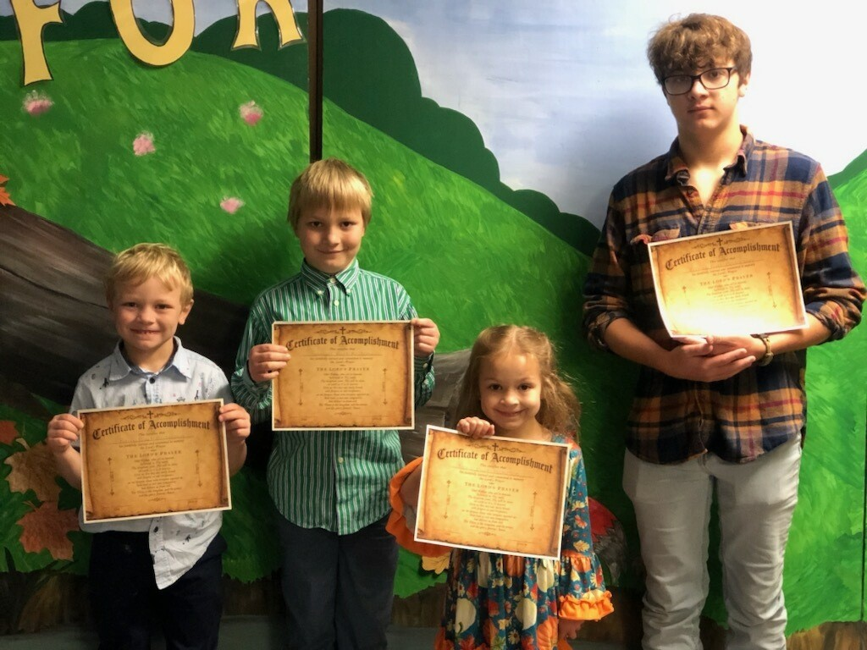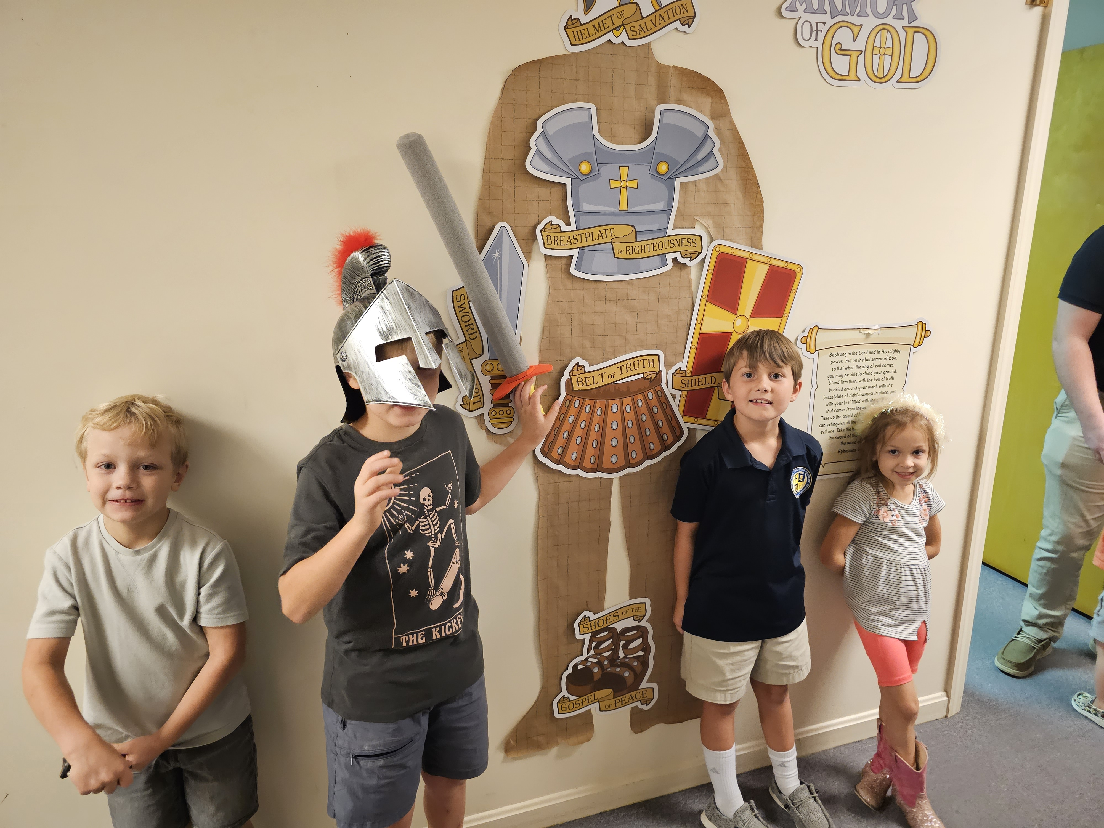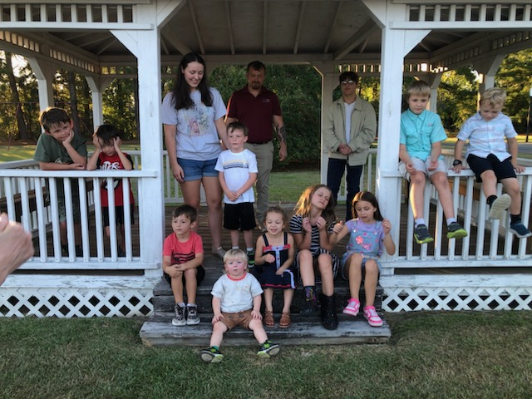
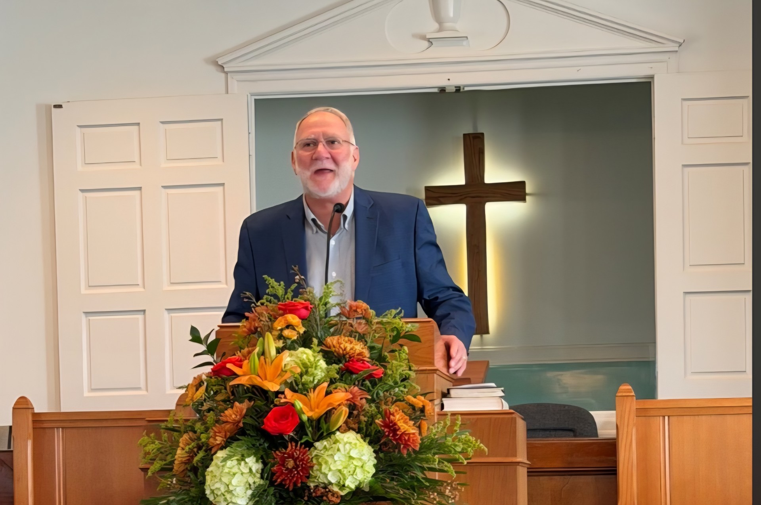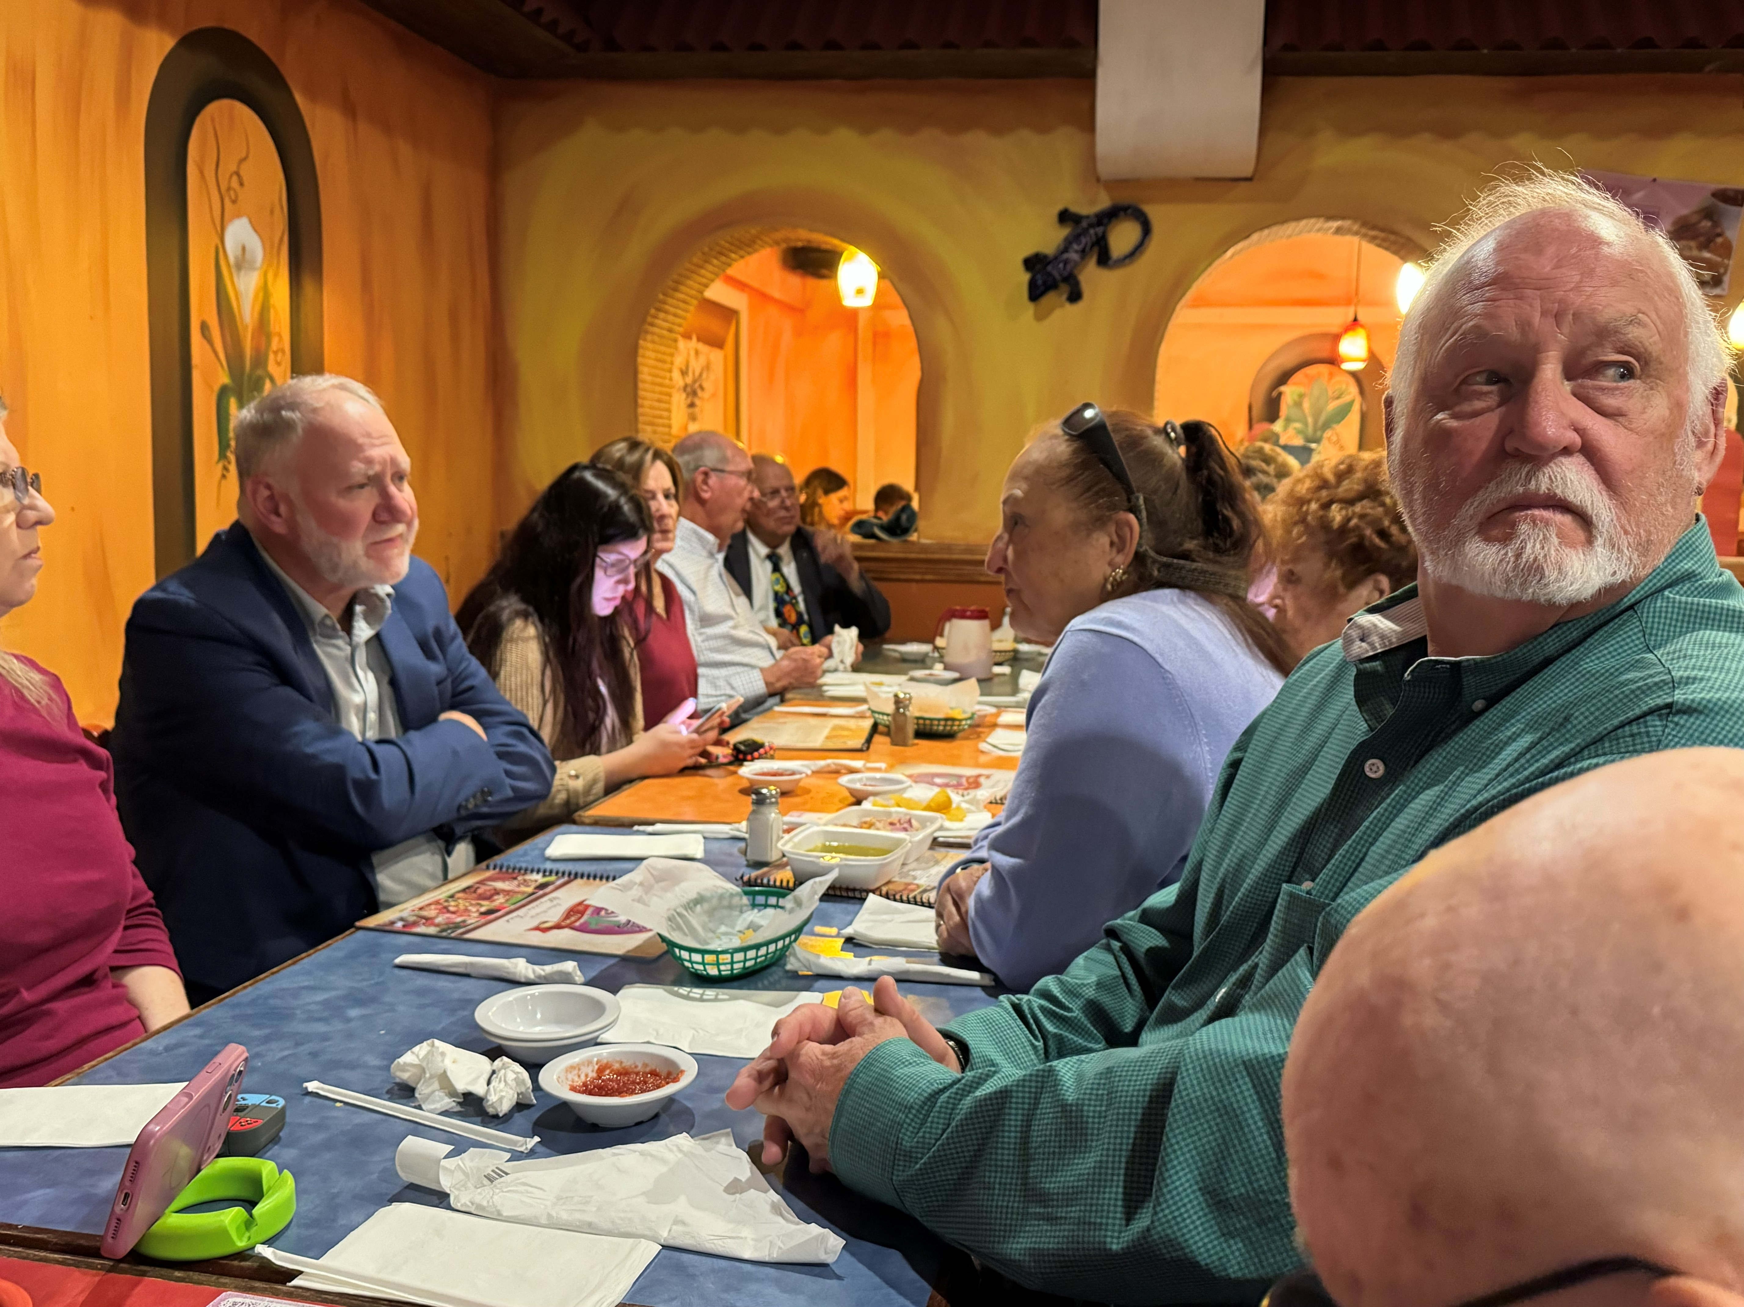

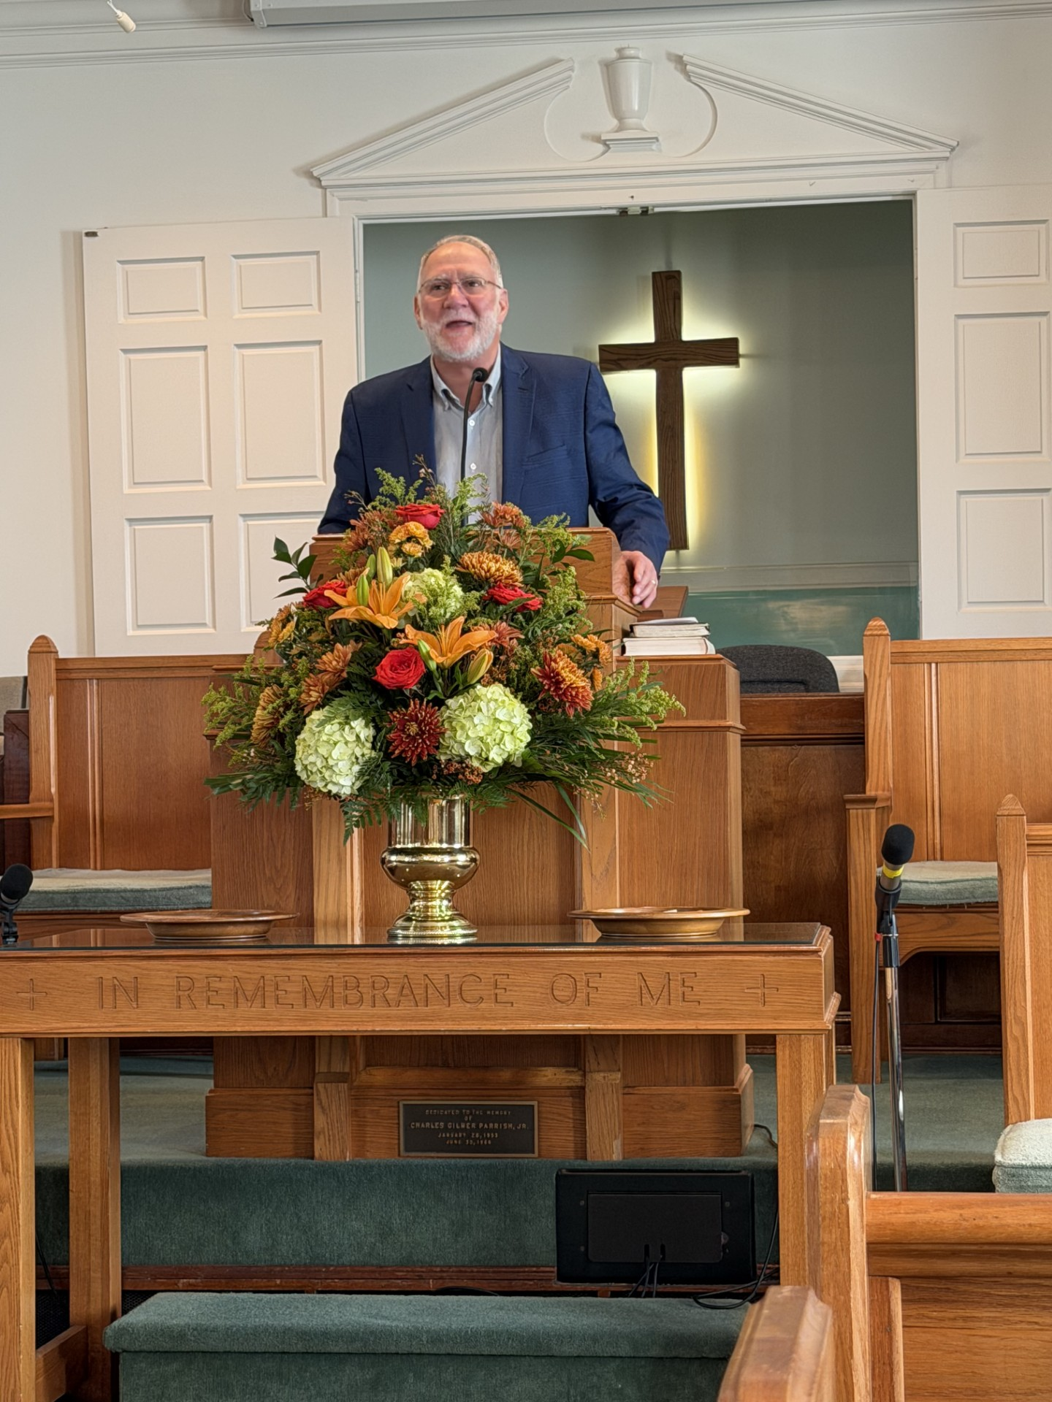

hat a fun, exciting, and meaningful month we have had during Wednesday Night Live
and Sunday school at Westfield! From learning God’s Word and making joyful music to
celebrating accomplishments and enjoying fellowship, it has been a month full of faith,
friendship, and fun. Earlier in the month the focus during WNL was on Psalm 25:4-5 exploring
how God guides us in the right direction. Through fun activities and thoughtful discussion, the
children practiced making choices that please God. We also explored Ephesians 6:10-18 and
learned about putting on the Armor of God. Our lessons reminded us that even when we face
difficult choices, fears, and challenges, God gives us strength and protection. No matter what
we encounter, we can trust that He is always with us and will never leave us alone! During SS
the children started a study from Galatians 5:22-23, learning about the Fruit of the Spirit and
the youth started the book, Experiencing the Heart of Jesus, by Max Lucado. These programs
will continue for most of the church year. Music has been another special part of our month!
The children sang “I’m in the Lord’s Army” and enjoyed playing the handbells to ”How Great
Thou Art.” We also had a wonderful accomplishment to celebrate. Congratulations to Nora,
Kain, Samuel, and Killian Burt-Anderson for learning The Lord’s Prayer. We wrapped up our
wonderful month with Westfield’s Trunk or Treat! A big thank-you to the wonderful members
of Westfield who helped host this exciting event and made it such a fun time for our children
and families. We look forward to all the wonderful things ahead as our children and youth
continue growing in their faith together!

What a fun, exciting, and meaningful month we have had during Wednesday Night Live
and Sunday school at Westfield! From learning God’s Word and making joyful music to
celebrating accomplishments and enjoying fellowship, it has been a month full of faith,
friendship, and fun. Earlier in the month the focus during WNL was on Psalm 25:4-5 exploring
how God guides us in the right direction. Through fun activities and thoughtful discussion, the
children practiced making choices that please God. We also explored Ephesians 6:10-18 and
learned about putting on the Armor of God. Our lessons reminded us that even when we face
difficult choices, fears, and challenges, God gives us strength and protection. No matter what
we encounter, we can trust that He is always with us and will never leave us alone! During SS
the children started a study from Galatians 5:22-23, learning about the Fruit of the Spirit and
the youth started the book, Experiencing the Heart of Jesus, by Max Lucado. These programs
will continue for most of the church year. Music has been another special part of our month!
The children sang “I’m in the Lord’s Army” and enjoyed playing the handbells to ”How Great
Thou Art.” We also had a wonderful accomplishment to celebrate. Congratulations to Nora,
Kain, Samuel, and Killian Burt-Anderson for learning The Lord’s Prayer. We wrapped up our
wonderful month with Westfield’s Trunk or Treat! A big thank-you to the wonderful members
of Westfield who helped host this exciting event and made it such a fun time for our children
and families. We look forward to all the wonderful things ahead as our children and youth
continue growing in their faith together!

What a fun, exciting, and meaningful month we have had during Wednesday Night Live
and Sunday school at Westfield! From learning God’s Word and making joyful music to
celebrating accomplishments and enjoying fellowship, it has been a month full of faith,
friendship, and fun. Earlier in the month the focus during WNL was on Psalm 25:4-5 exploring
how God guides us in the right direction. Through fun activities and thoughtful discussion, the
children practiced making choices that please God. We also explored Ephesians 6:10-18 and
learned about putting on the Armor of God. Our lessons reminded us that even when we face
difficult choices, fears, and challenges, God gives us strength and protection. No matter what
we encounter, we can trust that He is always with us and will never leave us alone! During SS
the children started a study from Galatians 5:22-23, learning about the Fruit of the Spirit and
the youth started the book, Experiencing the Heart of Jesus, by Max Lucado. These programs
will continue for most of the church year. Music has been another special part of our month!
The children sang “I’m in the Lord’s Army” and enjoyed playing the handbells to ”How Great
Thou Art.” We also had a wonderful accomplishment to celebrate. Congratulations to Nora,
Kain, Samuel, and Killian Burt-Anderson for learning The Lord’s Prayer. We wrapped up our
wonderful month with Westfield’s Trunk or Treat! A big thank-you to the wonderful members
of Westfield who helped host this exciting event and made it such a fun time for our children
and families. We look forward to all the wonderful things ahead as our children and youth
continue growing in their faith together!

What a fun, exciting, and meaningful month we have had during Wednesday Night Live
and Sunday school at Westfield! From learning God’s Word and making joyful music to
celebrating accomplishments and enjoying fellowship, it has been a month full of faith,
friendship, and fun. Earlier in the month the focus during WNL was on Psalm 25:4-5 exploring
how God guides us in the right direction. Through fun activities and thoughtful discussion, the
children practiced making choices that please God. We also explored Ephesians 6:10-18 and
learned about putting on the Armor of God. Our lessons reminded us that even when we face
difficult choices, fears, and challenges, God gives us strength and protection. No matter what
we encounter, we can trust that He is always with us and will never leave us alone! During SS
the children started a study from Galatians 5:22-23, learning about the Fruit of the Spirit and
the youth started the book, Experiencing the Heart of Jesus, by Max Lucado. These programs
will continue for most of the church year. Music has been another special part of our month!
The children sang “I’m in the Lord’s Army” and enjoyed playing the handbells to ”How Great
Thou Art.” We also had a wonderful accomplishment to celebrate. Congratulations to Nora,
Kain, Samuel, and Killian Burt-Anderson for learning The Lord’s Prayer. We wrapped up our
wonderful month with Westfield’s Trunk or Treat! A big thank-you to the wonderful members
of Westfield who helped host this exciting event and made it such a fun time for our children
and families. We look forward to all the wonderful things ahead as our children and youth
continue growing in their faith together!

at a fun, exciting, and meaningful month we have had during Wednesday Night Live
and Sunday school at Westfield! From learning God’s Word and making joyful music to
celebrating accomplishments and enjoying fellowship, it has been a month full of faith,
friendship, and fun. Earlier in the month the focus during WNL was on Psalm 25:4-5 exploring
how God guides us in the right direction. Through fun activities and thoughtful discussion, the
children practiced making choices that please God. We also explored Ephesians 6:10-18 and
learned about putting on the Armor of God. Our lessons reminded us that even when we face
difficult choices, fears, and challenges, God gives us strength and protection. No matter what
we encounter, we can trust that He is always with us and will never leave us alone! During SS
the children started a study from Galatians 5:22-23, learning about the Fruit of the Spirit and
the youth started the book, Experiencing the Heart of Jesus, by Max Lucado. These programs
will continue for most of the church year. Music has been another special part of our month!
The children sang “I’m in the Lord’s Army” and enjoyed playing the handbells to ”How Great
Thou Art.” We also had a wonderful accomplishment to celebrate. Congratulations to Nora,
Kain, Samuel, and Killian Burt-Anderson for learning The Lord’s Prayer. We wrapped up our
wonderful month with Westfield’s Trunk or Treat! A big thank-you to the wonderful members
of Westfield who helped host this exciting event and made it such a fun time for our children
and families. We look forward to all the wonderful things ahead as our children and youth
continue growing in their faith together!
hat a fun, exciting, and meaningful month we have had during Wednesday Night Live
and Sunday school at Westfield! From learning God’s Word and making joyful music to
celebrating accomplishments and enjoying fellowship, it has been a month full of faith,
friendship, and fun. Earlier in the month the focus during WNL was on Psalm 25:4-5 exploring
how God guides us in the right direction. Through fun activities and thoughtful discussion, the
children practiced making choices that please God. We also explored Ephesians 6:10-18 and
learned about putting on the Armor of God. Our lessons reminded us that even when we face
difficult choices, fears, and challenges, God gives us strength and protection. No matter what
we encounter, we can trust that He is always with us and will never leave us alone! During SS
the children started a study from Galatians 5:22-23, learning about the Fruit of the Spirit and
the youth started the book, Experiencing the Heart of Jesus, by Max Lucado. These programs
will continue for most of the church year. Music has been another special part of our month!
The children sang “I’m in the Lord’s Army” and enjoyed playing the handbells to ”How Great
Thou Art.” We also had a wonderful accomplishment to celebrate. Congratulations to Nora,
Kain, Samuel, and Killian Burt-Anderson for learning The Lord’s Prayer. We wrapped up our
wonderful month with Westfield’s Trunk or Treat! A big thank-you to the wonderful members
of Westfield who helped host this exciting event and made it such a fun time for our children
and families. We look forward to all the wonderful things ahead as our children and youth
continue growing in their faith together!
What a fun, exciting, and meaningful month we have had during Wednesday Night Live
and Sunday school at Westfield! From learning God’s Word and making joyful music to
celebrating accomplishments and enjoying fellowship, it has been a month full of faith,
friendship, and fun. Earlier in the month the focus during WNL was on Psalm 25:4-5 exploring
how God guides us in the right direction. Through fun activities and thoughtful discussion, the
children practiced making choices that please God. We also explored Ephesians 6:10-18 and
learned about putting on the Armor of God. Our lessons reminded us that even when we face
difficult choices, fears, and challenges, God gives us strength and protection. No matter what
we encounter, we can trust that He is always with us and will never leave us alone! During SS
the children started a study from Galatians 5:22-23, learning about the Fruit of the Spirit and
the youth started the book, Experiencing the Heart of Jesus, by Max Lucado. These programs
will continue for most of the church year. Music has been another special part of our month!
The children sang “I’m in the Lord’s Army” and enjoyed playing the handbells to ”How Great
Thou Art.” We also had a wonderful accomplishment to celebrate. Congratulations to Nora,
Kain, Samuel, and Killian Burt-Anderson for learning The Lord’s Prayer. We wrapped up our
wonderful month with Westfield’s Trunk or Treat! A big thank-you to the wonderful members
of Westfield who helped host this exciting event and made it such a fun time for our children
and families. We look forward to all the wonderful things ahead as our children and youth
continue growing in their faith together!

November Birthdays
& Anniversaries

3 Pam & Charles Wilkes
9 Ron Ader
Jeremy Lin
12 Katie & Charlie Reed
18 Carol Johnson
Mac Reed
19 Tyler & Corinne Carpenter
20 Pam Wilkes
24 Joyce Ballard
Prayer Concerns  Brenda Alberty  Jeanne Autry  Gary Ballard  Barbara Benson  Boone Blackburn  Judy Carrol  Charles Chance  Al Collins  Bill Dail  Wanda Dail  Tom Demmel  Glenda Denning  Trudy Elmore  Justyn Evangelista  Linda Faircloth  Timmie Forsyth  Judy Harrison  Samantha Hess  Scott & Mary Jackson  Elaine Jackson  Steve Jackson  Janet Langley  Katie Mastromonaco  Jennette Morrison  Janet Seymore | Mary Ellen Smith  Vann & Carol Stephens  Cheryl Ann Taylor  Kathy Tripp  Steve Turnage  Trisha Westbrook  Paul Wickham  Extended Prayer Needs  Amanda Alexander Terry Aman  Pearce Baker Hilda Bannerman Sharon Barnhill  Charlie Carpenter  Donald Chance  Warren Davenport  Joe Frischman Steven Glover Michael Harrison  Violet Jackson Tony Simpson Jane Smith Joy Spell Judy Taylor JoAnn Wells

Deacons of the Week

1 Angela Godwin
8 Ronnie Autry
15 Joyce Ballard
22 Manfred Hardee
29 Jimmy Bailey



Happy Pastor Appreciation Day,
Dr. Glenn Jonas
Answers to trivia questions on page 3:
1. True 2. Three 3. Black Friday 4. The fork 5. Mashed potatoes 6. A snood 7. Benjamin Franklin 8. Tan
9. Jingle Bells 10. Abraham Lincoln

S
Home Is Where the Heart Is!
The years go by fast and it’s almost here! “What?” you ask. Why, Westfield’s 62nd Homecoming. It’s on November 1st this year, the same day that Daylight Savings Time ends. It’s difficult to believe that our little church has been a part of this great community so long.
Thanks to the efforts and faith of a few dedicated families, this church began in a field with the purpose of ministering to children on the west side of Dunn, and it has survived. Probably the most difficult time to think about was the Covid pandemic beginning in 2020.
Although it was a crazy time for everyone, we endured and came out even stronger in our dedication and unity. God uses those who make themselves available to Him and His work. Our congregation has continued to lead God’s children to Him. We have a lot to be thankful for!
Dr. Jonas coined a phrase during his service to us that we found quite appropriate — “Westfield is a little church with a big heart.” God asks us to use our gifts in serving Him. That is what we try to do as we worship and as we lift each other up in times of stress. It is also what we do when we minister to the needs of our local area as well as worldwide.
We always want to remember those who came before us to make our pathway easier and to help our light shine brighter. Let us all join together on Sunday, November 1, to recognize the rich history our church has. Let us welcome former members and our wonderful visitors as well. Go ahead and circle that date in red on your calendar. It won’t be the same without YOU!

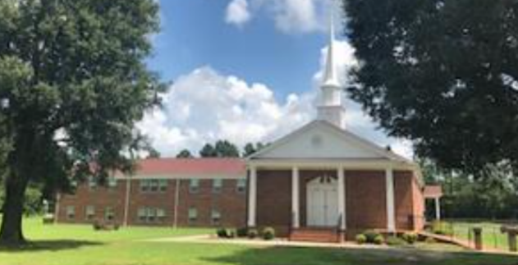
Thanksgiving Trivia Questions

1. Turkey wasn’t on the menu at the first Thanksgiving feast.
True or False.
2. How many women were present at the first Thanksgiving?
3. What is the day after Thanksgiving called?
4. At the first Thanksgiving which utensil was missing?
5. What is the 2nd most consumed food on Thanksgiving?
6. What is the skin that hangs off a turkey’s beak called?
7. Who wanted the turkey to be the national bird?
8. What color are turkey eggs?
9. What Christmas song was originally a Thanksgiving song?
10. Which U.S. President proclaimed Thanksgiving a national holiday in 1863?
Answers on page 3

The Westfield Wire

November 2026 Westfield Baptist Church Vol. 5, No. 11

“Enter his gates with thanksgiving and into his courts
with praise; give thanks to him and praise his name.
For the Lord is good and his love endures forever; his
faithfulness continues through all generations.”
Psalm 100:4-5
WESTFIELD BAPTIST CHURCH
700 N Ashe Avenue
Dunn, NC 28334
Phone: 910-892-2216
Fax: 910-892-4390
Web:www.westfieldbaptistchurch.com
Email: westfieldbaptistdunn@gmail.com
Fb: Westfield Baptist Church, Dunn NC



Greetings,
2 Kings 5 tells us the story of Naaman. Verse 1 describes Naaman’s greatness in a fourfold description: (1) He was the top military leader from Syria; (2) he was the favorite general of the king of Syria; (3) he was honored by the Syrian people for his military heroism; (4) he was a courageous warrior. However, despite Naaman’s greatness, he had a major problem. He was a leper. Leprosy was one of the most dreaded diseases in the ancient world. Naaman was desperate for a miracle. His desperation led him to seek out the prophet Elisha.
This story is another example of a little-known character in the Bible who does great things. Naaman’s healing is set into motion by a little slave girl who told Naaman’s wife about the prophet Elisha. Perhaps you know the story. Naaman almost missed the miracle of his healing because he lacked humility. So, this is a story about the importance of humility. A humble slave girl provided the information for Naaman’s healing, and the miracle occurs when he humbled himself enough to follow Elisha’s instructions and dip himself into the Jordan River seven times.
Our culture right now prizes strength, toughness, and yes, even meanness. Humility is not the fad right now. But humility is a value that is essential to living in the Kingdom of God. Jesus said it this way: “But he that is greatest among you shall be your servant. And whosoever shall exalt himself shall be abased; and he that shall humble himself shall be exalted” (Matthew 23:11–12).
I love you all!
Glenn


Altar Flowers
1 Memorial Committee
8 Ronnie & Jeanne Autry
15 Sylvia Byrd
22 Joyce Ballard
29 Poinsettia
UPCOMING EVENTS

November
1 Homecoming/DST ends
11 Veterans Day
26 Thanksgiving Day

December
5 Secret Pal Lunch
6 Communion
12 Choir Party
13 Cantata
20 Kids Program
24 Christmas Eve
25 Christmas Day
31 New Year’s Eve

SERVICE TIMES
Sunday: 9:15 a.m. Sunday School
10:30 a.m. Worship
Wednesday: 5:30-6:40 p.m. WNL
6:00 p.m. Prayer/Bible Study
6:45 Choir Practice
Westfield Staff
Pastor Dr. Glenn Jonas
Choir Director Trent Carpenter
Deacon Chair Ronnie Autry
Secretary Marian Honeycutt
Organist Joyce Ballard
WMU Director Susan Murray
Sound Technician: Jimmy Bailey

