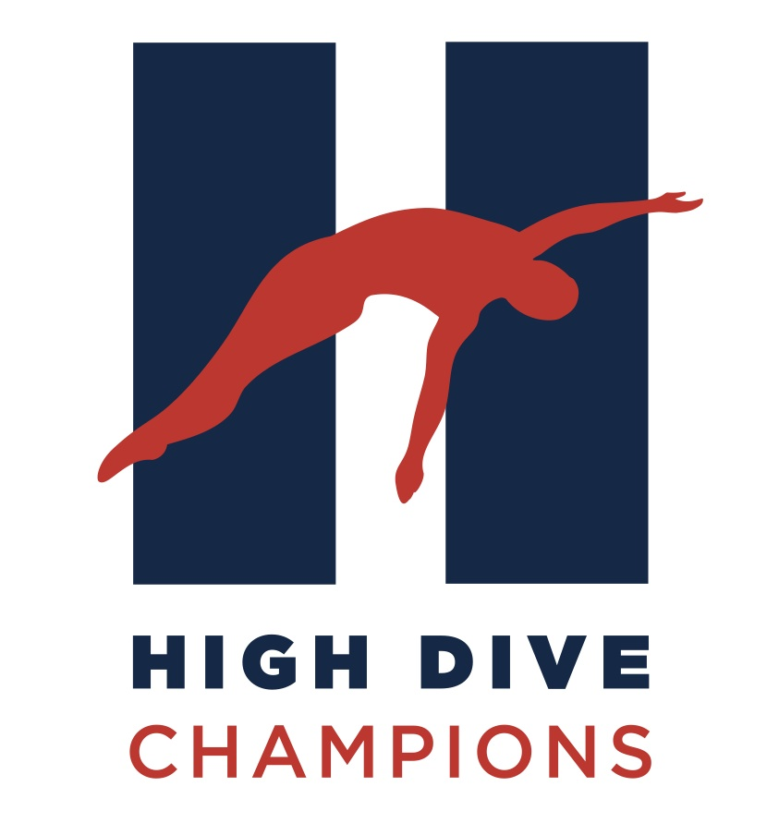

2021-2022 Participation Agreement, Waiver and Release of Liability
Diver Profile:
Please fill out completely and return to Head Diving Coach. Required before any diving participation.

Name of Diver_____________________________________________________________________________

Birthdate (mm/dd/year)__________________________Age_________Age on 12/31/22___________(Fina Age)

Parents Names (Mom) __________________________________(Dad) ________________________________

Mom’s Cell Phone_______________________________ Dad’s Cell Phone_____________________________

Phone (home/work)_________________________________________ ________________________________

E-mail(s)_________________________________ ______________________________________________

Home Address_______________________________________________________________________________
(Street/ city/town/ zip)

In order to participate with High Dive Champions the following agreement, waiver and release of liability must be read, agreed to and signed by each athlete (over 18 years old) and their parent or legal guardian:

- All divers must register with the Amateur Athletic Union (AAU) and U.S. Diving before participating in any activity associated with High Dive Champions. This can be done online at www.aausports.org and http://www.teamusa.org/USA-Diving
- In the unlikely event of injury during practice or competition or any other activity associated with the team, the diver and their parent/guardian agree to permit the coaches to take appropriate action to treat the injured athlete.
- Parent/guardian and divers understand the inherit risks of serious injury involved with participation in a diving program is beyond the control of the coaches and forgoes said risk and accepts personal responsibility for any damages following said injury.
- Parent/guardian and divers understand that at times there will be appropriate hands-on spotting as part of instruction during participation in diving activities.
- All divers and parents agree to follow the instructions given by the coaches and abide by all rules and regulations and standards of conduct during all activities associated with participation in the High Dive Champions program. Team rules, policies and standards of conduct are found on the following pages and at our team website http://www.highdivechampions.com/
- Parent/guardian and divers agree to release and waive liability and all rights to sue High Dive Champions, Michael Darland, Associated Coaches, Purchase College, State University of New York, State of New York, AAU, US Diving, the New Rochelle YMCA, Lewisboro Town Pool and their agents, representatives and successors for damages, injuries, or death as a result of participation in High Dive Champions Diving Team.
- I authorize High Dive Champions to utilize photos and bio information for the diver(s) named above for promotional purposes. Typical usage would include but not be limited to brochure, print and media advertising, social media, website and flyers.

I HAVE READ AND UNDERSTAND AND AGREE TO THE TERMS AS PUT FORTH IN THE ABOVE WAIVER AND RELEASE OF LIABILITY FORM. I HAVE ALSO READ AND UNDERSTAND AND AGREE TO THE TERMS AS PUT FORTH IN THE TEAM RULES, POLICIES & STANDARDS OF CONDUCT.

ATHLETE SIGNATURE (Over 18 years old only) __________________________________ DATE_________________

PARENT/GUARDIAN SIGNATURE___________________________________________DATE_____________________
2021-2022 Team Rules, Policies and Standards of Conduct & A Special Note from Head Coach Mike Darland (914) 522-5440

As a parent and long time coach, I believe a very important decision in your child’s life is “which athletic endeavors to choose”, and just as important, “who to choose as your coaches”. It is my mission to teach diving, and the positive lessons sports can provide, to boys and girls in a safe, fun, and professionally run program. To truly deliver on this for every diver, I have put into place a set of team rules, policies and standards.

Importantly, our team environment focuses on being very positive and encouraging. This is an environment that is best for generating athletic excellence. It is also an environment that is fun and more productive. I need everyone on the team, which includes, coaches, divers and parents to be committed to this end. Thank you parents for your support in this joint venture.
Rules
1. Everyone is to be respectful of one another. (Be Kind!)
*Please respect others personal space, no touching others. *Definitely, no hitting.
*No throwing any items on the pool deck. *No snapping of towels, or Sami’s.
*No inappropriate or salty language. *No bullying, treat everyone as your friend!

2. If you have a problem or see another person having a problem, tell a coach.
Coaches will help you. Coaches are there to make practices productive and fun.

3. Divers need to follow a coach’s direction before starting any practice activity. A diver should never be doing an activity alone, like jumping on a trampoline or doing a dive.

4. Divers need to ask a coaches permission to leave the practice area for any reason during a scheduled practice. This includes visiting a parent in the stands, visiting the restroom, getting a snack or refreshment or making a phone call. Coaches don’t want to “lose track” of any diver.

5. If a diver needs to leave practice early, please notify the head coach before the practice starts. In this way the coach can adjust the activities based on the time available.

6. Divers are expected to be in line for diving boards before their turn.
If there is more than one diver waiting for their turn, divers can keep warm in the hot shows under the diving boards. There should always be a diver “ready to go” on the diving board. Dive in order so no one loses a turn. On a second balk, the diver is to do a line up in order to keep a practice moving.

5. Divers are expected to discuss their dives, if necessary, before climbing on to the diving board. This allows everyone to dive in a timely and productive manner. Please wait for a coach’s cue before you dive.

6. Divers are to get on to the diving board by using the ladder and must use caution at all times. When using the 3-meter board, use both hands when climbing up the ladder. No playing, talking or distracting behavior when a diver is climbing a ladder or on the board. Serious injury can occur if a diver falls.

7. Divers are to surface immediately after a dive and look to the coach for their coaching tip.

8. Divers are to swim back under the side of their diving board and to get out of the water immediately, to stay clear of other divers.

9.Divers should address their coach as “Coach” and by the first name of the coach.

Parent & Additional Team Rules and Policies
- Practices are open to parents if allowed by Purchase College (Post Covid restrictions.) I think it is a wonderful thing to watch your child advance in their athletic endeavor. Parents, please do not “Coach or Direct” your son or daughter during the practice.
All divers are expected to be able to practice on their own with the Coaches supervision only.

- Parents are asked not to interrupt practices, except for emergencies. Interruptions are distracting for the divers and the coaches and are a safety concern. If there is an emergency situation, please bring that to the coaches’ attention immediately.

- Parents must watch from the viewing balcony.
Parents are not allowed on the pool deck except to enter or exit the pool area. This is a Purchase College rule.

4. Please have divers to practice on time. Please make sure there is a coach at practice before you leave. If a practice has been cancelled, we do not want your child to be stranded.

5. Please pick up your child on time. Parents or caregivers are responsible for their child at the end of all scheduled practices.

6. While a member of High Dive Champions, divers are not to dive with another team unless approved by Coach Darland. Exceptions are made with summer country club teams, High School teams, approved synchronized practices and approved summer camps.

7. Practice times and an overall schedule can be found on the team website.
Coach Mike Darland will post the practice schedule based on registration and the overall team composition.

8. Divers will be placed in a talent and age appropriate class by Coach Darland. Advanced divers may practice during an Intermediate practice with Coach Darland’s approval.

9. Coaches are available to parents by phone or by appointment.
Coaches will need to prepare and breakdown training tools immediately before and after practice The coaching staff likes to talk to parents, however, please provide them the ability to greet and transition divers without interruption. Coach Darland will be available to speak with parents before & after practice. If more time is needed than a brief conversation, an appointment can be made for a longer meeting or conversation. Feel free to call or text Coach Darland anytime outside of practice hours. Coach Darland 914 522-5440

10. No Food or Glass containers are permitted in the pool area. (Purchase College pool rule)

Team suits and gear will be made available after the start of the season.
Items will be made available for sale through our website www.highdivechampions.com.

Bad weather rarely closes the pool, however, there are some situations like severe winter storms, which may close the pool. Please call Coach Mike Darland if you think there may be a pool closure. Thunderstorms at Purchase College require the pool to be cleared for 30 minutes without another sound of thunder. In this event, the diving for a class may be limited, however, we may be allowed to train in a dryland area or on the trampoline.

Fees - In order to receive the on-time savings rate a check payable to "High Dive Champions" must be received by Coach Mike Darland one week prior to the first class of every new session or the date indicated on our website. All Fees and costs can be found on at www.highdivechampions.com

Make Up Classes - If you miss a class or you anticipate missing a class, please arrange a make up class within the 7-week session. Make up classes cannot be carried forward to a future session. To arrange a make up class, you can simply leave Coach Mike Darland a message when you will be coming at 914 522-5440. Coach Mike Darland will call you back if an alternate plan is necessary.

No Refunds – Staffing and coaches schedules are based on registration for a session. After a session has started no refunds will be made. In the event of injury or unforeseen situations, Head Coach Mike Darland may elect to provide a credit to a future session.

Additional Parent/Care Giver Instructions, Tips and FAQ’s are provided on our website, www.highdivechampions.com

