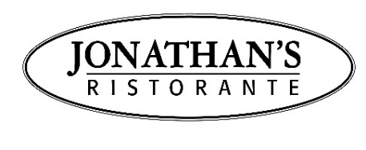

DINE HUNTINGTON 2025 – PRIX FIXE MENU
OCTOBER 12TH – 19TH | 3-COURSE PRIX FIXE: $46

ANTIPASTI

Insalata Tardiva
fennel, celery root, radicchio, walnuts, pomegranate & sweet gorgonzola

Fritto di Carciofini
sautéed baby artichokes & basil pesto

Lasagna
meat sauce, bechamel, creamed spinach & parmigiano

Arancini
mushroom mini rice balls with truffle aioli

Tuna Tartare *
raw yellow fin tuna, avocado salad, cucumber & wasabi aioli $6 supplement

SECONDI

Linguine Vongole
manilla clams, pancetta & grape tomatoes

Ravioli di Zucca
pumpkin ravioli, butter sage sauce, amaretti dust & shaved parmigiano

Branzino alla Piastra
borlotti bean salad & pepecrusco sauce

Pollo
half bell & evans roasted chicken with peperonata & torta di polenta

Risotto
tiger shrimp, grape tomato & zucchini

8 oz. Filet Mignon *
potato/leek au gratin & gorgonzola cream sauce $14 supplement

DOLCI

Homemade Tiramisu with Chocolate Shavings

Homemade Panna Cotta

Flourless Chocolate Cake with Coffee Gelato

No Substitutions | Menu Subject to Change
Saturday Night Last Seating at 6:30pm and Order Must be in by 7pm Latest

