**North Pocono Dairy**

1521 Madisonville Rd

Moscow PA 18444

DATE:___________

Email: [Info@NorthPoconoDairy.com](mailto:Info@NorthPoconoDairy.com)

Ph: 570-351-6162

[WWW.NorthPoconoDairy.com](http://WWW.NorthPoconoDairy.com)

RAW Milk

* One gallon whole (plastic) ____ qty. X $5.50
* Half gallon whole (plastic) ____ qty. X $3.25
* Quart whole (plastic) ____ qty. X $2.00
* Half skim (plastic) ____ qty. X $3.25
* Half gallon whole (GLASS) ____ qty. X $6.50 or 2.50 With Return
* Quart whole (GLASS) ____ qty. X $4.25 or 1.75 With Return
* Pint whole (GLASS) ____ qty. X $4.00 or 1.00 With Return
* Half gallon skim (GLASS) ____ qty. X $6.50 or 2.50 With Return

Pasteurized Milk

Customer Information

NAME:_________________________

Address:________________________

________________________

Phone No. ( ) _____-__________

EMAIL: ________________________

***Message to Dairy:*** _______________________________________________________________________________________________________________________________________________________________________________________________________________________________________________________________________________________

Thank YOU for your Support

* One gallon whole (plastic) ____ qty. X $5.00
* One gallon 2% (plastic) ____ qty. X $5.00
* Half gallon whole (plastic) ____ qty. X $3.25
* Half gallon 2% (plastic) ____ qty. X $3.25
* Quart whole (plastic) ____ qty. X $2.25
* Half gallon skim (plastic) ____ qty. X $3.25
* Half gallon whole (GLASS) ____ qty. X $6.25 or 2.00 With Return
* Quart whole (GLASS) ____ qty. X $2.25 or 2.00 With Return
* Pint whole (GLASS) ____ qty. X $2.25 or 2.00 With Return
* Half gallon skim (GLASS) ____ qty. X $6.25 or 2.00 With Return

Other Milk

* Buttermilk half gallon (plastic) ____ qty. X $3.25
* Heavy Cream quart (plastic) ____ qty. X $2.25
* ½ and ½ quart (plastic) ____ qty. X $2.25

Yogurt (Bulgarian Style)

* 8oz Plain ____ qty. X $1.50
* 8oz Strawberry ____ qty. X $1.65
* 8oz Mountain Blueberry ____ qty. X $1.65
* 8oz Peach ____ qty. X $1.65

Butter

* 8oz Unsalted ____ qty. X $4.00
* 8oz Pink Himalayan Sea Salt ____ qty. X $4.25
* 8oz Garlic ____ qty. X $4.50
* 8oz Tuscan Herb ____ qty. X $4.50
* 8oz Cinnamon Honey ____ qty. X $4.75

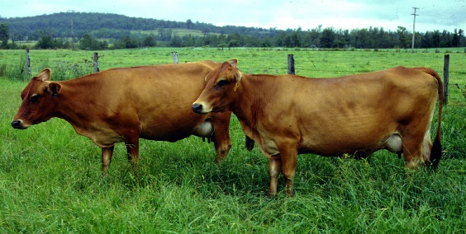

OTHER

* Doz. Fresh Brown Eggs _____ qty. X $3.50
* Hand Crafted Cow Milk Soap _____ qty. X $3.50
  + - Lavender_____ qty. / Watermelon _____ qty. / Rose_____ qty.
* Hand Crafted Cow Milk Scented Candles _____ qty. X $3.50

_____ qty. / _____ qty. / _____ qty.

Bringing a fresh twist to an old idea