RAW Milk

One gallon whole (plastic) ………………… $5.50

Half gallon whole (plastic) …………….…… $3.25

Half gallon Chocolate (plastic) …………… $3.95

Quart whole (plastic) ………………………… $2.00

Quart Chocolate (plastic) ………………..… $2.70

Half skim (plastic) ………….………………..… $3.25

Half gallon whole (GLASS) ……………..… $ 6.50 or $2.50 With Return

Half gallon Chocolate (GLASS) ……………$ 7.20 or $3.20 With Return

Quart whole (GLASS) ……………………..… $4.25 or $1.75 With Return

Pint whole (GLASS) ………………………..… $4.00 or $1.00 With Return

Half gallon skim (GLASS) ………………..… $6.50 or $2.50 With Return

**Pasteurized Milk (HTST)**

o One gallon whole (plastic) ……………………….$5.50

o Half gallon whole (plastic) ……………………….$3.25

o Quart whole (plastic) ……………………….$2.25

o Quart Chocolate (plastic) ……………………….$ 2.95

o Half gallon skim (plastic) ……………………….$3.25

o Half gallon Chocolate Milk (plastic) ………….$3.75

o Half gallon whole (GLASS) ……………………….$6.25 or $2.00 With Return

o Quart whole (GLASS) ……………………….$2.25 or $2.00 With Return

o Pint whole (GLASS) ………………………………..$2.25 or $2.00 With Return

o Half gallon skim (GLASS) ……………………….$6.25 or $2.00 With Return

**Other Milk /Cream**

o Buttermilk quart (plastic) ……………... $3.25

o Heavy Cream quart (plastic) ………... $4.25

o ½ and ½ quart (plastic) ………………... $2.25

t

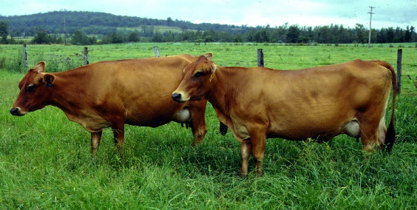

OTHER

o Doz. Fresh Brown Eggs ………………… $3.50

o Hand Crafted Cow Milk Soap ……….. $6.00

▪ Lavender Watermelon Rose

o Hand Crafted Cow Milk Scented Candles …… $5.50

**Yogurt (Bavarian Style)**

o 8oz Plain …………………………… $1.50

o 8oz Strawberry ………………… $1.65

o 8oz Mountain Blueberry …… $1.65

o 8oz Peach ………………………… $1.65

**Butter**

o 8oz Unsalted ………………………….. $4.00

o 8oz Pink Himalayan Sea Salt …. $4.25

o 8oz Garlic ………………………………. $4.50

o 8oz Tuscan Herb …………………….. $4.50

o 8oz Cinnamon Honey …………….. $4.75