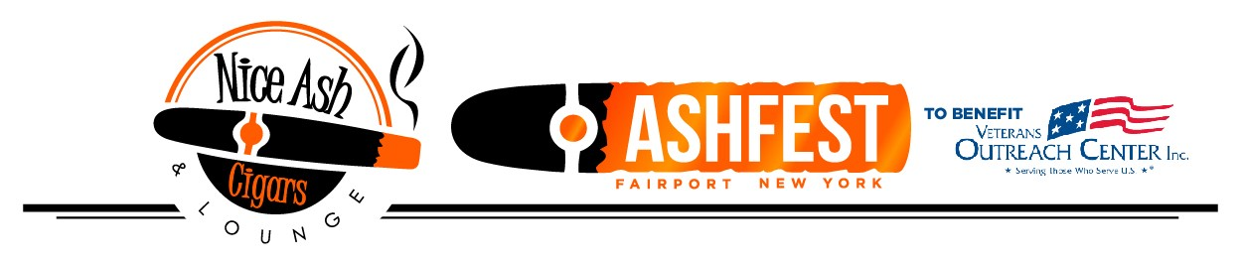

SPONSORSHIP LEVELS:

GOLD SPONSOR (VIP Lounge Sponsor) - $1000 (Only 2 Available)
Includes:
- 4 VIP Tickets ($796 value)
- VIP Lounge Sponsorship with Banner displayed in lounge
- Logo displayed on sponsorship banners at festival
- Logo Printed on Cigar Redemption Card Every Attendee Receives
- Reserved table
- Gold Sponsorship recognition w/Logo on AshFest website
- Gold Sponsorship recognition & exposure on social media and mass email promotions

SILVER SPONSOR (Vendor Tent Sponsor) - $750 (Only 6 Available)
Includes:
- 3 VIP Tickets ($597 value)
- Vendor Tent Sponsorship with Banner displayed at Entrance to Tent
- Logo displayed on sponsorship banners at festival
- Reserved table
- Silver Sponsorship recognition w/logo on AshFest website
- Silver Sponsorship recognition & exposure on social media and mass email promotions

BRONZE SPONSOR - $500 (Only 10 Available)
Includes:
- 2 VIP Tickets ($398 value)
- Reserved table
- Bronze Sponsorship recognition w/logo on AshFest website
- Bronze Sponsorship recognition & exposure on social media and mass email promotions

Interested in unique sponsorship opportunities?
Give us a call to discuss! 585-364-3773

SPONSORSHIP FORM

Company Name: ______________________________________________________________

Contact: ______________________________________________________________

Phone: ______________________________________________________________

Address: ______________________________________________________________

Date: ______________________________________________________________

email: ______________________________________________________________

___ GOLD SPONSOR - $1000

___ SILVER SPONSOR - $750
___ BRONZE SPONSOR - $500

For best placement and to be sure your name or ad is included in all possible promotional pieces, please return this form promptly.
CONTACT: sponsor representative David Kleehamer at 585-364-3773 or dave@niceashcigars.com
Please make checks payable to:
Nice Ash Cigars
36 Jefferson Ave.
Fairport, NY 14450

Ad/logo submission and formatting:
Please provide email in vector format (PDF or Ai files) for highest quality print results.
Thank you for your support!

