MONDAY | TUESDAY | WEDNESDAY | THURSDAY | FRIDAY
SUBSTITUTES:  May 1-8: Chicken Patty  May 11-22: Popcorn Chicken  Peanut Butter Sandwich |  |  |  | 1  CHEESEBURGER ON A BUN  French Fries  Fresh Fruit  Milk
4  SHREDDED CHICKEN ON BUN  Corn  Pears  Milk | 5  PEPPERONI PIZZA  Green Beans  Applesauce  Milk | 6  SALISBURY STEAK  Mashed Potatoes  Dinner Roll  Fresh Fruit  Milk | 7  TACO MEAT, CHEESE & CHIPS  Romaine Salad  Fruit  Milk | 8  MACARONI & CHEESE  Green Beans  Muffin  Milk
11  SAUSAGE PATTY  French Toast Sticks  Hash Brown  Juice  Milk | 12  SLOPPY JOE ON A BUN  French Fries  Peaches  Milk | 13  BBQ BEEF ON A BUN  Baked Beans  Fruit  Milk | 14  CHICKEN PATTY ON A BUN  Carrots  Pears  Milk | 15  CORN DOG  Baked Beans  Fresh Fruit  Milk
18  CHEESEBURGER ON A BUN  French Fries  Apples  Milk | 19  PIGS IN A BLANKET  Baked Beans  Applesauce  Milk | 20  CHICKEN NUGGETS  Tater Tots  Fresh Fruit  Milk | 21  CHEESE PIZZA  Carrots  Pineapple  Milk | 22  PACKED LUNCH  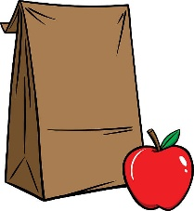  LAST DAY OF SCHOOL
25  MEMORIAL DAY | 26   | 27 | 28 | 29  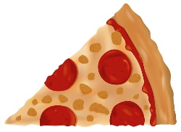
Happy Summer! See you on Wednesday, August 19th!
School Activities Calendar on Reverse Side
St. Mary’s School May 2026 Lunch Menu

