5100
Ser 7/
Eternity
MEMORANDUM

From: The Word (John 1:1)
To: Bible Students

Subj: ETERNAL SAFETY RAC (THE 5 LEVELS OF BIBLICAL DOCTRINE AND
THEIR RELATIVE IMPORTANCE – LESSON 5)

Ref: (a) The Holy Scriptures

Encl: (1) Risk Assessment Code (RAC) Explanation
(2) The 5 Levels of Biblical Doctrine Loss Matrix

1. Per reference (a), enclosures (1) and (2) are attached for your review, consideration and pursuit.

2. The RAC assignment is based upon a truly saved Christian who is fairly well grounded in the Holy Scriptures from discipleship and personal study. The doctrines assigned to each RAC may very some, depending on the people or studies that have influenced your present belief system. To be single-minded, have convictions, and discern the consequences of our convictions, opinions and ideas is a vital factor of our Christian faith and growth.

3. The Loss that may occur at the Judgement Seat of God can be prevented. We must all stand one day before our Creator. To prepare for this day I present the doctrines of the Bible in a RAC format that will help you understand and discern what is important and thus prioritize your time and efforts, as I trust you desire a full reward and abundant entry into the Kingdom of Heaven. A brief explanation of the RAC system follows:

a. RAC 1, 2 and 3 losses need written deficiency notices and must be posted in your mind until the knowledge is secure or the weakness made strong.

b. RAC 4 and 5 losses are low severity and don't need a written deficiency notice or posting.

4. Point of contact for this assessment and more instruction is Mr W. Heath at 241-2816 or romans6@nhyoko.med.navy.mil

By direction,
WILLIAM HEATH
Risk Assessment Code (RAC) Explanation

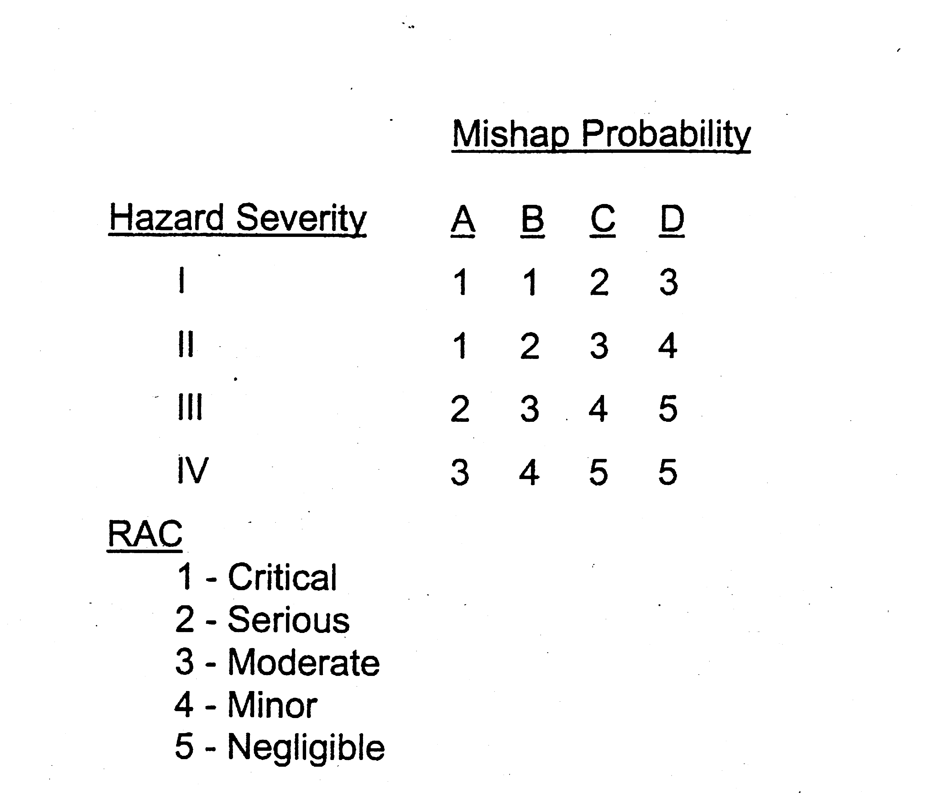Loss Assessment Matrix
Potential losses can be identified through self inspections and judgement, comparing ourselves to the commandments of the Bible and Jesus Christ, or with Godly mature Christians who we know personally.
a. Risk Assessment We shall assign assess the risks ourselves, with the help of the saints, the Holy Spirit and the Bible. Not necessarily in that order. You shall assign a Risk Assessment Code (RAC) to each doctrine of the faith.. The RAC represents the degree of risk associated with the hazard and combines the elements of hazard severity and mishap probability, taking into account temporary or eternal health effects from the hazard.
(1 ) Loss Severity. The hazard severity is an assessment of the worst reasonably expected consequence of disobedience to the Word of God, and is defined by degree of loss which is likely to occur as a result of a hazard. Christians shall assign hazard severity categories by Roman numeral according to the following criteria:
(a) Category I - Catastrophic: Will cause eternal death to the unbeliever.
(b) Category II - Critical: Will cause eternal loss of reward to the believer.
(c) Category III - Marginal: May cause eternal loss of reward to the believer.
(d) Category IV - Negligible: Probably would not affect our loss of reward, but nevertheless is a Biblical doctrine or Godly opinion
(2) Loss Probability. The mishap probability is the probability that a hazard will result in a loss. Christians shall assign a letter to mishap probability according to the following criteria:
(a} Subcategory A -Likely to occur immediately
(b) Subcategory B -Probably will occur in time
(c) Subcategory C -Possible to occur in time
(d) Subcategory D -Unlikely to occur.
NOTE: IN THE BIG PICTURE, LOSS SEVERITY IS MUCH MORE IMPORTANT TO FACTOR IN THEN LOSS PROBABILITY, IN THE SPIRITUAL SENSE OF THIS MATRIX. HOWEVER IN THE SMALL PICTURE OR PERSONAL APPLICATION, LOSS SEVERITY IS IMPORTANT, DEPENDING ON YOUR PERSONAL SIN AND AREAS OF WEAKNESSES.
Enclosure (1)

THE 5 LEVELS OF BIBLICAL DOCTRINE – PERSONAL ETERNAL LOSS MATRIX
RAC | THOUGHTS | LOSS SERVERITY | CONSEQUENCES | DOCTRINES
1 | CONVICTIONS | MAJOR,  PERMANENT,  TOTAL | ETERNAL DEATH  FOR THE UNBELIEVER  (Strong reason for division) | GOD is One and Holy, Bible is the only Book from God  JESUS is God's Son - He never sinned, Born of a Virgin  All Men are Sinners, Disobey the Law and need Repentance
2 | CONVICTIONS | MAJOR,  PERMANENT,  PARTIAL | ETERNAL Loss of REWARD  FOR THE BELIEVER  (Moderate reason for division) | LOVE ONE ANOTHER, Discipleship, Bible Study  Personal Holiness, Witnessing, Prayer, Suffering, Forgiving  Death and Resurrection of the Old Man, Flesh or Holy Spirit
3 | CONVICTIONS | MODERATE,  TEMPORARY,  PARTIAL | POSSIBLE LOSS FOR THE BELIEVER  (No reason for division) (The Whole Counsel of God) | Eternal Security, Pre-Destination or Freewill, Eschatology,  Bible Families of Manuscripts, Form of Believer's Baptism  Baptism and Gifts of the Holy Spirit, Finances, Family
4 | GODLY OPINIONS | MINOR,  TEMPORARY,  NEGLIGABLE | LITTLE LOSS FOR THE BELIEVER  (No reason for division) | 1 Corinthians 7 - about marriage, personal preferences  Traditions, Ceremonies and Philosophies, Music  Church Government (Polity). Outward Person
5 | IDEAS | TEMPORARY  NEGLIGABLE | NO LOSS FOR THE BELIEVER  (No reason for division) | Baptism in the name of Jesus, Worship of things on earth,  Cultic doctrines or practices, Tongues the sign of Baptism of H.S.  Unjust Balance in doctrine and practice
Conclusion: (1) Romans 14 "As a man thinks, so is he.” Thoughts move us to words and deeds 1 John 2:18 Daniel 12:3 states that knowledge shall be increased. With more knowledge is more business and more revelation – more responsibility, and privledge. (2) Unlearned and foolish questions avoid. Knowing they do gender strife. Enclosure (2)

