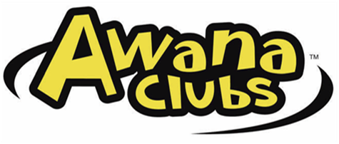 Fellowship Church/SMCA
9805 Faith Baptist Church Road
White Plains, Maryland 20695
(301) 870-2550

What does Awana mean?
Approved Workmen Are Not Ashamed - 2 Timothy 2:15

What is Awana and what is its mission?
The mission of Awana Clubs is to reach boys and girls with the gospel of Christ and train them to serve Him.

What goes on at Awana?
While Awana has many things to interest boys and girls, such as games and special activities, the heart of the program is the Bible memory work.

What does it cost?
The cost for the 2019-2020 Awana session is $50 per child, with a family maximum of $100. Payment will be due at the first meeting. Checks payable to Fellowship Church.

What time does Awana meet?
Awana clubs will meet on Wednesday evenings from 6:00 pm – 7:30 pm throughout the school year.

Who can come?
All boys and girls age 3 (potty-trained and age 3 as of September 1st) through grade 6.

How do I register my child?
Parent Registration Night, Wednesday, September 18, 2019, 6-7pm in the Chapel.

Where do we meet?
Awana club will begin meeting in SMCA’s Chapel, where the Opening Assembly will be held. Clubbers will then break up with their groups in selected classrooms.

What does my child need to bring each week?
Clubbers are awarded when they bring their Awana Handbooks, Bible, friends, and wear their Awana uniform each week.

Begins Wednesday, September 18, 2019
2019-2020 REGISTRATION FORM
Clubber’s Name _____________________________________________ Grade __________
Circle one: Cubbies (3-4 yrs) potty-trained Sparks (K5-2nd) T&T (3rd –5th)
TREK (6th-8th) JOURNEY (9th-12th)
Birthdate: __________________________________ Gender: M F
Health Problems/Allergies: ____________________________________________________
Address: _____________________________________________________________________
Street City Zip
Parent’s Name: _______________________________________________________________
Mom’s Hm. Ph: _____________________________Cell: _____________________________
Dad’s Hm. Ph: ______________________________Cell: _____________________________
Email: _______________________________________________________________________
Alternate people who may pick your child up from Awana: ______________________________________________________________________________
* Siblings in this Awana: ______________________________________________________
* Was your child in Awana last year? Yes No
* Can your child read? Yes No

I now give permission for my above named child to attend and participate in this Awana Club and any special activities and events planned by this Awana Club. I do now authorize emergency treatment and/or transportation be given if necessary. Reasonable effort will be made to reach me, the parent (s)/ guardian, once treatment and/or emergency transportation has occurred. I, the undersigned, also agree to release and hold harmless the AWANA leadership, Fellowship Church/SMCA Ministries and AWANA Clubs International from any and all liabilities or claims for personal injury which may be incurred by my child while attending and participating in the AWANA Club and its activities and special events. AWANA Fellowship Church will be using pictures of AWANA Clubbers for celebratory and promotional purposes unless a parent provides a written and signed letter restricting this.

Parent Signature:___________________________________________Date:_____________

For Awana Secretary Use Only Cash or Check # _________________________

Registration Fee: $50 $100 Date Paid: ______________________________

