**2 Samuel 20:14-22 (KJV) A Wise Woman Speaks Scripture to Save a City**

**Narrator:**  And Joab went through all the tribes of Israel unto Abel, and to Beth-maachah, and all the Berites: and they were gathered together, and went also after him. And they came and besieged Sheba in Abel of Beth-maachah, and they cast up a bank against the city, and it stood in the trench: and all the people that [*were*] with Joab battered the wall, to throw it down.

**Then cried a wise woman out of the city, (top of wall to the field where general Joab is directing his army)**

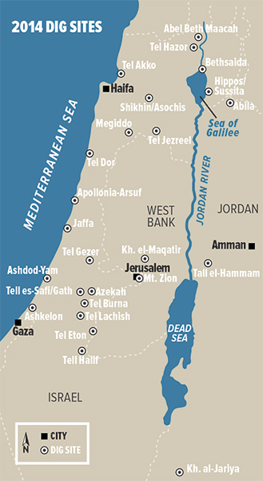**(1) Wise Woman:** Hear, hear; say, I pray you, Come near hither, that I may speak with thee.

**Joab comes near unto her (at the bottom of the wall of the city)**

**(2a) Wise Woman:** [*Art*] thou Joab?

Narrator: And he answered

**(2b) Joab:** I [*am he*].

Narrator: Then she said unto him,

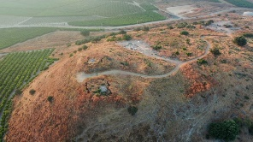**(3a) Wise Woman:** Hear the words of thine handmaid.

Narrator: And he answered,

**(3b) Joab:** I do hear.

Narrator: Then she spake, saying,

**(4a) Wise Woman:** They were wont to speak in old time, saying, They shall surely ask [*counsel*] at Abel: and so they ended [*the matter*]. I [*am one of them that are*] peaceable [*and*] faithful in Israel: thou seekest to destroy a city and a mother in Israel: why wilt thou swallow up the inheritance of the LORD?

Narrator:And Joab answered and said,

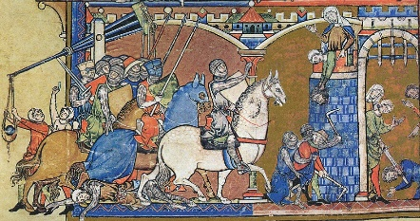**(4b) Joab:** Far be it, far be it from me, that I should swallow up or destroy. The matter [*is*] not so: but a man of mount Ephraim, Sheba the son of Bichri by name, hath lifted up his hand against the king, [*even*] against David: deliver him only, and I will depart from the city.

Narrator: And the woman said unto Joab,

**(5) Wise Woman:** Behold, his head shall be thrown to thee over the wall.

**Narrator:** Then the woman went unto all the people in her wisdom. And they cut off the head of Sheba the son of Bichri, and cast [*it*] out to Joab. And he blew a trumpet, and they retired from the city, every man to his tent. And Joab returned to Jerusalem unto the king.

**Lessons learned - for then and now.** She searched and knew the Holy Scriptures for wisdom. What saith the LORD?Deu. 20:10-12 (Laws of warfare 20:1-20). 1 Sa. 23: 2 & 30: 8 (King David inquires for battle).

1 Sam 1 (Hannah pleads) & 16: 23 (David soothes Saul). The wise woman (Proverbs 31 & 1 Peter 3) stands up for her city with what is written, for her husband with what is written, children, self, church, and community).