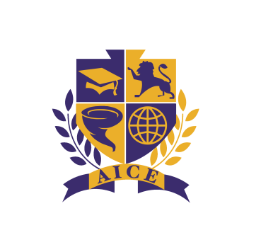
BHS Cambridge AICE Entrance Agreement

Congratulations on being accepted into the Booker High School Cambridge AICE program!
You should be proud of this accomplishment. Our AICE Committee looks at each application individually to determine if the applicant meets the requirements needed to gain entrance into the program. Our goal is to prepare you to not only be successful in high school but to be prepared for your education beyond your four years at Booker High School. We are committed to giving you a high quality, comprehensive, and rigorous academic education in an environment conducive to helping you realize your potential.

AICE faculty approach student success as a team effort: it begins with the faculty, who have been trained in AICE methods and curriculum, and the students, who have demonstrated great academic histories and promise. However, parents/guardians are also expected to take an active role in the success of their students.

Before starting at Booker High School.
We strongly recommend that students take the online HOPE (Health Opportunities in Physical Education) course that is offered through Sarasota Virtual School during the summer before their freshman year. This will meet two of your graduation requirements – completing an online course and the HOPE graduation requirement – before students start at BHS.

There are also summer assignments for incoming freshmen that are expected to be completed before entering your freshmen year. Your teachers will begin instruction with the expectation that these assignments have been completed. The assignments will be posted on our BHS AICE website.

In order to remain a member of the BHS Cambridge AICE program, every student must adhere to the following:
- Maintain a minimum GPA of 2.5 per quarter in his/her AICE courses with no D or F grades.
- Maintain an unweighted overall combined GPA of 2.5 per quarter, to include non-AICE courses.
- Demonstrate appropriate behavior and involvement in the classroom.
- Abide by all requirements of each AICE syllabus.
- Maintain attendance records that allow for students to be academically successful.
- Agree to participate in AICE sponsored, after school programs and activities (mock exams, etc.)
- Plagiarism or any other form of cheating may lead to removal from the AICE program
- Be present for every Cambridge AICE paper (test) at the end of each year for all classes the student is enrolled in.
- If a student does not sit for a course exam, they will be charged $100.00 for the test that was ordered for each course.

There will be a re-evaluation of BHS Cambridge AICE students after six weeks. If at that time a student is not meeting any of the above requirements, the student may be removed from the program. Student’s progress will also be continuously monitored throughout the year, thereafter.

Other opportunities for a successful experience.
We strongly recommend that parents obtain access to CrossPointe, our grading and attendance program. This can be done by visiting the district website and clicking on the “Parents” tab at the top. From there, click on “Parent Portal” and a new window will open. At the bottom of this window there is a link to register.

We also expect that BHS Cambridge AICE students begin accumulating volunteer hours their freshman year and continue throughout their entire high school career.

Student & Parent Commitment Statement
I understand the BHS Cambridge AICE diploma program is a rigorous academic program for academically talented and motivated students. I also understand that some of the readings will be of a more mature and sensitive nature. These readings are assigned by the University of Cambridge and are non-negotiable. Students and parents must also understand the importance of computer access for AICE Academy students. Students should have access to a computer with internet access and word processing capabilities, either at home or in their community. Students will be required to take Pre-AICE English and Pre-AICE Biology. Finally, all students should maintain a minimum of a “C” average in all courses, a 2.5 un-weighted core GPA overall. I understand the consequences for not meeting these standards may result in dismissal from the AICE program or individual AICE courses. If I am at Booker High School out of district and am removed from the AICE Program I may be returned to my districted high school. Cambridge exams (10th-12th) may take place outside of the school year (as late as 2nd week of June), and students are expected to take these exams.

