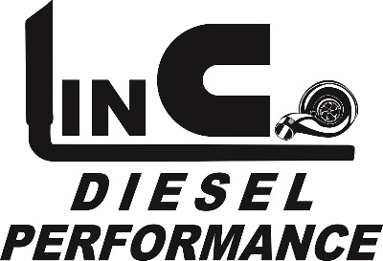

*MOTORSPORTS*

The 2019 truck pullin season will be here before we know it! That means it’s time to line up some sponsors for our events. We are anticipating at least 10 truck pulling events this season which means we will have plenty of sponsor opportunities. Another exciting addition to our 2019 season will be a points competition that will run through the county fairs in July in which the competitor in each class with the highest average finish will get a cash bonus! This will draw more competitors as well as spectators to the events which is better for everyone- including our sponsors. We will be needing a sponsor(or sponsors) for this points competition.

100% of the sponsor money at our events goes into the purse for that event. This added prize money helps draw more competitive trucks to our events along with more spectators which means more exposure for our sponsors. Class sponsors will get mentioned on Facebook as the class sponsor for the given event along with a short write up about your business plus links to your website. The day of the event we will display a sign or banner (provided by you) on or near the track, mention all sponsors throughout the event and read a write up (commercial) about your business at the start of the sponsored class. We do our best to promote our sponsors before, during and after each event. Again, the money goes to the class winners, not towards the event cost. We are expecting more competitors and better trucks than ever before in 2019. We have added one gas and one diesel class for 2019 which will make for an even better show. We look forward to working with our past sponsors again as well as bringing on some new sponsors.

If an event would get rained out or cancelled for any reason the money will roll over to the next event for the respected class purse if chosen, or we will refund the sponsors money.

If you would like a list of events, classes and pricing please contact Jeff:

Shop phone (daytime)- 636-528-1577

Cell (evening or text)- 636-262-2948

Email- [jeff@lincodieselperformance.com](mailto:jeff@lincodieselperformance.com)