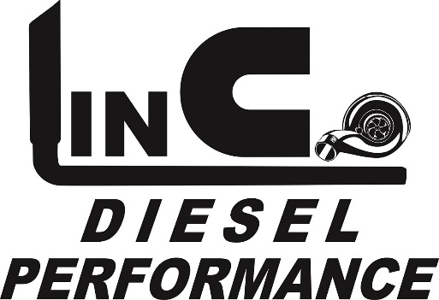
MOTORSPORTS
Truck pull sponsorship form
LDP Motorsports offers 2 levels of sponsorship-
Silver level sponsor $100- Silver level sponsors will be mentioned as a sponsor during the event along with display of a banner provided by sponsor.
Gold level(class) sponsor $200- Gold level sponsors will get an advertisement on our truck pull Facebook page with link to your website, have a one paragraph commercial type write up read by announcer during the selected class, be mentioned as a sponsor during the event as well as the display of a banner provided by sponsor at the event.
Class you choose to sponsor- Gold level:
Street Stock Diesel 2.4 Modified Street Stock Diesel 2.5 Work Stock Diesel

Hot Stock Diesel Unlimited Street Diesel

Street Stock Gas Hot Stock Gas Pro Street Gas

Open Gas- Only ran at certain events

Sponsor spots are first come first serve! Please verify availability before selecting class(s) and mailing check.
Event and date you would like to sponsor the class at:
Sponsoring business name, address and phone number: _____________________________
____________________________________________________________________________
____________________________________________________________________________
____________________________________________________________________________
Website: ____________________________________________________________________
Facebook page: Yes/No If yes name(user name)___________________________________

In one paragraph please describe your business- this will be used in advertising and will be read at the event before/ during the sponsored class:

Please make checks payable to:
LinCo Diesel Performance motorsports LLC
392 N. Lincoln Dr
Troy, MO 63379

jeff@lincodieselperformance.com
Shop- 636-528-1577
Jeff’s cell- 636-262-2948
Thank you for your support!

