# **Allison trans install instructions**

**What you need to know about Allison trans operation:**

**Your Allison trans is an electronically controlled clutch to clutch trans. What that means is a computer commands the shifts based on inputs from multiple sensors and modules. Engine and trans tuning effect trans operation! Trans tuning is NOT recommended on our units. 2011 and newer models must have stock file in TCM for warranty OR have a file written with STOCK line pressure command! Poor engine tuning will cause excessive defuel or in some cases not enough defuel time which can lead to bind up- this will break shit! Make sure your tuning is from a reputable tuner. Save yourself time, money and ensure the best performance out of your new trans by verifying tuning. If needed we can provide engine tuning and or stock trans files via EFI Live or EZ Lynk.**

**What you need to remove from your core!**

* Trans cooler line fittings(2)- we will supply new seals for you to reseal them
* Speed sensors- 1- 3 depending on year and 2wd or 4wd units- we will send new o rings
* Neutral safety switch: 2001-05 5 speeds only. We can supply new switch if needed.
* Inspection cover plate in bell housing- rectangular spring plate near spin on filter.
* Any and all brackets: ie fuel line, wiring harness, shifter cable ect.
* Transmission mount- we stock upgraded poly mounts. Order if needed.
* Selector valve lever- Located on driver’s side(where shifter cable attaches)
* Check to see if alignment dowels stayed in adapter plate! If 1 or both dowels came out with trans knock them out of bell and re-install in correct holes in adapter plate- dowels are tapered and need to be installed in engine side with taper facing trans.
* PLEASE DRAIN UNIT!! Remove torque converter, drain and reinstall. Swap our converter retaining bracket over to your core once you receive our unit and have unloaded it from crate. Spills may cause delay in shipping core back or additional fees!

# **Install Procedure**

# IT IS HIGHLY RECOMMENDED THAT THE INSTALL BE PERFORMED BY A REPUTABLE SHOP/TECH WITH EXPERIENCE IN TRANSMISSION REPAIR AND DIAGNOSTICS. A LINE PRESSURE GAUGE AND SCANNER ARE ALSO HIGHLY RECOMMENDED!

* THE TRANS COOLERS MUST BE FLUSHED!!! WE RECOMMEND USING A MINIMUM OF 2 CANS OF COOLER FLUSH AND 1 CAN OF BRAKE PARTS CLEANER. MUST FLUSH UNTIL LIQUID IS CLEAR. FLUSH BACKWARDS OF FLOW! CASE IS LABELED NEAR COOLER LINE FITTINGS. FLUSH THROUGH TOP LINE LABELED FROM COOLER. IF A UNIT IS RETURNED FOR WARRANTY AND OLD CONTAMINATED DEBRIS IS FOUND WARRANTY VOID- FLUSH YOUR COOLER RIGHT!

# note: if using a dipstick and or tube other than oem(ie- driver’s side tube) check depth of stick in both tubes to ensure proper fluid level. measure from flared point of tube to end of stick on both. damage caused by low fluid level will void warranty. an over filled unit will run hot and leak from vent potentially causing damage to unit.

# The torque converter has been filled with 2 quarts of fluid- no need to pull out of unit.

# Ensure torque converter is fully installed in front pump by measuring from the face of bell housing to cover- should measure at least 7/8”. If less tha 7/8” lift up on converter and turn while pushing in. If converter is not fully installed in pump and bell housing bolts are torqued damage to pump will occur! This type of damage is NOT covered under warranty.

# If reusing cooler line fittings reseal with provided seals and install in bell housing. Install speed sensors with new seals(provided).

* 2001-05 UNITS: NSBU SWITCH MUST BE REMOVED AND INSTALLED IN NEUTRAL AND CLOCKED TO ENSURE PROPER OPERATION AND AVOID DTCs.

# Align slotTED HOLE IN FLEX PLATE WITH STARTER HOLE FOR EASIER ALIGNMENT OF CONVERTER.

* INSTALL TRANS MAKING SURE CONVERTER SPINS FREE WHILE TIGHTENING BELL HOUSING BOLTS- CONVERTER CAN BE TURNED THROUGH ACCESS HOLE IN BOTTOM OF BELL HOUISNG.
* INSTALL NEW SUPPLIED TRANSFER CASE GASKET- DO NOT USE RTV!!
* **BE SURE TO CHECK DRIVELINE COMPONENTS FOR WEAR!!!!!!!!** BINDING OR LOOSE U JOINTS OR CARRIER BEARING MAY CAUSE VIBRATION WHICH CAN LEAD TO CRACKED EXTENSION HOUSING, BELL HOUSING OR ENGINE ADAPTER PLATE WHICH WILL NOT BE COVERED UNDER WARRANTY! FIX YOUR DRIVELINE IF NECESSARY TO AVOID COSTLY REPAIRS.
* IF LINE PRESSURE GAUGE IS AVAILABLE CONNECT TO PORT NEAR SPIN ON FILTER.

# FILL PROCEDURE: SHALLOW PAN ADD 12 QUARTS(DEEP 14) AND START ENGINE. ALLOW TO IDLE FOR 10 SECONDS AND SHUT OFF. ADD 4 QUARTS. RESTART ENGINE, ALLOW TO IDLE AND RUN THROUGH THE GEARS. TOP OFF AT FLUID WITH TRANS IN PARK. FILL TO MIDDLE OF COLD RANGE. NOTE- SHALLOW PAN TOTAL CAPACITY 20 QUARTS DEEP PAN 22-24 QUARTS.

* AT THIS POINT CLEAR ANY TROUBLE CODES FROM TCM. ON 2001-05 5 SPEEDS CLEAR TAP CELLS. WARM TRANS FLUID UP TO 110 DEGREES BY PUTTING IN GEAR AND RAISING RPM SLIGHTLY. PERFORM FAST RELEARN PROCEDURE WITH SCANNER OR EDGE MONITOR. ON 2001 MODEL YEAR TRUCKS THIS FUNCTION IS NOT AVAILABLE. DISCONNECT NEGATIVE CABLE FROM BOTH BATTERIES. TOUCH ONE NEGATIVE CABLE TO POSITIVE AND HOLD FOR 1 MINUTE. THIS WILL DRAIN THE MEMORY POWER FROM TCM AND RESET TCM LEARNED VALUES.
* THE INITIAL TEST DRIVE IS VERY CRUCIAL TO TRANS LIFE! DRIVE AT 25% THROTTLE ANGLE FOR A MINIMUM OF 4 UPSHIFTS THROUGH ALL GEARS OR UNTIL SHIFTS ARE SMOOTH. NEXT GO TO 50% AND REPEAT UNTIL SHIFTS ARE SMOOTH. FINALLY 100% AND LET IT RIP UNTIL SHIFTS ARE SMOOTH. ONCE TRANS SHIFTS GOOD UP AND DOWN AT ALL THROTTLE ANGLES REPEAT PROCEDURE IN TOW HAUL MODE.
* CHECK FLUID LEVEL AFTER TEST DRIVE. LEVEL SHOULD BE IN THE HOT RANGE. ADD AS NEEDED- DO NOT OVER FILL.
* IF LINE PRESSURE GAUGE WAS USED PLEASE REPORT BACK WITH MINIMUM PRESSURE AT IDLE IN ALL RANGES AND MAX PRESSURE IN GEAR TORQUE CONVERTER LOCKED AND UNLOCKED.
* IF ANY ASSISTANCE IS NEEDED DURING INSTALL CALL THE SHOP AND TALK TO JEFF OR MARK 636-528-1577.

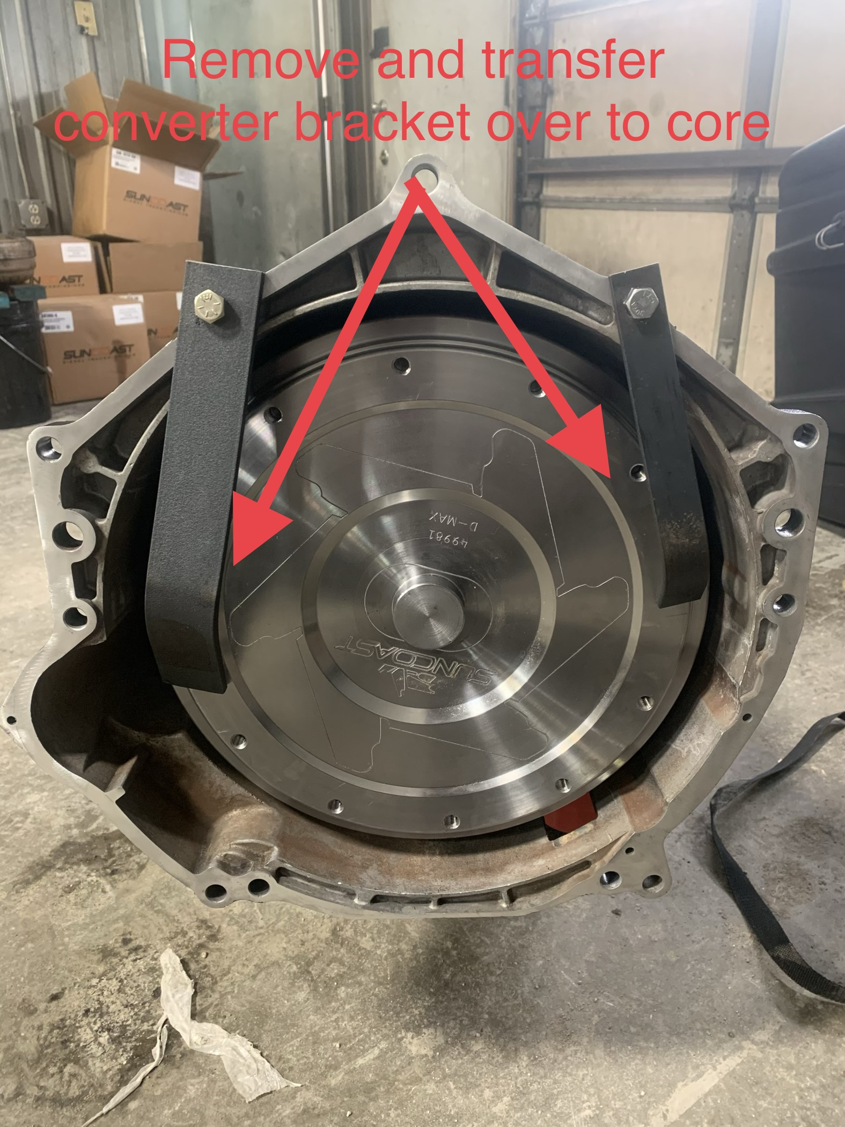

Remove and transfer brackets to your core before loading.

Make sure your converter is fully installed in front pump to avoid damage to pump gears.

Install hardware exactly as removed to ensure core does not leak during transport.

Remove and keep cooler line fittings.

LDP unit will be shipped with new O rings for fittings as well as internal line seal.

Remove tin cover from bell housing and keep with truck.

The small round plug may be removed as well although LDP unit may have one installed already.

* Note- this is where you can turn converter to line up threads with hole in flex plate during install*

2001-07(LBZ) trucks have sensor in bell housing. 2007.5-19 do not have sensor in bell housing.

All units have turbine speed sensor in case above PTO cover.

2wd units have output speed sensor in extension housing.

LDP unit will be shipped with new O rings for speed sensors.

*New sensors available upon request*