BYRON BEAR
FISHING TEAM
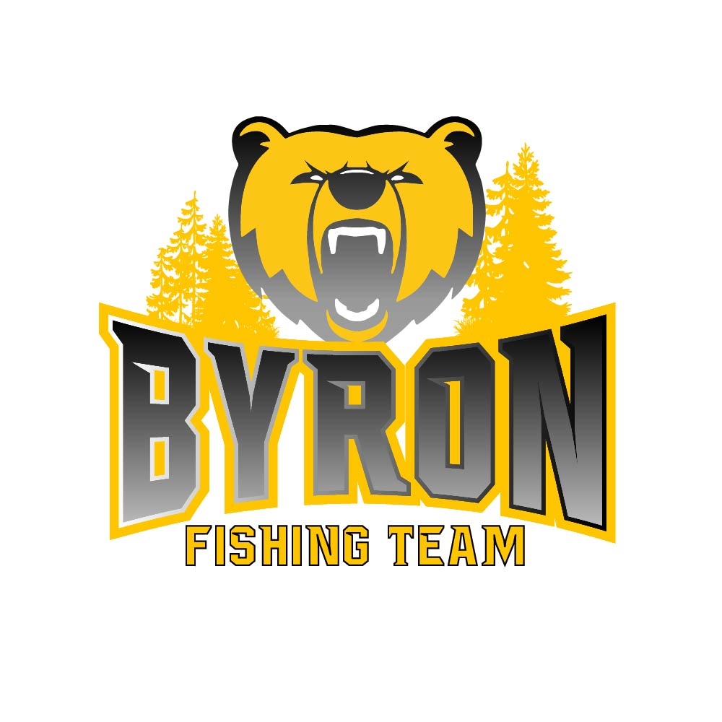 2020

Byron Bear Fishing Team Goals: 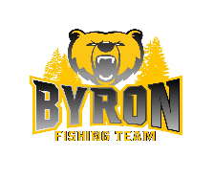

1. Teach Anglers boater safety and fishing techniques that they can use to
succeed on the water.
2. Improve angling skills to all anglers on the team.
3. Enjoy the sport of fishing.
4. Create a lifelong angler.
5. Help kids become stewards of the sport of fishing and of our natural
resources.

Coaches’ Expectations:

1. Attend registration meeting and complete registration form and pay
registration fee.
2. Attend as many meetings as possible.
3. Attend at least 2 tournament/event per year(For Jersey reimbursement).
4. Volunteer for a minimum of 1 fundraising or community service event per
year.
5. Respond to email communication as needed.
6. Represent the Byron Bear Fishing Team in a professional manner.
7. Learn and use boater safety skills on and off the water.
8. Be respectful to other people and their property.
9. Be prepared for all types of weather at an event. We are in an area where
the weather can change from one extreme to the next in a very short
period of time.
10. Be sure to come to tournaments prepared (food, drinks, etc.. ).
11. Maintain satisfactory grades in school.
12. Promote the program in a positive way.

Meetings:

1. Regular meetings and clinics will be scheduled throughout the year.
2. Arrive to meetings prepared and on time.
3. Listen to speakers and participate in any hands-on activities.
4. Meetings will be held in the Byron High School cafeteria, unless
announced with a different location.

Communication:

1. Email will be our most effective way of communication. Please respond as needed and as quickly as possible so we can coordinate events, etc.
2. We will be setting up a team Facebook page, Byron Bear Fishing Team.
3. Check out our website at www.byronbearfishingteam.com for schedule and other information.

Team Conduct:

1. We are a team! Help each other, encourage each other, and practice
good sportsmanship.
2. Conduct yourself in a mature, orderly, and respectful manner at all times.
You are representing not only our team but our sponsors when you are
wearing your jersey.
3. Thank your BOAT CAPTAINS, other VOLUNTEERS, and PARENTS. If it
weren’t for them we wouldn’t have a team!

Fundraising and Volunteering:

1. As a team, we will be participating in fundraising and community
volunteering events throughout the year. These will be announced with as
much advance notice as possible. Watch your email and check the
website for these announcements. These events are not only to raise money for our team but to give back to the community and businesses that have supported us.
2. We will volunteer at many LOCAL non-profit events (TBA).

Membership / Registration: February 2020-November 2020

1. The annual registration fee is: $60 (Grades 1-5) $150 (Grades 6-12)
2. Registration includes: Membership in the Student Angler Federation (SAF), The Bass Federation (TBF), and Fishing League Worldwide (FLW)
www.highschoolfishing.org

Insurance - Every member, boat captain and SAF club will have insurance
coverage for all official SAF school club events, which includes $1 million
of liability coverage, $25,000 excess medical coverage, $1 million for and
allegations of misconduct and $25,000 Amber Alert coverage Rapala
Student Angler Tournament Trail (SATT) fees - www.studentangler.org
Team sponsored seminars and education

Registration DOES NOT INCLUDE:
- Fishing equipment / tackle
- Life jacket
- $25.00 boat captain fee for tournaments (per angler)
- Boat/Boat Captain - We will assist in finding boats and boat
captains for tournaments, but YOU may be required to provide your
own boat and boat captain!
Requirements to join:
- Complete registration form
- Complete the online boating and safety course Boat Minnesota to
receive a youth Minnesota watercraft operator’s permit and use
boater safety skills on and off the water
- Purchase a MN fishing license ( 16 or older )
- Abide by all MN state fishing rules and regulations

Contests:

1. We will have ongoing fishing contests and challenges during the year.
Details will be made available before each contest.
2. Academic Awards - We do award additional inches to your fish for having
a 3.0 GPA and higher as well as a 4.0 GPA. We also award inches for
having perfect attendance during the contest period.

Tournaments:

1. All or our tournaments require advanced notice for participation. Please
respond timely to emails regarding registration for individual tournaments.
2. You can choose your own partner for tournaments and or event if you find
your own Boat Captain and notify us in a timely manner.
3. If you do not have a partner and Boat Captain you will be paired up with a
partner and a Boat Captain if we are able to. Finding boats and Boat Captains to take student anglers out from fishing is a big challenge. We can’t guarantee that we will be able to provide a boat or Boat Captain for every angler, but we will make every effort possible!
4. We will provide you with as much advance notice of tournament times,
regulations, and locations as possible. Note that sometimes we are not
notified until only a few days before an event. This will be communicated
via email.

Boats, Boat Captains and Team Partners:

1. It is not necessary that you or your family have a boat. We will do our best
to pair every angler with a boat and Boat Captain to take anglers out
fishing or participate in tournaments.
2. You can choose your own partner for tournaments and or events if you
find your own Boat Captain and notify us in a timely manner.
3. If you do not have a partner and Boat Captain you will be paired up with a
partner and a Boat Captain if we have one available.
4. We are looking for Boat Captains that are willing to volunteer their time
and use their boats to bring angler’s fishing. If you know of someone who
is willing to volunteer please have them contact us or give us their name and number and we will contact them. They can also go to our website and fill out a Boat Captain registration form to be added to our email list for Boat Captains.
5. Boat Captains MUST BE out of high school and a minimum age of 19.
6. All Boat Captains will need to pass a criminal background screening
check.

Angler of the Year:

We will award points throughout the year for attending meetings,
volunteering, participating in fundraising, tournament performance, grades, attendance, sportsmanship, and behavior. The top 5 point student anglers will have a chance for this award. The award(s) will be announced at the year end banquet ( TBA ).

Byron Bear Fishing Team lettering criteria: ( Not Byron or MSHSL endorsed )

1. All anglers in grades 6-12 who start the season on the first day and
continue through the last day, demonstrates good sportsmanship, boater safety, has a positive attitude, and represents our team in a professional manner. Angler must attend a minimum of 4 monthly meetings, participate in a minimum of 2 tournaments, 2 volunteering events and 1 fundraising event during the year to be eligible for a CLUB letter. Failure in meeting requirements as stated or personal misconduct will disqualify angler from earning a letter as well as Angler of the Year!
2. The Byron Bear Fishing Team coach(s) reserves the right to make the final decision regarding lettering for any angler.

Discounts:

1. Our team anglers get discounts at many different companies. It is very
important that you DO NOT share the discount codes or login information to anyone other than team members. If we abuse this privilege it will be taken away! Discounts and codes will be provided after the roster is finalized.
2. Organizations that provide discounts:

- Northland Tackle
- St. Croix Rods
- Rapala

Tournaments and Events:

1. See website for event dates and details. There will be tournaments
and events available for both junior and senior high anglers (TBA).

Chemical Eligibility Policy:

1. Byron Bear Fishing Team adheres to a strict NO Tolerance policy by any
angler. Any angler caught using these substances during a club event will be asked to leave. The angler will not be able to participant in ANY club events for the calendar year.

Coach / Contacts:

1. Chad Rolandson - Head Coach - 507-421-7916 - chad.rolandson@gmail.com
2. Trevor Augenstein - Coach - 618-401-6149 - trevoraugenstein@gmail.com
3. Wes Nigon - Coach - 507-398-6587 - wesnigon@gmail.com
4. Joe Schimek - Coach - 507-272-4712 - schimek.joe@gmail.com
5.
6.

