**Ten Tips for Powerful Presentations**

Copyright @ Regina M. Clark 2019

All rights reserved. No part of this book may be reproduced or transmitted in any form or by any means without written permission from the author.

Published and distributed by PCT Publishing

PO Box 383

Goshen, NY 10924

845-294-7089

ISBN: 9781099890239

**Table of Contents**

Introduction 6

Pay attention to the audience 7

Develop vocal variety 9

Have great content 11

Speak their language 17

Add some spice 19

Use effective visuals 16

Make a great first impression 25

Know the environment 28

Prepare for Q & A 30

Rehearse 31

Managing meetings 32

**Introduction**

When you are a good presenter, people notice. They pay attention. People want to listen. The opposite occurs when you are a bad or boring presenter. People want to run away. Every manager, leader, influencer, subject matter expert, and coach needs to be able to present information so that others will listen and take action. Anyone can learn the skills necessary to deliver a fabulous presentation. This workbook will help you design an effective presentation, it will not help you deliver an effective presentation. The only way to get really good at being an effective presenter is to practice. The more you practice, the better you will get.

The trick to delivering a great presentation is to remember that it is a privilege to be in front of an audience and you are there for them. The presentation is for the audience, not for you. Deliver a great presentation for them!

**Ten Tips**

Here are ten tips for improving your presentation skills:

1. **Pay attention to the audience**

Before you design any presentation, you must find out about your audience.

* Who are they? Friends or enemies? Confidants or strangers?
* What do they know about the subject?
* What do they expect?
* Do they have time to listen to you?
* Do they want to be in the audience or do they have to be?
* What’s in it for them?
* How many people are in the audience? Speaking to ten people is very different than speaking to 10,000.
* Are they technical experts or novices? Do they know more than you do about the topic?
* Will they understand industry jargon?
* Do they care?
* Are they jet lagged?
* Are they culturally diverse?
* Are there different ages in the audience? There are currently five generations in the workforce and there will likely be a variety of ages in the audience.
* Are they supportive of the project or opposed to it?
* Do you need to teach them or just provide an update?
* Is the information need to know or nice to know?

Who is your audience and what do you know about them?

1. **Develop vocal variety and sound like you care**

No one likes a monotone speaker!

**Rate** – too fast or too slow is not good. When speakers get nervous, which is very common, the rate of speech tends to increase. When delivering a formal presentation, the speaker needs to slow down by at least 20%. The rate of speech during a presentation is slower than conversational speech! One way to slow down your rate of speech is to concentrate on articulating your words.

**Volume** – too loud or too soft is not good. If a speaker has a natural tendency to be soft-spoken, he or she needs to use a microphone when presenting to a crowd. Never yell - you will damage to your vocal cords! If the audience can’t hear you, they might fall asleep or think about something else instead of the message that you are trying to deliver.

**Pitch** – When speakers get nervous, their pitch can go up. When this occurs, the sound is irritating. Think of Fran Dresher from the hit TV show The Nanny - her voice was high pitched and irritating. You don’t want to sound like that!

**Articulation** – Do you enunciate? Do you pronounce words properly? Most people don’t. If you were born in the northeastern part of the United States you probably drop your endings. You say swimmin instead of swimming, dancin instead of dancing. You might even smush all of your words together – whadoyawan, instead of what do you want. Jeff Foxworthy, the comedian, does a whole skit on poor articulation. Jeet instead of did you eat? Dyew instead of Did you? Often, people who learn English as a second language mispronounce words. This sounds like dis, those sounds like dose. If you want to improve your articulation, listen to your voice on a tape recorder. Then decide which sounds are not clear. Practice saying the words correctly. If you have young children, a great exercise for your voice is to read out loud to them and really exaggerate your sounds and tones.

**Resonance** – resonance is the ability of your voice to fill up space. To improve your resonance, open your mouth wider when you speak.

**Vocal variety** – every effective speaker has a great deal of vocal variety, which is the ability to change the sound of your voice and emphasize key words or key phrases. Pausing is also very effective. A two or three second pause after a key phrase is very dramatic and makes the phrase more memorable. Changing your voice to a whisper during a presentation also adds a dramatic moment. The audience isn’t expecting a whisper.

1. **Have great content**

**Know your material**. If you don’t know what you’re talking about, you shouldn’t be in front of an audience. It is the speaker’s responsibility to research and study the content prior to the presentation. If you are delivering material that someone else developed, find out what message the creator of the material had in mind. Very often I have watched good speakers flounder in front of an audience because they had no idea what the message on the power point slide was.

**Be concise**. Be conscious of limiting unnecessary filler words like - like, um, ah, er, you know, basically, hopefully, and ok.

**Use powerful language**. Powerful words influence people to take action. Powerful words inspire others. When a speaker uses powerful words, he or she is perceived as being confident, in control, and believable.

Weak language: Well, maybe if we get the money, we might be able to solve the problem.

Powerful language: When we get the money, we will fix the problem.

Weak language: I guess I’m done; does everyone understand?

Powerful language: Thank you for your attention.

Weak language: I think we have the right people on the team, we’ll probably meet our deadline.

Powerful language: We will meet the deadline; we have a terrific team.

**Use positive words**. Tell me what you can do, not what you can’t do. Tell me how to fix a problem, stop complaining about the problem. Tell me what will work, not what won’t work. Tell me how your project is going to solve my problem. People respond better to positive people.

Do you know anyone who is always complaining? They whine about the weather, the traffic, their boss, the food in the cafeteria. These people suck the life out of us! They bring us down. We need people to lift us up. Tell me something good. Be positive!

Change the negative words below to give the listener hope.

|  |  |
| --- | --- |
| **Weak** | **Positive** |
| That’s not my job. |  |
| We will never be able to meet the deadline. |  |
| The customer is not reasonable, we can’t accommodate her. |  |
| There are too many problems, we must stop the project. |  |
| The team isn’t going to agree with this solution. |  |
| The merger isn’t making anyone’s life easy. |  |
| That solution will never work. |  |

**Create structure**. When planning a presentation, develop an opening, key points, and a closing statement. Begin with the end in mind. People will never listen to everything you say. Create a memorable ending! Too many people end presentations by saying, “I’m done,” “That’s it,” “I’m out of time,” or “Any questions?” Always end a presentation with a powerful, memorable statement. When designing the closing, ask yourself, “What do I want the audience to remember after I finish speaking?” Ending with questions can leave you vulnerable. You want the audience to remember your key point, not a challenging question.

Here’s a powerful ending: “In conclusion, we expect to save 2.5 million dollars by the end of the first quarter. Thank you for your attention.”

|  |  |  |
| --- | --- | --- |
| Opening | Do I need an introduction? | time |
| Objectives | What do I want the audience to know? To do? When I finish speaking |  |
| Key Point  Q & A | Story, example, chart, PowerPoint |  |
| Key Point  Q & A | Story, example, chart, PowerPoint |  |
| Key Point  Q & A | Story example, chart, PowerPoint |  |
| Closing | What do I want the audience to remember? |  |

Design your presentation

|  |  |  |  |
| --- | --- | --- | --- |
|  |  | Time | Visual/Story/Example |
| Opening |  |  |  |
| Key Point |  |  |  |
| Key Point |  |  |  |
| Key Point |  |  |  |
| Closing |  |  |  |

Add relevant stories and examples. Audiences really enjoy stories, especially when they are your own. There are a few ways to find stories: from your personal life, from the news, from history, or from third party reports. You can retell a story that belongs to someone else as long as you get their permission. Stories, just like the rest of a presentation, must be rehearsed.

Describe a story from your personal life that you can use during a presentation to make a relevant point.

* Your greatest challenge.
* Your biggest mistake.
* An embarrassing moment.
* A fabulous customer experience.
* A huge risk that you took.
* A team experience.
* Managing change.

**Never, ever use offensive or off-color language**! Once you offend someone in the audience with offensive language, you lose them. When in doubt, don’t say it. When you speak to a culturally diverse audience, keep your language simple and concise. What might be considered offensive in one culture is not offensive in another culture, but how will you know? As a speaker, you have a responsibility to the audience and to the organization that you represent. Keep it clean and be professional at all times.

1. **Speak their language**

When you take the time to understand your audience, you will know what language they use. I’m not talking about English, Spanish or French. I’m talking about using jargon, acronyms, and slang. Every industry and profession have their own language. Many organizations use so many acronyms that they have dictionaries to explain the acronyms.

* Educators talk about magnet schools and inclusion.
* Lawyers talk about quid pro quo and depositions.
* Law enforcement talk about DWI (driving while intoxicated) and DOB (date of birth).
* Doctors talk about scripts and consults.
* Restaurant workers talk about front of the house and back of the house.

What are some acronyms that you use?

Americans use phrases that don’t translate well or don’t mean anything in other languages.

* Catch-22 situation
* Getting to first base
* Swinging for the fences
* Cold feet
* Between a rock and a hard place
* Blast from the past
* Break a leg
* On cloud nine
* Fit as a fiddle
* What’s up?

When you use language that the audience doesn’t understand, there is a possibility that you might lose some listeners. People usually don’t like to admit ignorance. They won’t raise their hand and ask what something means. Instead, they will miss the point or interpret the message in the wrong way.

1. **Add some spice to your presentation**

Adding stories, examples, props, digital images to PowerPoint can mean the difference between a dull presentation and an interesting one. The best presentations are the ones that tell a story. Think creatively! Make your presentation memorable. Years ago, I saw an engineer deliver a safety tip with the use of props. He was talking about preparing his car for winter travel. He brought with him a milk crate filled with sand, chains for the car tires, a blanket, a shovel, and other items that would come in handy if his car broke down in the winter time.

Here is an example of using balloons during a presentation. The balloons represented obstacles and the audience volunteers were asked to share their obstacles and then pop the balloon.

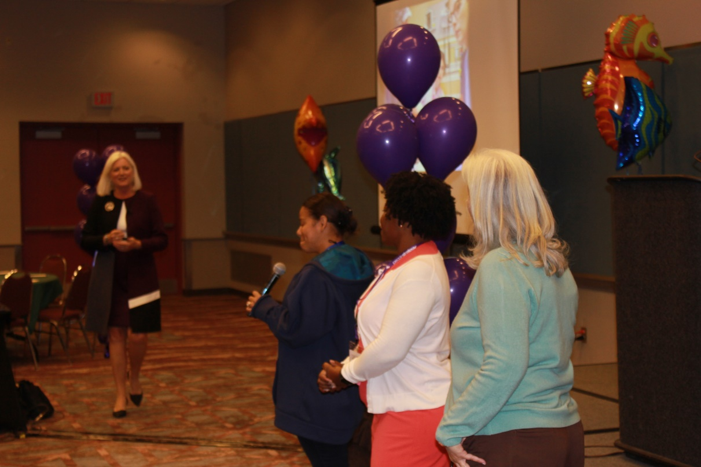

1. **Use effective visual aids**

Visual aids are tools to support the presentation; visual aids alone are NOT the presentation. PowerPoint is a powerful tool that has been widely abused in the corporate world. PowerPoint slides should be simple and easy to read.

Avoid verbal/visual interference. When you a saying something, the PowerPoint slide should complement what you are communicating. If the PowerPoint slide shows something different, the audience will be confused.

Never, ever show a graphic that the audience can’t see. When a speaker says, “I know you can’t see it but….” it’s like telling the audience that you really don’t care about them. All you care about is showing your complicated visual. If the visual contains critical information, put it in a handout and say, “turn to page 9 in your handout, there is a graph of XYZ….”

Make visual aids VISUAL and simple. A Minitab six pack is an overwhelming visual for most people. (Minitab is software designed to perform statistical functions). If you are in a Black Belt training program, the instructors will love to see Minitab six packs because they know how to analyze them. A senior executive that never even went through Black Belt training, on the other hand, might not know how to interpret the Minitab six pack.

This is a very busy visual which most people won’t understand. Perhaps sharing this information in four different charts would be more effective. It depends on the audience.

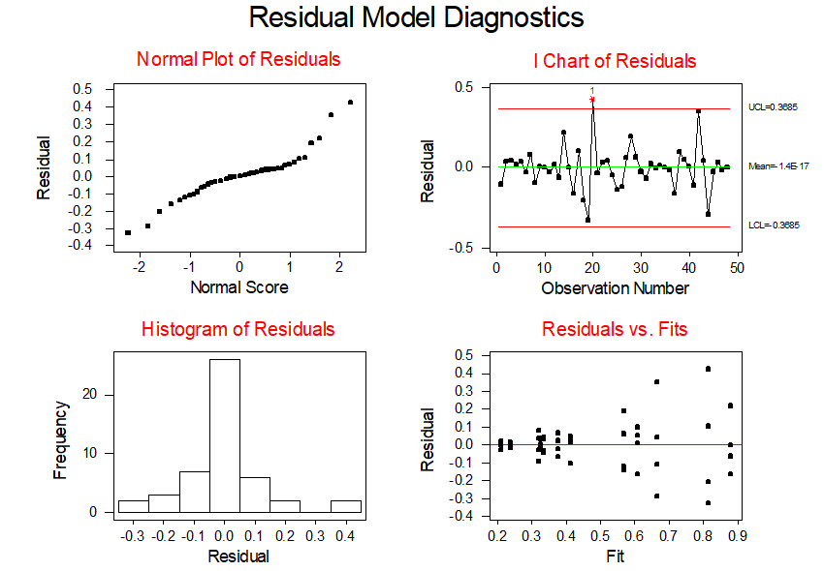

A great visual is like a billboard that you drive by at 65 MPH and you still get the message. Always remember, less is best when it comes to visuals. This is a great visual.

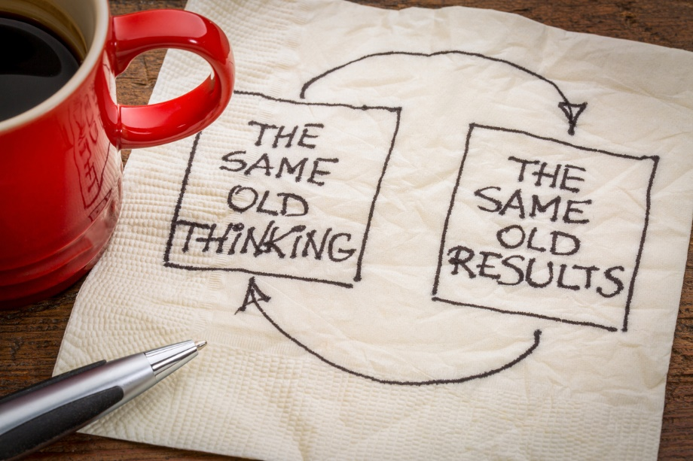

What do you think of this visual?

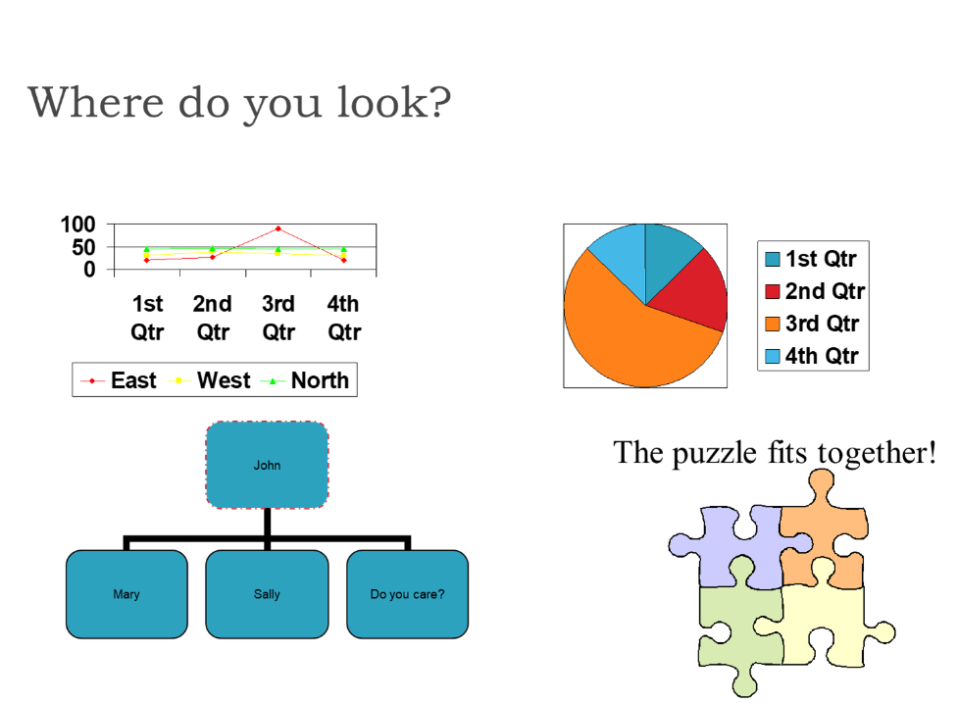

There are many different types of visuals. The most commonly used platform in business is PowerPoint.

**Types of visuals**

* Overhead transparency (which is becoming obsolete)
* PowerPoint slides using LCD projector
* Prezi slides
* Props
* Flip chart
* Dry erase board
* SMART board
* Infographics

The infographic on the next page was designed using Venngage. For more information about creating your own infographics go to, www.venngage.com.

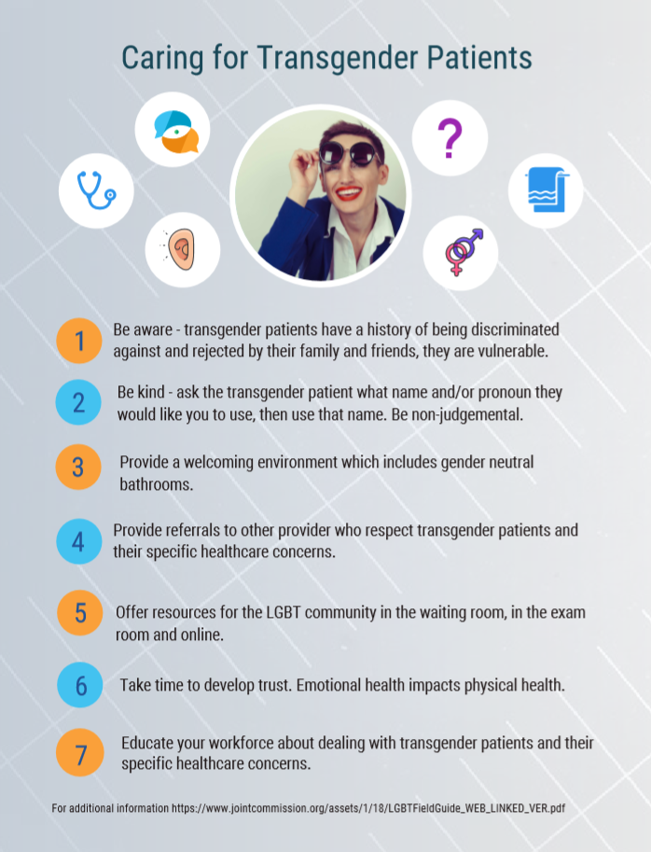

1. **Make a great first impression**

Like it or not, you only have a few seconds to make a first impression.

**Always dress appropriately**. Loud colors and lots of jewelry are not good for most corporate audiences. If the dress is business casual, find out what that means. Business casual in some organizations includes jeans, sweatshirts and sneakers. In other companies, business casual simply means no ties for men. Use your common sense. Work attire is different from beach attire - anything skimpy, see through or revealing is not appropriate! Make sure your clothing is clean, pressed and fits correctly. Limit, cover up, or eliminate body piercing and tattoos. If you are a mess, the audience will think your work is messy! If you are well put together, the audience will perceive that your work is organized and well thought out. If you need assistance with putting a work wardrobe together, visit a major department store and consult with a professional shopper, or hire an image consultant and let them know what your budget is.

**Turn your nervous energy into positive action**. Nervous energy is good -- it means that you care. Take the nervous energy and pump yourself up. When you are speaking, you are on stage. There is an element of performance that goes along with public speaking. Never tell the audience that you are nervous. They won’t know!

**Look confident**. Stand up straight and smile. It gives the audience the impression that you want to be there, that you want to share information with them. Don’t sway, dance around, or pace. These are all signs of nervousness.

**Maintain eye contact** - speak to the audience, not to the visuals behind you. When you make eye contact look at a person for 2-3 seconds and then switch. Any shorter and it looks like your eyes are jumping around the room. Any longer and it looks like you are staring at someone.

**Use appropriate hand gestures**. Think about your language and then use gestures to compliment your language. For example, if you say, “there are three key points that I want you to remember,” you can hold up three fingers.

**Choreograph the presentation**. Move deliberately. Pick a center spot and move from that spot, two or three steps. Don’t wander all over the room and don’t go to a place where you can’t make eye contact with everyone in the audience. Let’s use the same example of three key points. You can take a step forward each time you cover a point. When you finish, you can move three steps back.

**Pay attention to proxemics**. The term proxemics was introduced by anthropologist Edward T. Hall in 1966 to describe set measurable distances between people as they interact. Proxemics is the relationship between space and communication. Different cultures maintain different standards of personal space. In Latin cultures, for instance, those relative distances are smaller, and people tend to be more comfortable standing close to each other; in Nordic cultures the opposite is true. Realizing and recognizing these cultural differences improves cross-cultural understanding, and helps eliminate discomfort people may feel if the interpersonal distance is too large ("stand-offish") or too small (intrusive). Comfortable personal distances also depend on the culture, social situation, gender, and individual preference. When I deliver training programs in Europe, it is not unusual for men to kiss me hello and goodbye. This would never happen in the United States.

In the United States, the following distances are acceptable:

Intimate distance for embracing, touching or whispering

Close phase - less than 6 inches

Far phase - 6 to 18 inches

Personal distance for interactions among good friends

Close phase - 1.5 to 2.5 feet

Far phase - 2.5 to 4 feet

Social distance for interactions among acquaintances

Close phase - 5 to 7 feet

Far phase - 7 to 12 feet

Public distance used for public speaking

Close phase - 12 to 25 feet

Far phase - 25 feet or more

Enjoy the opportunity to be in front of the audience. The visibility is fabulous for your career!

1. **Know the environment.**

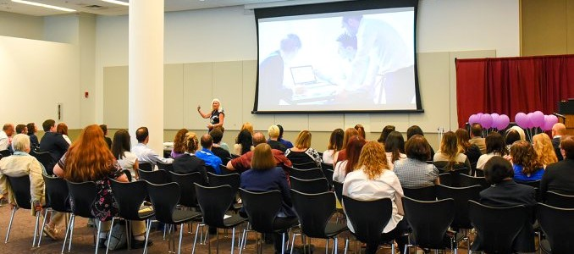

**Room set up.** Make sure that everyone can see you and the visuals. Get to the room before your audience and make sure that you are comfortable with the room’s layout. If you are working with AV people, introduce yourself and go over the details with them. They should help you with a sound check and any other details, like speakers for music or having a handheld microphone available for the audience.

**Equipment**. Always check, re-check, and check the equipment again.

**Day/time**. Audiences are more alert and more receptive to listening to a speaker in the morning. After lunch and Friday afternoons are always difficult. The worst time to speak to an audience is after dinner when the audience has had cocktails during dinner. If this happens to you, forget the PowerPoint. Keep the presentation light and lively!

**Noise level**. When a loud noise or distraction occurs (like a train whistle or cell phone ringing), stop speaking for a moment. The audience will be distracted. When the audience gets focused again, start speaking again. If you have a quick, witty sense of humor, use it to say something funny about the distracting noise.

**Temperature.** If the audience is too hot or too cold, they will have trouble concentrating on your message. Try to adjust the temperature in the room to keep the audience comfortable. When I speak, I always like a cold room because I move around a lot…but, it’s not about me, it’s about my audience!

**Location**. If you are speaking at a resort location and the audience is going to play golf immediately following your speech, make sure your presentation is concise and value added. You might even use some golf metaphors. If you are speaking in a trailer at a chemical plant during lunch hour and there is no air conditioning, keep it brief. The location, temperature, time of day, and mood of the audience will impact your effectiveness as a presenter.

1. **Prepare for Q & A**

When you develop your presentation, you also need to anticipate difficult questions and prepare answers for those questions ahead of time.

When you don’t know the answer to a question, immediately say that you don’t know the answer but will find out and get back to that person by a specific time.

When there is a subject matter expert in the room, use that person as a resource during Q & A, as long as you know that the expert will answer questions briefly and not use up all of your time.

Always look at a person when he/she is asking a question. Look at the audience when answering. If the audience cannot hear the person asking the question, repeat the question for the audience.

It is acceptable to not answer a question! The question might be of a confidential nature or not appropriate for the audience. When this occurs, look at the person asking the question and say, “I’d rather not answer that question, does anyone else have question?” Then change your eye contact to look at someone else in the audience.

There are a few common mistakes that presenters make during Q & A sessions that you should avoid:

* Giving too much information.
* Not answering the question.
* Trying to answer every question.

1. **Rehearse!**

There is no magic to being an effective speaker. Speaking is a skill and most people can master the art of speaking if they are willing to work at developing the skill. Like developing any skill, effective speaking takes practice. Find an empty conference room, stand up and practice. The rehearsal must be mental and physical. Speaking requires energy and movement!

A common mistake that presenters make is to run through PowerPoint slides in their head. This doesn’t work. You need to speak the words out loud, time the presentation, use the equipment and allow for audience interaction.

Delivering a presentation without rehearsing it will only get you so far in your career. Either you want to be a great speaker, or you don’t care. It’s your decision. We all know and have witnessed bad speakers.

Rehearsing a presentation also helps reduce nervous energy. Many presenters experience nervousness before they get in front of an audience. The larger the audience, the more nervous I get. Nervous energy can be good. Use your nervous energy to pump yourself up before you present. Take a few deep breathes to focus and visualize yourself delivering a fabulous presentation.

The first few minutes in front of the audience is always the hardest. Plan your opening remarks and rehearse saying the sentences prior to getting on the stage. It doesn’t matter if you are in a board room, an office, a church or a school – you are always on stage!

**Managing Meetings**

Here is a checklist to run an effective meeting.

* Create an agenda and share the agenda prior to the meeting.

The agenda must include an objective. Why are we having this meeting?

* Invite the right people and confirm attendance prior to the meeting.
* Follow the agenda and the timeframe. Start on time. When you start late, you inadvertently punish the people who arrived on time.
* Have a parking lot for items that come up during the meeting but are not on the agenda.
* Introduce ground rules at the start of the meeting so that the meeting can be efficient. A good ground rule is to silence cell phones.
* Assign roles and responsibilities - competent note taker, a timekeeper, a facilitator and someone who is accountable for following up.
* Create action items and follow up.

**Your Action Plan**

What do you need to do to become a more effective presenter? By when?

Who can provide support, mentoring?

**Contact Us**

Regina M. Clark, CSP is an international speaker, author, and founder of **Creative Performance Solutions, LLC.** For the past 30 years she has been energizing audiences with her content rich, fast paced, interactive programs. Regina also delivers training programs for **Business Training Works.**

While delivering management development programs for AlliedSignal, Regina was asked to teach a group of Six Sigma Black Belts Presentation Skills. At the time, Regina had no idea what a Black Belt was, but she knew how to present information so that an audience would listen! Since then, Regina has coached thousands of people in the art and science of effective communication.

She is a professional member of the National Speakers Association, past president of the New Jersey chapter and a Certified Speaking Professional, a designation held by less than 10% of speakers worldwide.

She is also author of:

• Deadlines & Diapers: 65 Tips for Working Moms

• Are We Having Fun Yet? 75 Ways to Create a Motivating Work Environment.

• WOW Your Customer or Somebody Else Will

• 101 Ways to Improve the Patient Experience

• 101 Ways to Get Fit by Fifty

For more information, contact Regina at www.reginaclark.net, 845-294-7089 or Business Training Works at 301-934-3250.