**NEWS RELEASE**

# National Park Service and partner agencies announce Save America’s Treasures Grant for The Whittemore House, Washington, DC

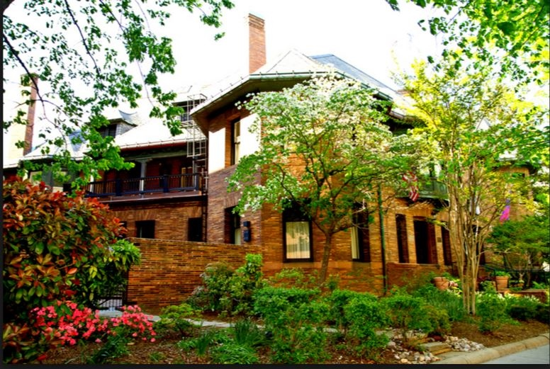

The Save America's Treasures grant helps preserve structures like The Whittemore House in Washington, DC, designed by Harvey Page and built in 1892-4.

**News Release Date:** Sept. 11, 2022

WASHINGTON – The National Park Service (NPS) recently announced a $.313 million Save America’s Treasures grant to the WNDC Educational Foundation for restoration and repair of The Whittemore House at 1526 New Hampshire Avenue, NW in the District of Columbia. As required, the grant will be matched by at least an equivalent amount in private and public support from donors and friends of the WNDC Educational Foundation.

The SAT grant, given in partnership with the National Endowment for the Arts, the National Endowment for the Humanities, and the Institute for Museum and Library Services, is only available to properties that are on the National Register of Historic Places.

The Whittemore House is both architecturally and historically significant as described in the form nominating it to the National Register of Historic Places in 1973 and an amendment detailing its national significance with respect to women’s history and rights. Purchased in 1927 by the Woman's National Democratic Club, for almost a century, the house has served as a hub and base of support for politically engaged women across the United States to answer the question posed by suffragist and founder Emily Blair following the passage of the 19th Amendment – “What shall we do with it: The ballot, of course! We have it! Now what?”

The State Historic Preservation Officer of DC described the Whittemore House as:

“ . . . one of the most masterful pieces of residential architecture in Washington, DC. Designed by Washington architect Harvey L. Page and built in 1892-1894, the building presents a restrained and unornamented exterior that remains one of the finest English-inspired Arts and Crafts exteriors in the city.”

The SAT grant and matching donations will support a multi-year preservation program including the restoration and repair of a copper bay, exterior windows and doors, and four brick chimneys in the exquisite undulating slate roof.

The WNDC Educational Foundation is a 501(c)(3) nonpartisan public charity dedicated to civic engagement and education concerning the history of women’s rights as well as the preservation of the historic Whittemore House and Museum—a home for women’s political engagement in the nation’s capital for nearly a century.