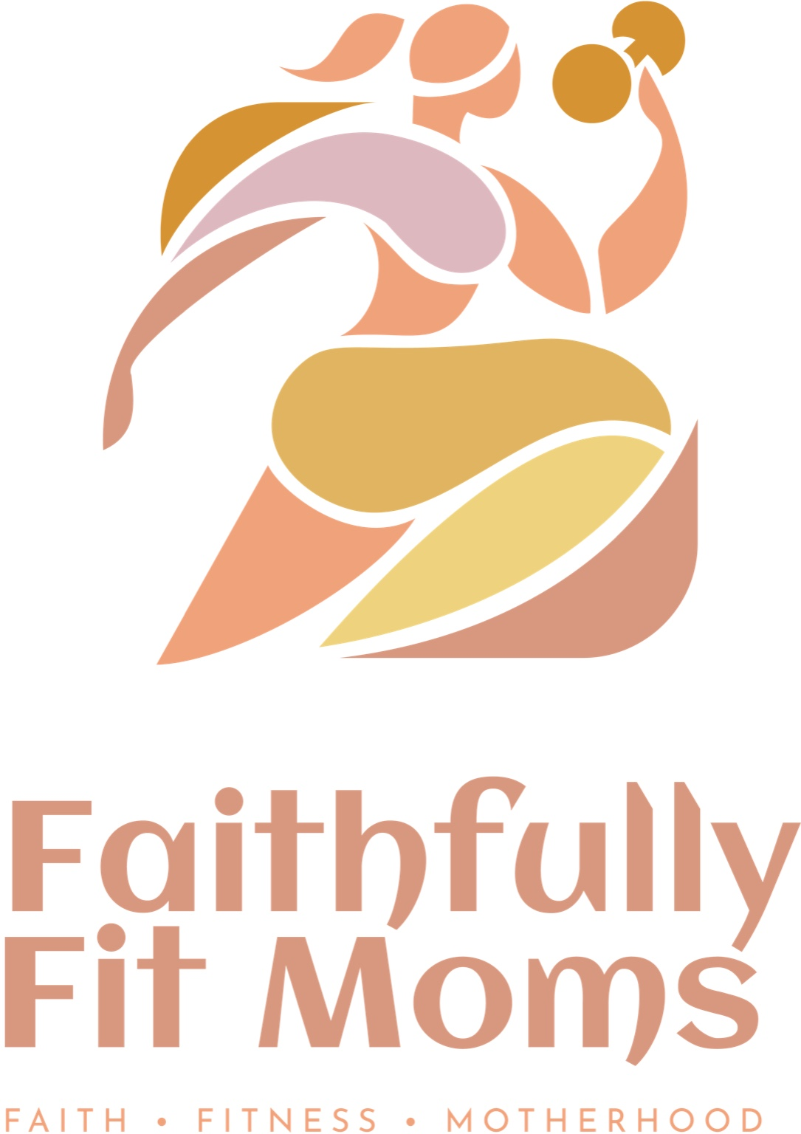
✨ A Word of Encouragement
"But those who hope in the Lord will renew their strength. They will soar on wings like eagles; they will run and not grow weary, they will walk and not be faint." — Isaiah 40:31
Dear Sisters,
As we step into this new month, let us be reminded that our strength does not come from our busy schedules, our to-do lists, or even our physical stamina — it comes from the Lord. When we anchor our hope in Him, He equips us to thrive in both faith and wellness. Take this as your gentle reminder: your body is a temple, your mind is a gift, and your spirit is renewed in Christ daily.
🥗 Wellness Corner: Meal Prep Tips for Busy Moms
Keeping your family nourished doesn’t have to be overwhelming. Here are three simple strategies:
1. Choose a Theme Night — (e.g., “Meatless Monday” or “Taco Tuesday”) to cut down decision fatigue.
2. Batch Cook Staples — Prepare proteins (grilled chicken, beans, or quinoa) and veggies on Sunday to mix into meals during the week.
3. Snack Smart — Wash and portion fruits, nuts, and yogurt cups ahead of time so you always have healthy grab-and-go options.
🧘 Morning Movement: Stretch Into Your Day
Before the rush begins, take 5–7 minutes to stretch and awaken your body:
• Neck Rolls — Gently roll side to side to release tension.
• Shoulder Openers — Reach arms wide, roll back slowly.
• Standing Forward Fold — Stretch your hamstrings and lower back.
• Deep Breathing — Place one hand on your heart, the other on your belly, and inhale God’s peace.
🌿 Closing Prayer
Lord, thank You for the gift of a new day. Renew our strength, refresh our minds, and help us honor You with the way we care for our bodies and families. May our lives reflect Your love in every moment. Amen.

📌 Reminders
• Next Bible study is on 9/21 at 10:00 AM on Krog St.
• Don’t forget to send your contact information.

