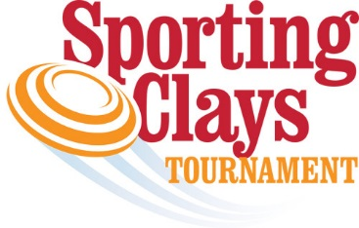
Dear United Way Supporter:
Habersham County United Way
We are delighted to announce the 6th Annual United Way Charity Clays Tournament benefiting the Habersham County United Way, to be held on Saturday, November 20, 2021.
This event is one of the fundraisers that the Habersham County United Way hosts throughout the year to raise funds for the annual Campaign Goal. The campaign fundraisers for 2021 will be used to help fund over 22 non-profit agencies and programs that benefit Habersham County residents in times of need. The mission of the Habersham County United Way is to ensure that funds raised go to help the people right here at home in the most efficient and effective ways possible. Without the generous support from the community, the Habersham County United Way could not help fund these agencies that service our community. Support the Habersham United Way by participating in the Charity Sporting Clays Tournament!
Registration forms are attached to secure your individual or team spots in this year’s tournament. Individual entry is $125 or team of 4 is $500. We have plenty of team space available so make plans to join us on November 20th! Our goal this year is 40 teams, so please help us spread the word! You can pay registration with a check or by credit card. If you wish to pay with a card, contact Connie Foster for PayPal invoicing. Day of event registrations are allowed as long as space permits.
We’ve also included information on how you or your business can become a tournament partner. For inclusion in print materials and other tournament publicity opportunities, partner commitments are due no later than Friday, October 29th. If your company is interested in donating an in-kind donation, please complete the enclosed donation form. You will be recognized for your contribution and anything over $125 will be provided the benefits of the level closest to the value of your donation.
Please contact Connie Foster (Campaign Chair) with any questions at 706-778-5100 ext 2516 (Fieldale Farms Corp), cell phone at 706-768-1158 or via email at conniefoster@fieldale.com.
Important Dates:
Friday, October 29th – Partnership Commitment Deadline (guarantee inclusion in all marketing materials)
Friday, November 12th – Early Bird Registration Deadline
Again, thank you for your support of the Habersham County United Way and the 6th Annual Charity Clays Tournament. Your support is needed and greatly appreciated!

Sincerely,
Connie Foster Bob Cook Billy Boyd
Campaign Chair President, Board of Directors Executive Director

