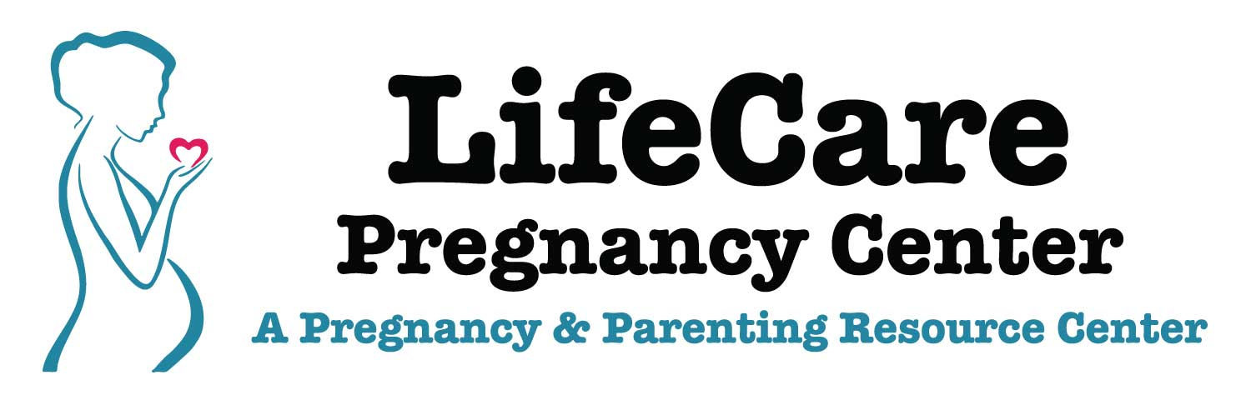
2017 Hwy 59 SE, PO Box 972, Thief River Falls, MN 56701
Office: 218-681-1279 24 Hour Hotline: 218-689-5454
Email: lifecaredirector@wiktel.com Website: https://lifecarerf.org
VOLUNTEER QUESTIONAIRE
NAME:________________________________________________________ DATE:________________
PHONE: ________________________________
ADDRESS: _________________________________CITY/STATE/ZIP:_______________________________
EMAIL: ______________________________________________________________________________
How can we contact you (circle one): Call Text Email Mail
Please indicate roles you are interested in volunteering for:
Please indicate (X) your skill level/experience in each of the following areas:
 | None | Beginner | Intermediate | Advanced
Fundraising
Organization
Event Planning
Public Speaking
Marketing
Desktop Publishing/Writing
Painting/Interior Design
Office/Secretarial Duties
Childcare

What are any additional skills you can contribute by volunteering:

What is your current Occupation? ________________________________________________________
What days and times are you available to volunteer (circle all that apply)?
Monday Mornings
Tuesday Afternoons
Wednesday Evenings
Thursday Any Time
Friday
Saturday
Sunday
How would you discuss these topics with individuals:
- Pregnant unwed teenage girls: _______________________________________________
______________________________________________________________________________
- An abortion-minded woman: ________________________________________________
______________________________________________________________________________
- Abortion in cases of rape, incest or fetal deformity: ______________________________
______________________________________________________________________________
- A woman who has had an abortion: ___________________________________________
______________________________________________________________________________
- Adoption: _______________________________________________________________
______________________________________________________________________________
- Contraception: ___________________________________________________________
______________________________________________________________________________
Have you had any personal experiences or educational background relating to pregnancy counseling, abortion, adoption, problem pregnancy, birth defects etc. that you can share?

