Looking Back……
Women’s Club of New Seabury
June 2017

The May luncheon had no gimmicks-but it did have thingamabobs, widgets, doodads and all sorts of utensils for the cook in the family. Even some of our long-time culinary wizards found some new and inventive ways to work in the kitchen.
The new chef at New Seabury, Mark Porcaro, also greeted the group, who gave a big thumbs up for our delicious meal.
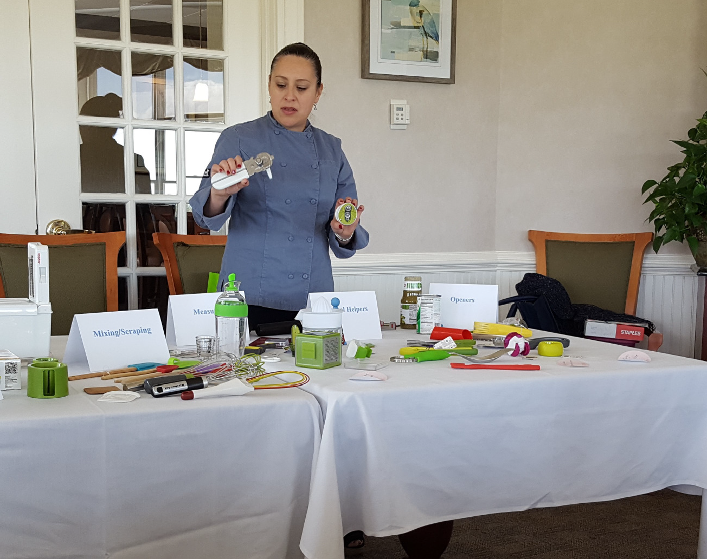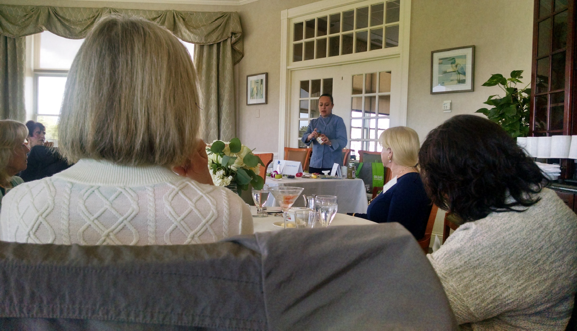The slate of officers for 2017-2019 was presented to the members in attendance and the slate was elected unanimously.

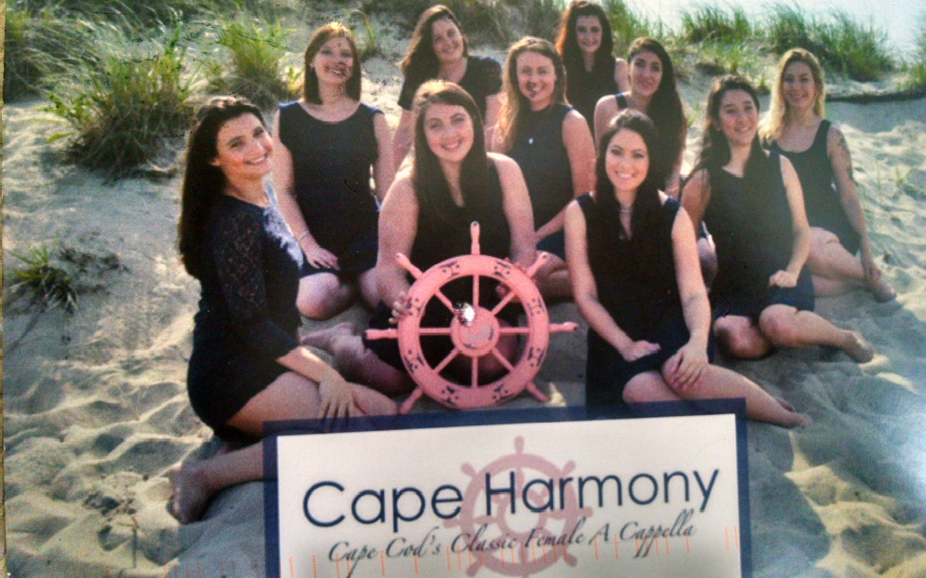Looking Ahead…….
SUMMER IS COMING, SO START IT WITH A SONG.
CAPE HARMONY, a group of women who come from around the country and SING A CAPPELLA on Cape Cod each summer, will per- form.
They sing top 40’s songs, oldies, and Cape Cod classics. This will be an unforgettable program. Bring a friend and enjoy a musical afternoon.
See enclosed flyer and send your reservation today.
Reservations due by June 6.
Wednesday, June 14 at the Poppy

Still Looking Ahead……
WCNS has purchased a limited number of tickets for the College Light Opera Company’s production of
“My Fair Lady” at Highfield Hall on Thursday, July 13th at 2 PM.
Please contact Kitty Gold at 508-477-5106 to purchase your tickets.
First come, first served.
Website: www.womensclubofnewseabury.com

Newly Elected Slate of Oﬃcers for the Women’s Club of New Seabury
2017-2019
President
Mary Jane Richardson (mjr4700@comcast.net or 508-477-3280)
Co-Vice-Presidents
Susan Finkle
Janet Kinnally
Recording Secretary
Sandra Grainger
Corresponding Secretary Ann Marie Higgins
Treasurer Muriel Golden
Congratulations to the new Oﬃcers of the Women’s Club of New Seabury. The fun be- gins on the next two years. There are several Committees that are also busy keeping our club running smoothly and vigorously. We have committees for Publicity, Membership, Programs, Newsletter, Website, Philanthropy, Ways and Means, and Programs.
If you have an interest, please contact our new President and come sit in on a Board meeting. No pressure, just observe, and see if there is an area where you would like to contribute your time.

Women’s Club of New Seabury
ANNOUNCEMENT:
Our one and only fundraiser, the Bazaar and Auction, will have a new look this fall. First and foremost, we are changing the date to a Wednesday in early October. The reason for this is to accommodate those who leave for warmer climates later in the month.
Secondly, the “event” will have some new ideas, and we are omitting some as well. Times change and we are making changes, too. The committee wants to encourage as much partic- ipation by our members as possible. Suggestions have included making the “event” more in- teractive with attendees.

CONTEST
Our first step is to ask our members to give a new name to our “Bazaar/Auction Event”.
Please submit your suggestion for a new title that reflects flair, joy, and a spirit of giving
---as that is the main goal---”RAISING MONEY TO SUPPORT OUR PHILANTHROPY PROGRAM”. All suggestions should be emailed to jkinnally@comcast.net no later than JULY 20, 2017. There will be a prize for the woman who names our 2017 Event.
As of 2016, the Women’s Club of New Seabury has donated over $124,000 from the proceeds of our Auction, to local organizations that supply food to the needy.
Also, if you would like to participate in the planning of our “Annual Event”, your input, ideas, and help will be much appreciated.
Please contact Susan Finkle at cumbjaysue@aol.com or 508-540-5551.

PHOTO OP
Finally, if you have a garden that you treasure, and would like to see a photo of it in a collection of note cards (to be for sale at the as-yet-unnamed EVENT), please contact
Janet Kinnally at jkinnally@comcast.net. She will make arrangements to photograph your garden at your convenience and at the height of its summer beauty. Note cards will be sold at the “EVENT”.

