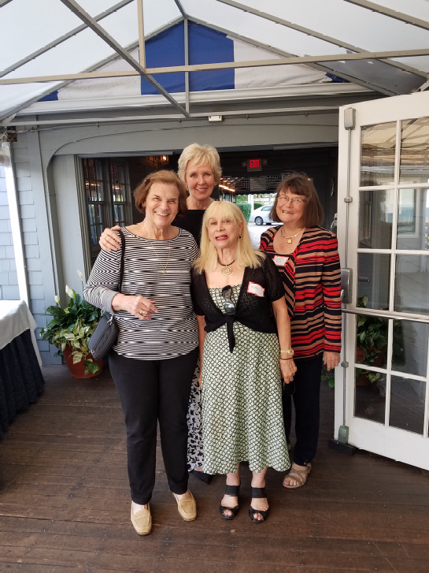
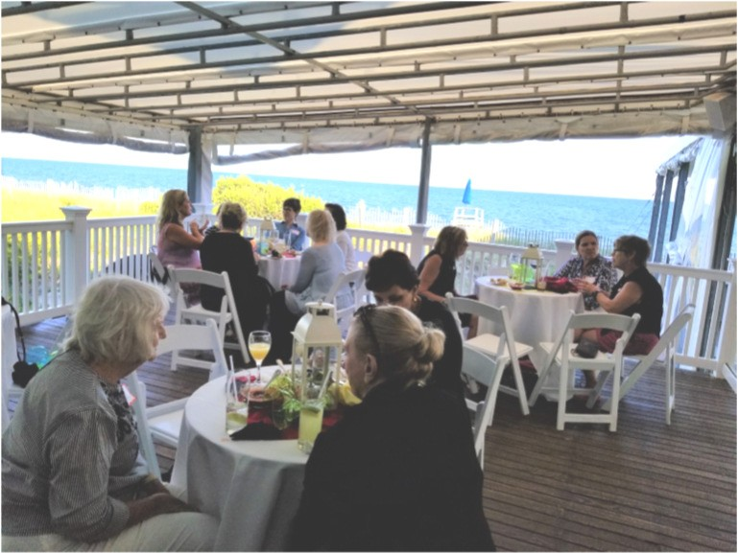
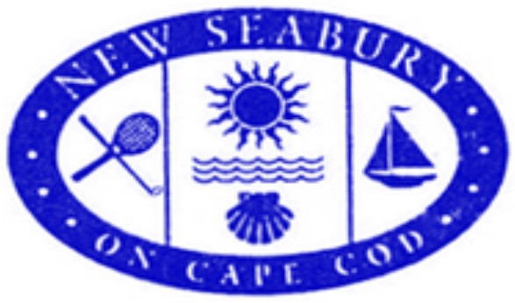

Women’s Club of New Seabury
September 2017

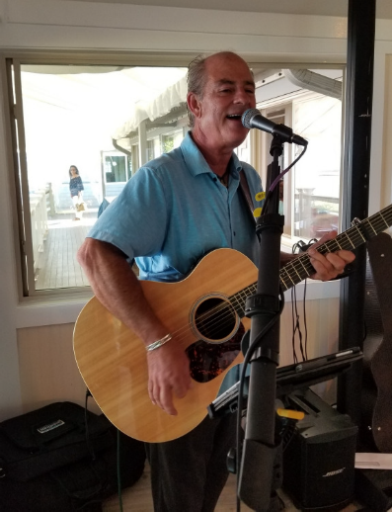
Looking Back……….
GIRLS NIGHT OUT WAS A HIT! A BEAUTIFUL SETTING COMBINED WITH MUSIC, MERRIMENT, AND
SMALL PLATES of Mexican food. About 40 women gathered for a spectacular twilight. It was wonderful to welcome back Jane Goubeaux. She is an inspiration for us all with her fortitude and pluck.
The music by Paul Good was a great back drop for those of us who know James Taylor, The Eagles, and the Beatles. It was easy listening at its best. .
Looking Ahead…….
“Simply Irresistible”! The annual fashion show is around the corner. Fashions will be presented by IRRESISTIBLES of Osterville. Our models are choosing their outfits and will walk the runway with dash and their inimitable style !
The Fashion Show flyer is attached. The date is WEDNESDAY, September 13. Make your reservations early as this luncheon is always a sell-out!

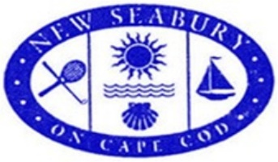

Our annual WCNS Fashion Show and Luncheon will feature clothing from IRRESISTIBLES in Osterville. Their merchandise is a collection of women's cloth- ing, jewelry, and accessories. Today, there are 12 IRRESISTIBLES stores along the east coast. Soft piano music will be provided by Lee Donaise.
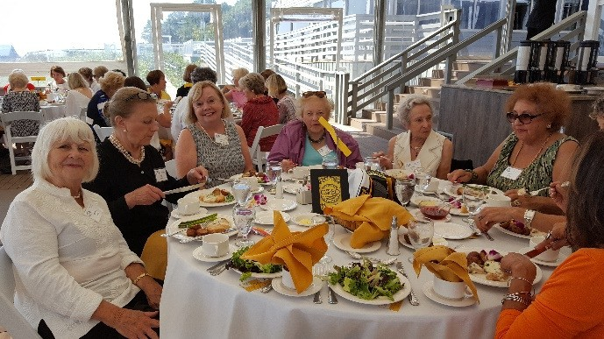
From September 2016
Join us. Bring a friend!
Wednesday, September 13, 2017
at Popponesset Inn
Check in begins at 11:30 AM. Luncheon served at Noon, Followed by Fashion Show
- - - - - - - - - - - - - - - - - - - - - - - - - - - - - - - - - - - - - - - - - - - - - - - - - ———
REPLY SLIP – Must be received by September 6

Your name: $25.00

Your guest(s): $25.00 pp

Please send this slip and your payment of $ (payable to WCNS) to WCNS, Post Oﬃce Box 906, Mashpee, MA 02649

WOMEN’S CLUB OF NEW SEABURY
Cordially invites you to
''WE CARE'' GIVING FAIR
to benefit Mashpee and Falmouth food pantries and shelters and the Mashpee Scholarship Foundation Trust
Wednesday, October 4, 2017
The Club at New Seabury• 11:00 A.M.

RAFFLES, CONTESTS & MORE!
ALL ARE WELCOME!

Reservations must be made for an individual or table of 10.

Please send your name and payment ($30 per person) to:
WCNS, PO Box 906, Mashpee, MA 02649
by September 26 to confirm your reservation. Reservation Form is on the back of this invitation.

“WE CARE” GIVING FAIR

PLEASE NOTE: For the ﬁrst time, credit cards will be accepted at the Fair! MasterCard, Visa, or Discover cards. As always, checks and cash are also gladly accepted!

RAFFLE TICKETS SALES
We are hoping for 100% Raﬄe Book Returns.
If you need more raﬄe booklets to sell, please contact Susan Finkle at 508-540-5551 or cumbjaysue@aol.com
She will deliver!

New Seabury Women’s Club
2017 “We Care”
Giving Fair will feature the famous
“Bakery Table”

Share your culinary favorite: Anything cooked in a kitchen is welcome...
savory or sweet, a few or many,
fresh or preserved

To add your treat to our table on Wednesday, October 4th Contact: Carol Stenberg
508-477-2187 carol@stenberg.com You cook. We will package and decorate!

GIVING FAIR REQUESTS:
A thoughtful way to say thank you or get well or cheer up is with a small gift basket.
So in that spirit, please donate a basket to the “WE CARE” Giving Fair. Something for the hostess or a gift for a friend, school teacher, or nurse.
BE CREATIVE
Please contact
Janet Kinnally at 508-539-3974 or jkinnally@comcast.net with questions or to donate a basket. She will pick up your donation or you can deliver it to her at your convenience.
Ideas for baskets include: breakfast basket; bird watcher’s basket; book lovers basket; spa basket; fireside basket; movie time basket; golfer’s basket; baby basket; wine lovers basket; something’s cooking basket.

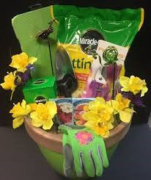
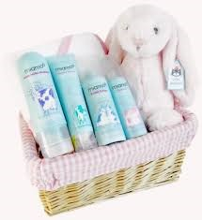

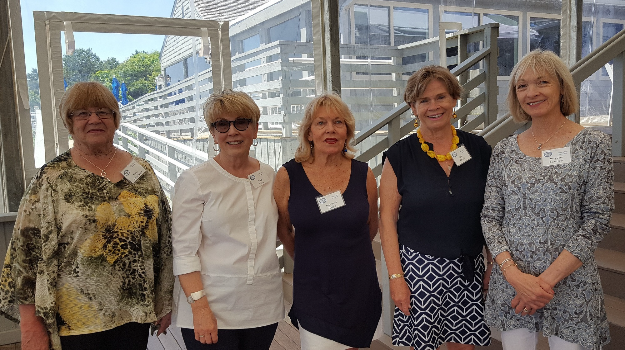
Newly elected oﬃcers of WCNS: Right to left, Mary Jane Richardson, President; Janet Kinnally, Co-Vice-President; Ann Marie Higgins, Corresponding Secretary; Susan Finkle Co-Vice President, and Muriel Golden, Treasurer.
Not pictured is Sandy Grainger, Recording Secretary.

Membership Booklets are at the printers and will be available in September.
Thanks for your patience.

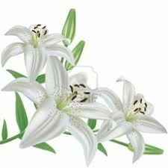
Our Sincere Condolences
to Ina Boyd on the recent loss of her husband, Keats.

Website: www.womensclubofnewseabury.com

