WOMEN’S CLUB OF NEW SEABURY

www.womensclubofnewseabury.com
JOIN US!!! The friends you haven’t met yet!
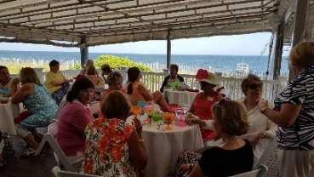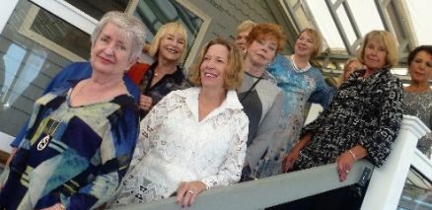
....Join us, and experience how fulfilling it can be to help our community and have fun at the same time. Remember, you only have to live in or have once lived in New Seabury (or Daniel’s Island, Popponesset, Popponesset Island) to be a member. During these five decades, members have contributed their time, talents, and financial support to numerous civic, educational, and charitable organizations in Mashpee and the broader Cape Cod community.
WCNS meets for monthly luncheons and programs, but also other events are planned throughout the year, with a concentration on the summer months. We hope you will join us to make friends, have fun, and better our community!
For further information, please contact Lisa Clifford at lisa.memberships@yahoo.com or 781-929-3845 or visit our website (www.womensclubofnewseabury.com). You may return the form below with your annual dues of $30.00 to WCNS, P.O. Box 906, Mashpee, MA 02649.
______________________________________________________________________________
July 1, 2019- June 30, 2020 Membership Form
New ( ) Renewal ( ) Date _________________________________
Name ______________________________________________________________ ______________________
Last First Middle Initial First Name for nametag
Local telephone # _ _ _ - _ _ _ - _ _ _ _ Alternate / cell telephone # _ _ _ - _ _ _ - _ _ _ _
Mailing address – street or PO Box _______________________________________________
City, state, zip code ___________________________________________________________
E-mail address _______________________________________________________________
Please check off or write in your areas of interest to keep our club vibrant:
Philanthropy (scholarships; distribution of funds) ________ Membership (welcome new members)_________
Hospitality (greeters for luncheons; 50/50 raffles _________ Publicity (photos, news items)_______________
Suggestions for activities or programs are appreciated _______________________________________________
Return form to WCNS, P.O. Box 906, Mashpee, MA 02649 with your dues of $30.00.

