Women’s Club of New Seabury
JOIN US!!! And the friends you haven’t met yet!
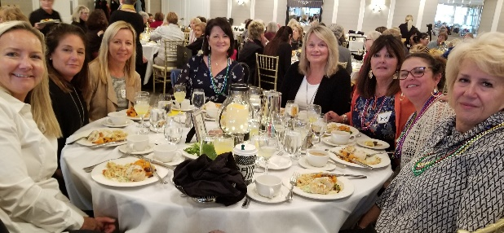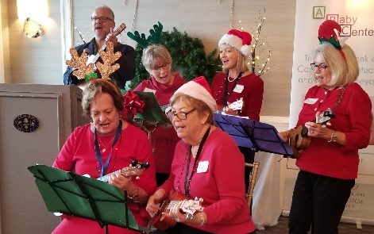
Join us and experience how fulfilling it can be to support our community and have fun at the same time. Current or past residents of New Seabury, Popponesset. Popponesset Island, Daniels Island, or members of the New Seabury Country Club are welcome to join. For over 50 years, members have contributed their time, talents, and financial support to numerous civic and charitable organizations in Mashpee and the broader Cape Cod community. The Women’s Club has donated close to $200,000 to local nonprofits over the past decade.
WCNS meets monthly and offers a variety of programs and events that promote fellowship, fun and philanthropy to support the needs of our community. For further information, please contact LisaxClifford@verizon.net, text call 781-929-3845 or visit our website (www.womensclubofnewseabury.com). Please return the form below with your annual dues of $50.00 to WCNS, P.O. Box 906, Mashpee, MA 02649.
______________________________________________________________________________________
July 1, 2020- June 30, 2021 Membership Form
New ( ) Renewal ( ) Date ___________________________________
Name ______________________________________________________________ _____________________
Last First Middle Initial First Name for name tag
Local telephone # _ _ _ - _ _ _ - _ _ _ _ Alternate / cell telephone # _ _ _ - _ _ _ - _ _ _ _
Mailing address – street or PO Box ______________________________________________
City, state, zip code __________________________________________________________
E-mail address ______________________________________________________________
Please check off or write in your areas of interest to keep our club vibrant.
Philanthropy (scholarships; distribution of funds) ________ Membership (welcome new members) _________
Hospitality (greeters for luncheons; 50/50 raffles _________ Publicity (photos, news items) ________________
Suggestions for activities or programs are appreciated _______________________________________________
For new members, we are interested in how you learned of the Women’s Club. (Please check all that apply)
Family/Friends____ Attended Women’s Club Event_____ Internet Search____ Newspaper______
New Seabury Club email/website____ Referenced on another website_______ Other___________________

